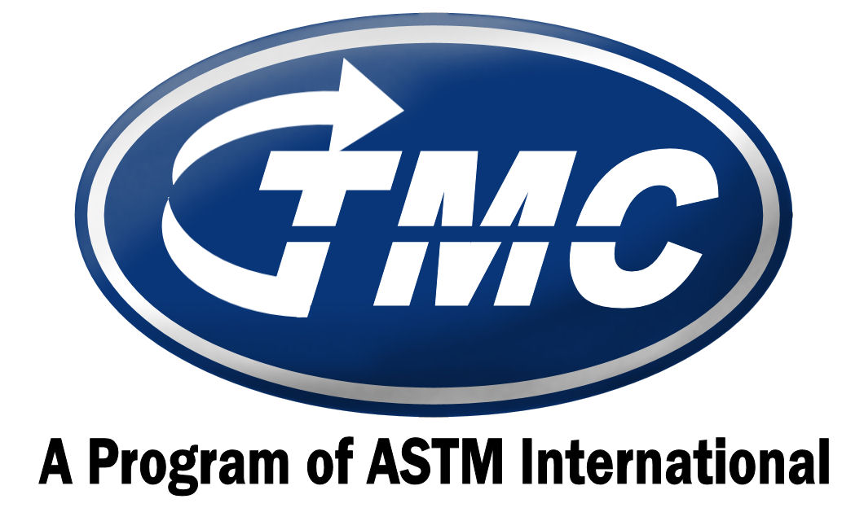

Group | TMC  Test Type | ASTM  D Number | Common Name | Test Fee | Oil  Quantity | Oil Price
 | IIIH/AB | D8111 | Sequence IIIH | $4,000 | 2.5 gal. | $80/gallon
 | IVA | D6891 | Sequence IVA | $3,000 | 4 gal. | $80/gallon
 | IVB | N/A | Sequence IVB | $3,000 | 5 gal. | $80/gallon
Gasoline | VH | D8256 | Sequence VH | $3,000 | 3 gal. | $80/gallon
 | VIE | D8114 | Sequence VIE | $3,000 | 6 gal. | $80/gallon
 | VIF | D8226 | Sequence VIF | $3,000 | 6 gal. | $80/gallon
 | VIII | D6709 | Sequence VIII | $3,000 | 2 gal. | $80/gallon
 | IX | D8291 | Sequence IX | $3,000 | 5 gal. | $80/gallon
 | X | D8279 | Chain Wear Test | $3,000 | 5 gal. | $80/gallon
 | 1K/1N & 1MPC | D6750 & D6618 | CAT Single Cylinder | $3,000 | 10 gal. | $80/gallon
 | 1P/1R | D6681 / D6923 | CAT Single Cylinder | $3,000 | 15 gal. | $80/gallon
 | ISM | D7468 | Cummins ISM | $3,000 | 25 gal. | $80/gallon
 | ISB | D7484 | Cummins ISB | $3,000 | 20 gal. | $80/gallon
 | C13 | D7546 | CAT C13 | $3,000 | 25 gal. | $80/gallon
 | T8/T8E | D5967 | T-8 | $3,000 | 35 gal. | $80/gallon
Diesel | T11 | D7156 | Mack T-11 | $3,000 | 28 gal. | $80/gallon
 | T12 | D7422 | Mack T-12 | $3,000 | 25 gal. | $80/gallon
 | T12A | D7422 | Mack T-12A | $3,000 | 25 gal. | $80/gallon
 | T13 | D8048 | Mack T-13 | $3,000 | 20 gal. | $80/gallon
 | RFWT | D5966 | Roller Follower Wear | $3,000 | 7 gal. | $80/gallon
 | COAT | D8047 | CAT Oil Aeration Test | $3,000 | 28 gal. | $80/gallon
 | EOAT | D6894 | Engine Oil Aeration Test | $3,000 | 12 gal. | $80/gallon
 | JDCCT | D7583 | John Deere Coolant Cavitation Test | $3,000 | NA | NA
 | DD13 | N/A | DD13 Scuff | $3,000 | 25 gal. | $80/gallon
 | D6417  D6417QC | D6417  D6417QC | Volatility by GC  Volatility by GC – Quality Control | $500  NA | 4 ml.  130 ml. | $35/sample  $45/sample
 | GI | D5133 | Gelation Index | $500 | 25 ml. | $35/sample
 | D5800 | D5800 | Volatility by Noack | $500 | 100 ml. | $35/sample
 | D5800QC | D5800QC | Volatility by Noack– Quality Control | NA | 1 liter  1 gal.  5 gal. | $45/sample  $170/sample  $830/sample
 | D6082 | D6082 | High Temperature Foam | $500 | 525 ml. | $45/sample
 | D874  D874QC | D874  D874QC | Sulfated Ash  Sulfated Ash – Quality Control | $500  NA | 32 ml.  1 liter | $35/sample  $45/sample
 | ROBO  ROBO QC | D7528  ROBO QC | Bench Oxidation  Bench Oxidation – Quality Control | $500  NA | 300 ml  1 liter | $35/sample  $45/sample
Bench | TEOST | D6335 | TEOST | $500 | 130 ml. | $35/sample
 | MTEOS | D7097 | MHT TEOST | $500 | 17 ml. | $35/sample
 | EOEC | D7216 | Automotive Elastomers | $100 | 750 ml. | $45/sample
 | LDEOC | D7216 | GF-5 Automotive Elastomers | $100 | 750 ml. | $45/sample
 | EOFT | D6795 | Engine Oil Filterability | $100 | 290 ml. | $35/sample
 | EOWT | D6794 | Engine Oil Filterability - Water | $100 | 290 ml. | $35/sample
 | CBT | D5968 | Corrosion Bench Test | $100 | 130 ml. | $35/sample
 | HTCBT | D6594 | High Temperature Corrosion Bench | $100 | 130 ml. | $35/sample
 | BRT | D6557 | Ball Rust Test | $100 | 30 ml | $35/sample
 | L-33-1 | D7038 | L-33-1 Rust | ~ $6836¹ | 1 gal. | $80/gallon
 | L-37 | D6121 | L-37 Pinion Distress | ~ $6836¹ | 1 gal. | $80/gallon
 | L-37-1 | D8165 | L-37-1 Pinion Distress | ~$6836¹ | 1 gal. | $80/gallon
 | L-37 RC | NA | L-37 Rater Calibration | $305/4pinions | NA | NA
Gear | L-42 | D7452 | L-42 Ring Gear Scoring | ~ $6836^{1*} | 1/2 gal. | $80/gallon
 | L-42 RC | NA | L-42 Rater Calibration | $420/4 pinions | NA | NA
 | L60-1 | D5704 | L60-1 | ~ $6836¹ | 8 oz | $23/sample
 | OSCT | D5662 | Oil Seal Compatibility | ~ $6836¹ | 750 ml. | $31/sample
 | HTCT | D5579 | High Temperature Cyclic Durability | ~ $6836¹ | 11 gal. | $80/gallon
ONLINE STORE | DFLUB  (DFA20 & DFB20) | D6078/D6079 | Diesel Fuel Lubricity (SBOCLE/HFRR) | NA | 500 mL | $70/sample
 |  |  |  |  | 1/2 gal. | $100/sample
ONLINE STORE | JFLUB | D5001 | Jet Fuel Lubricity | NA | 1/2 gal. | $75/sample
ONLINE STORE | SSCT | D7603 | Storage Stability and Compatibility in Automotive Gear Oils | NA | 1 qt. | $31/sample
ONLINE STORE | ELAS  (SL107) | NA | Elastomer - Service Fluid 107 | NA | 1 gal. | $75/sample
 |  |  |  |  | 5 gal. | $275/sample
 |  |  |  |  | 48 gal. | $2075/sample
ONLINE STORE | H & M | D6922 | Homogeneity and Miscibility in Automotive Engine Oils | NA | 1 liter | $40/sample
 | EM 2 | D7563 | Emulsion Retention | NA | 1 liter | $40/sample
 | EM5 | D7563 | Emulsion Retention | NA | 1 liter | $40/sample
 | RL269-1 | L-14-A-93 | CEC Shear Stability by Diesel Injector | NA | 1 gal. | $170/gallon
 |  |  |  |  | 53 gal. | $3500/sample
 | RL270-1 | L-14-A-93 | CEC Shear Stability by Diesel Injector | NA | 1 gal. | $170/gallon
 |  |  |  |  | 48 gal. | $3300/sample
 | RL233-6 | L-14-A-95/ D6278 | Shear Stability | NA | 1 liter | $55/sample
 |  |  |  |  | 52 gallons | $3150/sample

¹ Determined based on available stands and billed semi-annually.

International shipping, tax, & duty fees may apply

ALL shipping is now FREIGHT COLLECT

Contact Amanda Darcy at 412-365-1022 or ahd@astmtmc.cmu.edu for more up to date prices.

Updated 12/19/19

