Best Practices for ROBO

- Vacuum control valve cleaning in Method (11)
  - Mark VCV to retain the same settings after cleaning. No need to remove valve from rig. On each run VCV stem is removed and cleaned by removing the packing nut, unscrewing the stem from the valve body, and wiping the needle valve with solvent and dried. (To clean body seat use cellulous swab). Reassemble the stem to its seated position, tighten packing nut, and return VCV to its original setting. It has been found that not cleaning leads to mild severity conditions the degree of which depends on the amount of residue deposited during the previous run(s) after the last valve cleaning.

- Recording of vacuum source (acfm) measurements (flow & pressure)
  - It has been found that recording of the vacuum source measurement can determine deterioration of vacuum flow. For best results the initial measurement should be on a cleaned system. eg; oil changed screen filter cleanings, etc. Measurement is taken before the rigs’ VCV. It is possible that you can not detect the deterioration of flow during the preset vacuum flow in Method (10.4) and mild severity conditions may exist.

- Vacuum flow gauge cleaning
  - Imperative as defined in Method (11.5). An unclean gauge will lead to inconsistent conditions.

- Correct reading of Vacuum flow gauge (scfm)
  - Proper way to determine reading is at eye level. Misread gauge will lead to inconsistent conditions.

- Vacuum check rig for leaks
  - Imperative as defined in Method (10.3.2). Leaks on rigs lead to mild conditions.

- To achieve proper oxidation
  - Voltage to reactor set at 40 VAC as defined in Method (6.9). In order to maintain the oxidation as the main oil aging characteristic, it has been found that hot skin temperatures are ideal. With that said, having the volts set to 40 achieves this, leaving volatility as the second characteristic.

Notes

- Temperature controller – (Digi Sense)
  - In order to determine if any alarm conditions were encountered, it is necessary to set the temperature controller to shut off the output (heat). The timer is set to 48 hours which controls power to the controller.

- Precision needle valve for NO₂ control of flow. Method (6.15)
  - Another example of a valve that provides excellent control is Swagelok double pattern S series valve.

- Charging Nitrogen Dioxide Method (10.5.3).
  - Another example of transferred apparatus for better control.

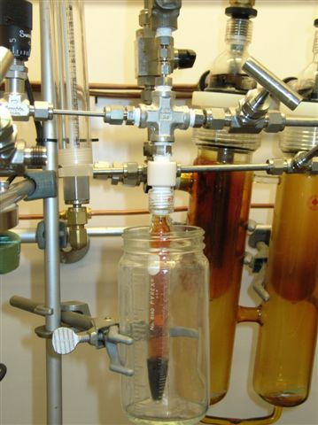
Stainless Steel 1/8” NPT female cross
McMaster-Carr # 48805K62
1/16” O.D. tubing
McMaster-Carr # 51755K11 sold in 1foot lengths.
Tube length is 4.5 inches scour with file and snap.
Stainless Steel 1/8” NPT male connector 1/16”tube O.D.
McMaster-Carr # 5182K435
Insert on bottom of NO2 fill valve.

Stainless Steel 1/8” NPT male connector 1/16”tube O.D. Bore Thru
Swagelok # SS-100-1-2BT
Insert on top of NO2 female cross.

Vent for NO2
Stainless Steel 1/8” NPT female cross
McMaster-carr # 48805K62
Stainless Steel 1/8” NPT male connector 1/16”tube O.D. Bore Thru
Swage-lok # SS-100-1-2BT
Insert on top of NO2 female cross.

