29 December 1997

Minutes of the DCC Functional Acknowledgment Sub-committee Meeting
Date: 9 Dec 97
Attendees:
Mike Basore Doug Blinn Mark Griffin Kathy Haskell
Dave Hood Sheldon Kwok Sally Lloyd Julia Oswald

Mark Griffin began the meeting with a review of the DCC charter given for the functional acknowledgment sub committee.

The group had a creative discussion about the definition of the functional acknowledgment. The group reviewed the EDI definitions of Functional Acknowledgment versus Application Acknowledgment. Acknowledgment of receipt versus acknowledgment that the file was received and processed and the requirements for each were discussed at length and in detail.

After re-focusing on defining the scope and objectives of the committee, the group agreed on the following:

Scope:
To design and test a protocol for acknowledgments to be used with electronic data transmissions.

An acknowledgment is a data communications packet which is generated by the data consumer to acknowledge receipt (RA) and processing (PA) into the data consumer’s internal database of a subsequent data transmission from a data producer.

Objective:
- Define the content and format of the Receipt Acknowledgment (RA)
- Define the content and format of the Process Acknowledgment (PA)
- Address Implementation Issues

The objectives are to be done in phases by the sub-committee.

The group then began addressing the objectives.

Receipt Acknowledgment

Figure 1
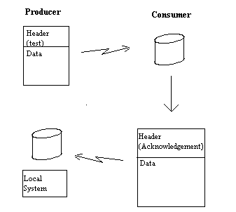

The group agreed that the header for the acknowledgment would be standard and that the following fields would be mandatory:

Mnemonic | Mandatory | Comment
VERHDR | Yes
TESTTYPE | Yes | ACK
TESTSPON
LAB
CMIR
OILCODE
DTCOMP
TESTNUM
DTTRANS | Yes | Date of ACK
TITRANS | Yes | Time of ACK
FORM
PURPCODE | Yes | 06=Confirmed, 12=Not Processed
SPONID
VERSION | Yes | Date of ACK Data Dictionary

The possibility of acknowledgment of multiple tests sent in one transmission was discussed. The group agreed that the acknowledgment would be sent back the same way in that the header would be followed by the data dictionary for each test acknowledged.

Process Acknowledgment

The group discussed a range of possibilities of how in depth the coding should be to communicate that original file was not processed. Agreement was reached that there would be three types of errors (see diagram below):
- Data Problem: A problem with the data in the body of the file
- Mnemonic Problem: A problem with the mnemonic
- Header Problem: A problem with the header

Figure 2
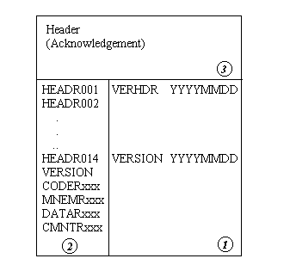

The body of the file will contain 6 fields
Field | Mnemonic | Length | Data Type | Comment
1 | VERSION | 8 | C | Version of the ACK Data Dictionary
2 | HEADRxxx | 71 | C | These fields will contain the mnemonic and data from the header of the file that was received from the data producer
3 | CODERxxx | 2 | N | 1=Data, 2=Mnemonic, 3=Header
4 | MNEMRxxx | 8 | C | The mnemonic in the original file with which there is a problem
5 | DATARxxx | 71 | C | The data included in the original file from the mnemonic with which there is a problem
6 | CMNTRxxx | 71 | C | An optional comment line

Implementation

Much of the discussion during the third objective, implementation, centered around who should receive the acknowledgment packet. Options which were deliberated included sending the acknowledgment to a set mail box, sending the acknowledgment back to the sender of the original data file and including a field in the header of the test file which would identify where the acknowledgment should be sent.

This topic was not completely agreed upon, however, the group ended the discussion focusing on the option of sending the acknowledgment to a set mail box.

Doug agreed to create the data dictionary and set up an ftp file.

The lab and sponsor representatives agreed on multiple beta tests. As soon as the systems at the sponsor companies are ready the labs will participate in the beta tests.

