Caterpillar Surveillance Panel

Cat Oil Aeration Test

January 15, 2020

**American Petroleum Institute**

**Mr. Jeffrey Harmening**

**Request for Funding**

**Scope:**

The Cat Surveillance Panel (SP) is planning activities to help establish COAT equivalency parameters for the EOAT in legacy categories (API CH-4, API CI-4 and API CJ-4).

Funding is requested to support the test matrix planned to allow for this equivalency to be established. The SP recommends running of 6 tests:

* The comparison oil will be reference oil 1005-5. This reference oil is used as a reference oil currently for the EOAT. There also exists established data available in LTMS for Reference oil 1005-5 and all prior versions of this reference oil for the EOAT.
* Reference oil 1005-5 will be run twice at each calibrated lab in the COAT to help establish equivalency limits (see table 1).

Table 1

|  |  |  |  |
| --- | --- | --- | --- |
| **Ref oil 1005-5** | **Lab A** | **Lab B** | **Lab G** |
| **No. of tests** | **2** | **2** | **2** |

These six tests will help guide the equivalency of the COAT to the EOAT for legacy categories.

**Request:**

API support of the matrix (Table 1) to allow COAT equivalency limits for the EOAT in legacy categories (API CH-4, API CI-4 and API CJ-4).

1. Test cost: estimate of $25K / test
2. Total No. of tests: Six. Three participating labs, one test stand per lab. Each lab will run two tests
3. Total API funding requested: estimate of $150 K USD to be distributed across the three participating labs

Funding support from API for establishing equivalency limit analysis would help bring this critical step into fruition in an expedient manner.

**Background:**

The COAT Working Group and Cat Surveillance Panel will be working to conduct tests that allow development of equivalency of COAT for EOAT in legacy API categories API CH-4, API CI-4 and API CJ-4. The EOAT engine life is questionable due to its age and lack of parts availability.

The SP had included the 1005-4 reference oil in earlier COAT testing matrices in order to support the equivalency of this test for legacy categories. Figure 1 below shows historic data from prior matrices run in the COAT test that can be used for establishing equivalency.

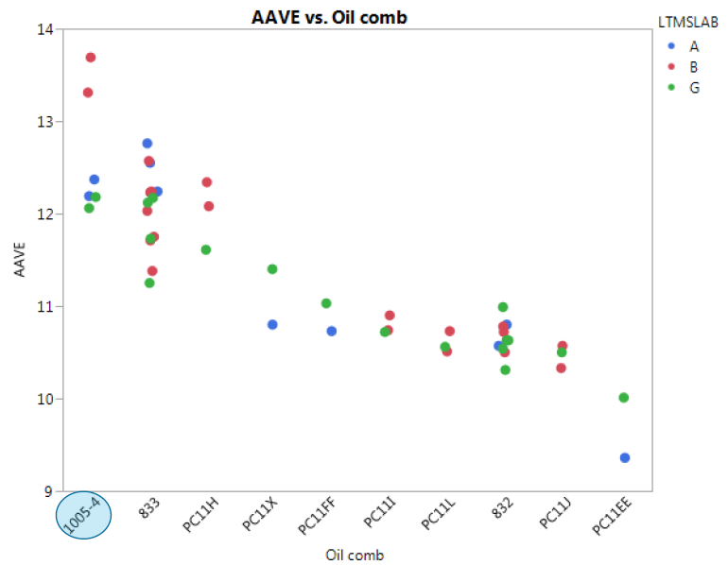

**Figure 1: COAT results from LTMS for Reference and Matrix oils.**

Since the COAT test has gone through fundamental changes and improvements to re-establish its availability to the industry (and has been running reliably since May 2019), the SP believes that new tests need to be run to confirm the prior equivalency comparison. For this reason, testing of reference oil 1005-5 is recommended to help establish equivalency for the COAT for legacy categories.

Respectfully,

*Hind M Abi-Akar*

COAT test sponsor, for the COAT Working Group