C13 Oil Jet Target Fixture info C Dutart 26Apr2005

See targets in file: Oil Jet Targets.tif

Nominal jet hole diameters:

Hole D = 2.4 mm
Hole N = 1.5 mm

Engine block jet seat seat width = 22.5 +- 0.1 mm
- Gives zero to 0.3 mm clearance for oil jet body

Engine block counterbore to allow oil around bolt = 12 mm dia X 8 mm deep

Oil jet bolt is 8 mm x 1.25 mm pitch

Position of jet seat to head deck: 253 mm

Position of jet bolt hole relative to bore (see sketch):
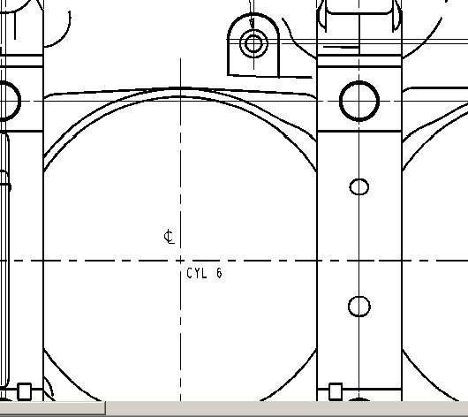
94 mm
32 mm

