Draft 10 January 30, 2007

This document is not an ASTM standard; it is under consideration within an ASTM technical committee but has not received all approvals required to become an ASTM standard. It shall not be reproduced or circulated or quoted, in whole or in part, outside of ASTM committee activities except with the approval of the chairman of the committee having jurisdiction and the president of the society. Copyright ASTM, 100 Barr Harbor Drive, West Conshohocken, PA 19428-2959. All Rights Reserved.

Test Method Manuscript
ASTM Designation: DXXXX – XX

Standard Test Method for

Cummins ISM Test¹

1. Scope

1.1 This test method is commonly referred to as the Cummins ISM Test². The test method defines a heavy-duty diesel engine test procedure conducted under high soot conditions to evaluate oil performance with regard to valve train wear, top ring wear, sludge deposits, and oil filter plugging³ in an EGR environment.
1.2 The values stated in SI units are to be regarded as the standard. The values given in parenthesis are for information only. The only exception is where there is no direct SI equivalent such as screw threads, national pipe threads/diameters, and tubing sizes.
1.3 This standard does not purport to address all of the safety concerns, if any associated with its use. It is the responsibility of the user of this standard to establish appropriate safety and health practices, and determine the applicability of regulatory limitations prior to use. See Annex A1 for general safety precautions.

1.4 Table of Contents:
Scope 1
Referenced Documents 2
Terminology 3
Summary of Test Method 4
Significance and Use 5
Apparatus 6
Test Engine Configuration 6.1
Test Engine 6.1.1
Oil Heat Exchanger, Adapter Blocks, and Block Off Plate 6.1.2
Oil Filter Head Modification 6.1.3
Oil Pan Modification 6.1.4
Engine Control Module 6.1.5
Engine Position Sensor 6.1.6
Air Compressor and Fuel Pump 6.1.7
Test Stand Configuration 6.2
Engine Mounting 6.2.1
Intake Air System 6.2.2
Aftercooler 6.2.3
Exhaust System 6.2.4
Exhaust Gas Recirculation System 6.2.5
Fuel Supply 6.2.6
Coolant System 6.2.7
Pressurized Oil Fill System 6.2.8
External Oil System 6.2.9
Crankcase Aspiration 6.2.10
Blowby Rate 6.2.11
System Time Responses 6.3
Oil Sample Containers 6.4
Mass Balance 6.5
Engine and Cleaning Fluids 7
Test Oil 7.1
Test Fuel 7.2
Engine Coolant 7.3
Solvent 7.4
Preparation of Apparatus 8
Cleaning of Parts 8.1
General 8.1.1
Engine Block 8.1.2
Cylinder Head 8.1.3
Rocker Cover and Oil Pan 8.1.4
External Oil System 8.1.5
Crosshead Cleaning and Measurement 8.1.6
Rod Bearing Cleaning and Measurement 8.1.7
Ring Cleaning and Measurement 8.1.8
Injector Adjusting Screw Cleaning and Measurement 8.1.9
Engine Assembly 8.2
General 8.2.1
Parts Reuse and Replacement 8.2.2
Build-Up Oil 8.2.3
Coolant Thermostat 8.2.4
Oil Thermostat 8.2.5
Fuel Injectors 8.2.6
New Parts 8.2.7
Operational Measurements 8.3
Units and Formats 8.3.1
Instrumentation Calibration 8.3.2
Temperatures 8.3.3
Pressures 8.3.4
Flow Rates 8.3.5
Intake and Exhaust CO₂ Measurement 8.3.6
Engine/Stand Calibration and Non-Reference Oil Tests 9
General 9.1
New Test Stand 9.2
New Test Stand Calibration 9.2.1
Stand Calibration Period 9.3
Stand Modification and Calibration Status 9.4
Test Numbering System 9.5
General 9.5.1
Reference Oil Tests 9.5.2
Non-Reference Oil Tests 9.5.3
Reference Oil Test Acceptance 9.6
Unacceptable Reference Oil Test 9.7
Reference Oil Accountability 9.8
Non-Reference Oil Tests 9.9
Last Start Date 9.9.2
Test Procedure 10
Engine Installation and Stand Connections 10.1
Coolant System Fill 10.2
Oil Fill for Break-in 10.3
Engine Build Committed 10.3.3
Fuel Samples 10.4
Engine Warm-up 10.5
Shutdown During Warm-up 10.5.1
Engine Break-in 10.6
Shutdown and Maintenance 10.7
Normal Shutdown 10.7.1
Emergency Shutdown 10.7.2
Maintenance 10.7.3
Downtime 10.7.4
200-h Test Procedure 10.8
Oil Fill for Test 10.8.2
Operating Conditions 10.8.4
Injection Timing Change 10.8.5
Mass % Soot Validity 10.8.6
Test Timer 10.8.7
Operational Data Acquisition 10.8.8
Oil Purge, Sample and Addition 10.8.9
End of Test (EOT) 10.9
Engine Disassembly 10.9.4
Calculations, Ratings and Test Validity 11
Crosshead Mass Loss 11.1
Injector Adjusting Screw Mass Loss 11.2
Ring Mass Loss 11.4
Sludge Ratings 11.5
Oil Filter Plugging 11.7
Oil Analyses 11.8
Oil Consumption 11.9
Fuel Analyses 11.10
Assessment of Operational Validity 11.11
Assessment of Test Interpretability 11.12
Test Report 12
Precision and Bias 13
Keywords 14
Annexes
Safety Precautions Annex A1
Intake Air Aftercooler Annex A2
Engine Build Parts Kit Annex A3
Sensor Locations and Special Hardware Annex A4
External Oil System Annex A5
Fuel Specification Annex A6
Cummins Service Publications Annex A7
Specified Units and Formats Annex A8
Report Forms and Data Dictionary Annex A9
Sludge Rating Worksheets Annex A10
Piston Rating Locations Annex A11
Oil Analyses Annex A12
Oil Filter Plugging Annex A13
Determination of Operational Validity Annex A14
Exhaust CO₂ Sampling Probe Annex A15
Appendixes
Non-Mandatory Suppliers List X1
Typical System Configurations X2
2. Referenced Documents
2.1 ASTM Standards:
D 86 Standard Test Method for Distillation of Petroleum Products⁴
D 92 Standard Test Method for Flash and Fire Points by Cleveland Open Cup⁴
D 97 Standard Test Method for Pour Point of Petroleum Products⁴
D 130 Standard Test Method for Detection of Copper Corrosion from Petroleum Products by the Copper Strip Tarnish Test⁴
D 235 Standard Specification for Mineral Spirits ²⁰
D 287 Standard Test Method for API Gravity of Crude Petroleum and Petroleum Products (Hydrometer Method)⁴
D 445 Standard Test Method for Kinematic Viscosity of Transparent and Opaque Liquids (and the Calculation of Dynamic Viscosity)⁴
D 482 Standard Test Method for Ash from Petroleum Products⁴
D 524 Standard Test Method for Ramsbottom Carbon Residue of Petroleum Products⁴
D 613 Standard Test Method for Cetane Number of Diesel Fuel Oil⁵
D 664 Standard Test Method for Acid Number of Petroleum Products by Potentiometric Titration⁴
D 1319 Standard Test Method for Hydrocarbon Types in Liquid Petroleum Products by Fluorescent Indicator Absorption⁴
D 2500 Standard Test Method for Cloud Point of Petroleum Products⁴
D 2622 Standard Test Method for Sulfur in Petroleum Products by x-ray Spectrometry⁶
D 2709 Standard Test Method for Water and Sediment in Middle Distillate Fuels by Centrifuge⁶
D 2896 Standard Test method for Base Number of Petroleum Products by Potentionmetric Perchloric Acid Titration⁶
D 4294 Standard Test Method for Sulfur in Petroleum and Petroleum Products by Energy-Dispersive X-Ray Fluorescence Spectrometry⁵
D 4485 Specification for Performance of Engine Oils⁶
D 4737 Standard Test Method for Calculated Cetane Index by Four Variable Equation⁷
D 4739 Standard Test method for Base Number Determination by Potentiometric Titration⁷
D 5185 Standard Test Method for Determination of Additive Elements, Wear Metals, and Contaminants in Used Lubricating Oils and Determination of Selected Elements in Base Oils by Inductively Coupled Plasma Atomic Emission Spectrometry (ICP-AES)⁷
D 5302 Test Method for Evaluation of Automotive Engine Oils for Inhibition of Deposit Formation and Wear in a Spark-Ignition Internal Combustion Engine Fueled with Gasoline and Operated Under Low-Temperature, Light Duty Conditions⁷

D 5453 Standard Test Method for Determination of Total Sulfur in Light Hydrocarbons, Spark Ignition Engine Fuel, Diesel Engine Fuel, and Engine Oil by Ultraviolet Fluorescence⁵
D 5844 Standard Test Method for Evaluation of Automotive Engine Oils for Inhibition of Rusting (Sequence IID)⁷
D 5967 Standard Test Method for Evaluation of Diesel Engine Oils in T-8 Diesel Engine⁷
D 6483 Standard Test Method for Evaluation of Diesel Engine Oils in T-9 Diesel Engine
E 29 Practice for Using Significant Digits in Test Data to Determine Conformance with Specifications⁸
E 178 Standard Practice for Dealing with Outlying Observations
E 344 Terminology Relating to Thermometry in Hydromometry⁹
2.2 Coordinating Research Council:
CRC Manual No. 20¹⁰
2.3 National Archives and Records Administration:
Code of Federal Regulations Title 40 Part 86.310-79¹¹
3. Terminology
3.1 Definitions:
3.1.1 blind reference oil, n — a reference oil, the identity of which is unknown by the test facility. D 5844
3.1.2 blowby, n ⎯ in internal combustion engines, the combustion products and unburned air-and-fuel mixture that enter the crankcase. D 5302
3.1.3 calibrate, v — to determine the indication or output of a measuring device with respect to that of a standard. E 344
3.1.4 heavy-duty, adj – in internal combustion engine operation, characterized by average speeds, power output, and internal temperatures that are close to the potential maximum. D 4485
3.1.5 heavy-duty engine, adj – in internal combustion engines, one that is designed to allow operation continuously at or close to its peak output. D 4485
3.1.6 non-reference oil, n ⎯ any oil other than a reference oil, such as a research formulation, commercial oil or candidate oil. D 5844
3.1.7 non-standard test, n – a test that is not conducted in conformance with the requirements in the standard test method; such as running in an non-calibrated test stand or using different test equipment, applying different equipment assembly procedures, or using modified operating conditions. D 5844
3.1.8 reference oil, n – an oil of known performance characteristics, used as a basis for comparison. D 4485
3.1.9 sludge, n ⎯ in internal combustion engines, a deposit, principally composed of insoluble resins and oxidation products from fuel combustion and the lubricant, that does not drain from engine parts but can be removed by wiping with a cloth. D 5302
3.1.10 test oil, n ⎯ any oil subjected to evaluation in an established procedure. D 6557
3.1.11 wear, n ⎯ the loss of material from, or relocation of material on, a surface.
3.1.11.1 Discussion– Wear generally occurs between two surfaces moving relative to each other, and is the result of mechanical or chemical action or by a combination of mechanical and chemical actions. D 5302
3.2 Definitions of Terms Specific to This Standard:
3.2.1 crosshead, n ⎯ an overhead component, located between the rocker arm and each intake valve and exhaust valve pair, that transfers rocker arm travel to the opening and closing of each valve pair.
3.2.1.1 Discussion — Each cylinder has two crossheads, one for each pair of intake valves and exhaust valves.
3.2.2 de-rate protocols, n — protocols in the engine control module that cause the engine to reduce power output when certain operating parameters are exceeded.
3.2.3 exhaust gas recirculation (EGR), n — a method by which a portion of the engine exhaust is returned to the combustion chambers through the intake system.
3.2.4 overhead, n – in internal combustion engines, the components of the valve train located in or above the cylinder head.
3.2.5 overfuel, v – to cause the fuel flow to exceed the standard production setting.
3.2.6 valve train, n – in internal combustion engines, the series of components, such as valves, crossheads, rocker arms, push rods and camshaft, that open and close the intake and exhaust valves.
4. Summary of Test Method
4.1 This test method uses a Cummins ISM 500 diesel engine with a specially modified engine block. Test operation includes a 25-min. warm-up, a 2-h break-in, and 200 h in four 50-h stages. During stages A and C the engine is operated with retarded fuel injection timing and is overfueled to generate excess soot. During stages B and D the engine is operated at conditions to increase valve train wear.
4.2 Prior to each test, the engine is cleaned and assembled with new cylinder liners, pistons, piston rings and overhead valve train components. All aspects of the assembly are specified.
4.3 A forced oil drain, an oil sample and an oil addition, equivalent to an oil consumption of 0.23 g/kW-h, is performed at the end of each 25-h period.
4.4 The test stand is equipped with the appropriate instrumentation to control engine speed, fuel flow, and other operating parameters.
4.5 Oil performance is determined by assessing crosshead wear, top ring mass loss, injector adjusting screw mass loss, sludge deposits, and oil filter plugging.
5. Significance and Use
5.1 This test method was developed to assess the performance of an engine oil to control engine wear and deposits under heavy-duty operating conditions selected to accelerate soot generation, valve train wear, and deposit formation in a turbocharged, aftercooled four-stroke-cycle diesel engine equipped with exhaust gas recirculation hardware.
5.2 This test method may be used for engine oil specification acceptance when all details of this test method are in compliance. Applicable engine oil service categories are included in Specification D 4485.
5.3 The design of the engine used in this test method is representative of many, but not all, modern diesel engines. This factor, along with the accelerated operating conditions needs to be considered when extrapolating test results.
6. Apparatus
6.1 Test Engine Configuration:
6.1.1 Test Engine — The Cummins ISM 500 is an in-line six-cylinder heavy-duty diesel engine with 11 L of displacement and is turbocharged and aftercooled. The engine has an overhead valve configuration and EGR hardware. It features a 2002 emissions configuration with electronic control of fuel metering and fuel injection timing. Obtain the test engine and the engine build parts kit from the central parts distributor (CPD)¹². The components of the engine build parts kit are shown in Table A3.1. Non-kit parts are shown in Table A3.2.
6.1.2 Oil Heat Exchanger, Adapter Blocks, and Block-off Plate — The oil heat exchanger is relocated from the stock position with the use of adapter blocks as shown in Fig. A4.1¹³. Install an oil cooler block-off plate on the back of the coolant thermostat housing (Fig. A4.1). Control the oil temperature by directing process water through the oil heat exchanger (Fig. A4.1).
6.1.3 Oil Filter Head Modification – Modify the oil filter head by plugging the filter bypass return to sump line and the engine oil thermostat (Fig. A4.2). Block the thermostat passage to route all of the engine oil into the oil cooler. The casting shown in Fig. A4.2 is available from Cummins in assembly PN 3895946.
6.1.4 Oil Pan Modification — Modify the oil pan as shown in Fig. A4.3¹³.
6.1.5 Engine Control Module (ECM) — Obtain the ECM from the CPD¹². The ECM programming is modified, using the Cummins engineering tool, to provide retarded injection timing, increasing soot generation and valve and injector train wear. Some engine protection protocols are disabled to allow test conditions to be attained. Before a test lab can obtain the Cummins engineering tool and instructions describing how to disable the engine protection protocols, the test lab must have a signed confidentiality agreement in place with Cummins. Contact the TMC to obtain the identification of the current ECM calibration file and current communication protocol file. Calibration and communication protocol files must be obtained from Cummins.
6.1.6 Engine Position Sensor – When using the CM870 ECM, disable the secondary engine position sensor measurement coil by cutting the two outside wires colored red and black. The red and black wires are labeled A and D respectively on the engine position sensor plug (Fig. A4.4).
6.1.7 Intake Manifold Temperature Sensor — Substitute a 1.8k ohm resistor or potentiometer for the intake manifold temperature sensor. The Cummins engineering tool must indicate 150 F after the intake manifold temperature sensor has been replaced with the appropriate resistance.
6.1.8 Barometric Pressure Sensor — Disconnect the barometric pressure sensor. Replace the sensor with a 200 ohm resistor or potentiometer from power to ground (pins 1 and 2) and an 800 ohm resistor or potentiometer from signal to ground (pins 2 and 3). The Cummins engineering tool must indicate 29.9 in Hg after the barometric pressure sensor has been replaced with the appropriate resistance.
6.1.9 Turbocharger Controller — Supply nominal 80 psig air pressure to the turbocharger controller.
6.1.10 Power Supply Voltage — The nominal power supply (battery) voltage is 12 vdc, as displayed on the Cummins engineering tool.
6.1.11 Air Compressor and Fuel Pump — The engine-mounted air compressor is not used for this test method. Remove the air compressor and install the fuel injection pump in its place (Fig. A4.5). The fuel injection pump is driven with Cummins coupling P/N 208755¹⁴.
6.1.12 Engine Block Preparation — Verify the oil capacitors have been disabled. If the oil capacitors have not been disabled, use the following procedure.
6.1.12.1 Modify a nominal 25 mm hole saw by replacing the drill bit from the drive arbor with a rod protruding from the saw cutting surface (Fig. A4.16). The rod prevents damage to the engine block as the hole saw breaks through the block.
6.1.12.2 Insert the modified hole saw arbor into the cast oil drain back hole in the bottom of the capacitor.
6.1.12.3 Saw through the bottom of the capacitor wall (Fig. A4.17) and remove the core produced by the hole saw.
6.1.12.4 Remove all burrs and debris from the area around the hole.
6.2 Test Stand Configuration:
6.2.1 Engine Mounting — Install the engine so that it is upright and the crankshaft is horizontal.
6.2.1.1 The engine mounting hardware should be configured to minimize block distortion when the engine is fastened to the mounts. Excessive block distortion may influence test results.
6.2.2 Intake Air System– With the exception of the intake air tube, the intake air system is not specified. A typical configuration is shown in Fig. X1.1. The air filter should be typical of air filters used for engines in heavy-duty applications. Install the intake air tube (Fig. A4.6) at the intake of the turbocharger compressor. The system shall allow control of applicable parameters listed in Table 5.
Note 1: Difficulty in achieving or maintaining intake manifold pressure or intake manifold temperature, or both, may be indicative of insufficient or excessive restriction.
6.2.3 Aftercooler – Use a Modine aftercooler for aftercooling. Instructions for obtaining the correct aftercooler are listed in A2.1.
6.2.4 Exhaust System – Install the exhaust tube (Fig. A4.7) at the discharge flange of the turbocharger turbine housing. The piping downstream of the exhaust tube is not specified. A method to control exhaust pressure is required.
6.2.5 Exhaust Gas Recirculation System — The EGR system is supplied with the engine. Modify the EGR valve by drilling vent holes in the actuator case (Fig. A4.18). Provide 20 psig air to the EGR valve actuator. Vent the coolant from the coolant vent block to the bottom of the expansion tank as shown in Fig. X1.3.
6.2.6 Fuel System – The fuel supply and filtration system is not specified. A typical configuration is shown in Fig. X1.2. The fuel consumption rate is determined by measuring the rate of fuel flowing into the day tank. A method to control the fuel temperature is required.
6.2.7 Coolant System – The system configuration is not specified. A typical configuration consists of a non-ferrous core heat exchanger, a reservoir (expansion tank), a temperature control valve, and a vent line from the coolant vent block on the engine to the bottom of the expansion tank as shown in Fig. X1.3. Pressurize the system by regulating air pressure at the top of the expansion tank. The system should have a sight glass to detect air entrapment.
6.2.7.1 — Although the system volume is not specified, an excessively large volume may increase the time required for the engine fluid temperatures to attain specification. A system volume of 45 L or less, including the volume contained in the engine, has proven satisfactory.
6.2.8 Pressurized Oil Fill System – The oil fill system is not specified. A typical configuration includes an electric pump, a 50-L reservoir, and a transfer hose. The location for the pressurized fill is located on the filter head (Fig. A4.2)
6.2.9 External Oil System — Configure the external oil system according to Fig. A5.1. Use a 10 to 13 L container for the external oil reservoir. Use Viking Pump model number SG053514. Nominal pump motor speed is 1725 r/min.
6.2.9.1 Oil Sample Valve Location —Locate the oil sample valve on the return line from the external oil system to the engine. Locate the valve as close to the return pump as possible (Fig. A5.1).
6.2.9.2 Unacceptable Oil System Materials — Brass or copper fittings can influence used oil wear metals analyses and shall not be used in the external oil system.
6.2.10 Crankcase Aspiration – Vent the blowby gas at the port located on the left side of the valve cover (Fig. A4.8). Route the vent line downward from the valve cover port to the blowby canister. The line shall be between 1.2 and 1.8 m in length and minimum 1.5875 cm inside diameter.
6.2.11 Blowby Rate — The flowrate measurement device is not specified. The blowby canister shall be minimum 35 L in volume. The outlet of the blowby canister to the flowrate device shall be minimum 3.175 cm inside diameter. The hose connecting the blowby canister to the flowrate device shall be minimum 3.81 cm inside diameter. The length of this hose is not specified.
6.3 System Time Responses – The maximum allowable system time responses are shown in Table 1. Determine system time responses in accordance with the Data Acquisition and Control Automation II (DACA II) Task Force Report¹⁶.

Table 1 Maximum Allowable System Time Responses
_________________________________________________________
Measurement Time Response (s)
_________________________________________________________
Speed 2.0
Temperature 3.0
Pressure 3.0
Flow 45 _________________________________________________________

6.4 Oil Sample Containers — High-density polyethylene containers are recommended for oil samples. Warning — Glass containers may break and may cause injury or exposure to hazardous materials, or both.
6.5 Mass Balance — A balance is required to measure the mass of the crossheads, rod bearings, injector adjusting screws, and piston rings. An electronic or mechanical balance may be utilized. The balance shall have a minimum display resolution of 0.1 mg.
7. Engine and Cleaning Fluids
7.1 Test Oil — Approximately 75 L of test oil is required to complete the test.
7.2 Test Fuel — Approximately 15,500 L of Chevron Philips PC-9 diesel fuel¹⁷ is required to complete the test. Fuel property tolerances are shown in Annex A6.
7.3 Engine Coolant – Use pre-mixed 50 / 50 Fleetguard Compleat PG¹⁴.
7.4 Solvent – Use a solvent which meets D 235 for mineral spirits, Type II, Class C for Aromatic Content (0-2% vol), Flash Point (142° F / 61° C, min), and Color (not darker than +25 on Saybolt Scale or 25 on Pt-Co Scale)²¹. Obtain a Certificate of Analysis for each batch of solvent from the supplier. Warning – Combustible. Health Hazard. Use adequate safety pre-cautions with all solvents and cleaners.
8. Preparation of Apparatus
8.1 Cleaning of Parts:
8.1.1 General – The preparation of test engine components specific to the Cummins ISM test are indicated in this section. Use the Cummins service publications¹⁴ (Annex A7) for the preparation of other engine components. Take precautions to prevent rusting of iron components.
8.1.2 Engine Block – Disassemble the engine, including removal of the crankshaft, camshaft, piston cooling tubes, oil pump, and oil gallery plugs. Thoroughly clean the surfaces and oil passages (galleries). Use a brush to clean the oil passages. Removal of camshaft bearings is at the discretion of the laboratory.
8.1.3 Cylinder Head – Disassemble and clean the cylinder head. Use a brush as necessary to remove deposits.
8.1.4 Rocker Cover and Oil Pan – Clean the rocker cover and oil pan. Use a brush as necessary to remove deposits.
8.1.5 External Oil System — Flush the internal surfaces of the oil lines and the external reservoir with solvent. Repeat until the solvent drains clean. Flush solvent through the oil pumps until the solvent drains clean.
8.1.6 Crosshead Cleaning and Measurement
8.1.6.1 Handling and Orientation — Avoid handling the crossheads with bare hands, use gloves or plastic covered tongs. Orient the crossheads in the engine with the elongated slot toward the exhaust valve.
8.1.6.2 Clean the crossheads with solvent. Use a non-metallic soft bristle brush if necessary.
8.1.6.3 Spray the crossheads with air until dry.
8.1.6.4 Rinse the crossheads in pentane and dry with air.
8.1.6.5 Measure crosshead mass to a tenth of a milligram (xxx.x mg).
8.1.6.6 If an electronic scale is used for mass measurement, use the following procedure:
(1) Demagnetize (degauss) each crosshead prior to measurement
(2) Measure the crosshead two times. Make the second measurement with the crossheads in an orientation that is 90° from the original orientation. If the difference between the two mass measurements is greater than 0.2 mg, demagnetize the crosshead and repeat the measurement process.
8.1.7 Rod Bearing Cleaning and Measurement
8.1.7.1 Clean the rod bearings with solvent. Use a non-metallic soft bristle brush if necessary. Avoid handling the rod bearings with bare hands. Use gloves or plastic covered tongs.
8.1.7.2 Spray the rod bearings with air until dry.

8.1.7.3 Rinse the rod bearings in pentane and dry with air.
8.1.7.4 Measure the mass of each bearing half to a tenth of a milligram (xxx.x mg).
8.1.8 Ring Cleaning and Measurement
8.1.8.1 Clean and measure the rings according to the Mack Test Ring Cleaning and Measuring procedure, available from the TMC. Avoid handling the rings with bare hands. Use gloves or plastic covered tongs.
8.1.9 Injector Adjusting Screw Cleaning and Measurement
8.1.9.1 Clean the injector adjusting screws with solvent. Use a soft bristle brush if necessary. Avoid handling the injector adjusting screws with bare hands. Use gloves or plastic covered tongs.
8.1.9.2 Spray the injector adjusting screws with air until dry.
8.1.9.3 Rinse the injector adjusting screws with pentane and dry with air
8.1.9.4 Measure injector adjusting screw mass to a tenth of a milligram (xxx.x mg).
8.1.9.5 If an electronic scale is used for mass measurement, then use the following procedure:
(1) Demagnetize each injector adjusting screw prior to measurement
(2) Measure the adjusting screw two times. Make the second measurement with the injector adjusting screw in an orientation that is 90° from the original orientation. If the difference between the two mass measurements is greater than 0.2 mg, demagnetize the injector adjusting screw and repeat the measurement process.
8.2 Engine Assembly:
8.2.1 General ⎯ Except as noted in this section, use the procedures indicated in the Cummins service publications¹⁴ (Annex A7). Assemble the engine with the components from the Engine Build Parts Kit¹² (Annex A3).
8.2.2 Parts Reuse and Replacement — Engine components may be reused or replaced at the discretion of the laboratory, except as noted in 8.2.7.
8.2.3 Build-Up Oil – Use Cummins Premium Blue¹⁴ or test oil to lubricate parts for the engine build. If test oil is used, then the engine build is valid only for the respective test oil.
8.2.4 Coolant Thermostat — Lock the engine coolant thermostat open.
8.2.5 Oil Thermostat — Remove the oil thermostat and plug the oil passage. This will route all of the oil flow through the oil cooler (Fig. A4.2).
8.2.6 Fuel Injectors – The fuel injectors may be reused. Dedicate the injectors to a particular cylinder. Install the injectors according to the torque wrench method as noted in the Cummins service publications (Annex A7).
8.2.7 New Parts – The parts listed below are contained in the Engine Build Parts Kit and are not reusable (except as noted in 10.3.3). Clean the parts prior to use. Replacement of any part listed below during a test will invalidate the test.
8.2.7.1 pistons (crown, skirt)
8.2.7.2 piston rings (top, second, oil)
8.2.7.3 cylinder liners
8.2.7.4 rocker lever shafts
8.2.7.5 rocker levers (exhaust, intake, injector)
8.2.7.6 rocker lever sockets (intake and exhaust)
8.2.7.7 valves (intake, exhaust)
8.2.7.8 valve stem guides
8.2.7.9 valve inserts
8.2.7.10 piston cooling nozzles
8.2.7.11 valve crossheads
8.2.7.12 connecting rod bearings
8.2.7.13 adjusting screws
8.3 Operational Measurements:
8.3.1 Units and Formats – See Annex A8.
8.3.2 Instrumentation Calibration
8.3.2.1 Fuel Consumption Rate Measurement Calibration —Calibrate the fuel consumption rate measurement system before every reference test sequence and at least once every nine months. Temperature-compensate volumetric systems, and calibrate them against a mass flow device. The flowmeter located on the test stand shall indicate within 0.2% of the calibration standard. Trace the calibration standard to national standards.
8.3.2.2 Temperature Measurement Calibration — Calibrate the temperature measurement systems before every reference test sequence and at least once every nine months. Each temperature measurement system shall indicate within ± 0.5 °C of the laboratory calibration standard. Trace the calibration standard to national standards.
8.3.2.3 Pressure Measurement Calibration — Calibrate the pressure measurement systems before every reference test sequence and at least once every nine months. Trace the calibration standard to national standards.
8.3.3 Temperatures:
8.3.3.1 Measurement Location – The temperature measurement locations are specified in this section. The measurement equipment is not specified. Install the sensors such that the tip is located midstream of the flow unless otherwise indicated. Follow the guidelines detailed in the Data Acquisition and Control Automation II Task Force Report¹⁶ for the accuracy and resolution of the temperature measurement sensors and the complete measurement system.
8.3.3.2 Coolant Out Temperature — Install the sensor in the 3/4 in. NPT hole at the top of the coolant out tube. (Fig. A4.10).
8.3.3.3 Coolant In Temperature – Install the sensor on the right side of the coolant pump intake housing at the 1-in. NPT port (Fig. A4.11).
8.3.3.4 Fuel In Temperature — Install the sensor in the fuel pump inlet fitting (Fig. A4.5).
8.3.3.5 Oil Gallery Temperature — Install the sensor at the 1/4-in. NPT hole on the left rear of the engine (Figs. A4.5 and A4.12).
8.3.3.6 Intake Air Temperature – Install the sensor (Fig. A4.6).
8.3.3.7 Intake Manifold Temperature — Install the sensor 30 mm from the outside edge of the manifold and 16 mm forward from the air inlet to the manifold. (Fig. A4.8, Fig. A4.9).
8.3.3.8 Exhaust Temperature – Install the sensor (Fig. A4.7).
8.3.3.9 Additional – Monitor any additional temperatures considered to be beneficial.
Note 2: Additional exhaust sensor locations are recommended, such as the exhaust ports and pre-turbine (front and rear). The detection of changes in exhaust temperature(s) is an important diagnostic. Measurement of the EGR cooler gas inlet and outlet temperatures and coolant inlet and outlet temperatures is recommended.
8.3.4 Pressures:
8.3.4.1 Measurement Location and Equipment – The pressure measurement locations are specified in this section. The measurement equipment is not specified. Follow the guidelines detailed in the Data Acquisition and Control Automation II Task Force Report¹⁶ for the accuracy and resolution of the pressure measurement sensors and the complete measurement system.
8.3.4.2 A condensation trap should be installed at the lowest elevation of the tubing between the pressure measurement location and the final pressure sensor for Crankcase Pressure, Intake Air Pressure, and Exhaust Pressure. Route the tubing to avoid intermediate loops or low spots before and after the condensation trap.
8.3.4.3 Oil Gallery Pressure — Measure the pressure at the left-rear of the engine, in the 3/8-in. NPT port behind ECM, in front of the oil gallery temperature measurement location (Figs. A4.5 and A4.12).
8.3.4.4 Oil Filter Inlet Pressure ⎯ Measure the pressure at the 7/8 in.-14 o-ring plug located on the oil filter assembly (Fig. A4.2).
8.3.4.5 Oil Filter Outlet Pressure ⎯ Measure the pressure at the 1/4-in. NPT port located on the oil filter assembly (Fig. A4.2).
8.3.4.6 Intake Manifold Pressure — Measure the pressure at the 1/4-in. NPT port located on the intake air elbow (Fig. A4.13).
8.3.4.7 Crankcase Pressure — Measure the pressure at the boss on the top-front, left-hand side of the rocker cover (Fig. A4.8).
8.3.4.8 Intake Air Pressure — Measure the pressure on the intake air tube (Fig. A4.6).
8.3.4.9 Exhaust Pressure — Measure the pressure on the exhaust tube (Fig. A4.7).
8.3.4.10 Fuel Pressure — Measure the pressure at the 9/16 in.-18 Compucheck adapter on fuel pump body (Fig. A4.5).
8.3.4.11 Coolant Pressure – Measure the pressure on top of the expansion tank (Fig. X1.3).
8.3.4.12 Additional Pressures – Monitor any additional pressures considered to be beneficial.
8.3.5 Flow Rates:
8.3.5.1 Flow Rate Location and Measurement Equipment — The flow rate measurement locations are specified in this section. The equipment for the blow-by rate and the fuel rate are not specified. Follow the guidelines detailed in the Data Acquisition and Control Automation II Task Force Report¹⁶ for the accuracy and resolution of the flow rate measurement system.
8.3.5.2 Blowby — The device used to measure the blowby flow rate is not specified. See 6.2.11 for blowby measurement system configuration details.
8.3.5.3 Fuel Flow — The fuel consumption rate is determined by measuring the fuel flowing to the day tank (Fig. X1.2).
8.3.6 Intake and Exhaust CO₂ Measurement:
8.3.6.1 Sampling Probes – Instructions for obtaining general specifications and fabrication details for the intake and exhaust CO₂ probes are shown in Annex A15. The intake and exhaust probes may also be obtained from the CPD¹².
8.3.6.2 Sampling Probe Locations – Install the intake CO₂ probe 51 mm forward from the manifold pressure sensor on the same centerline (Fig. A4.14). The exhaust CO₂ probe location is shown in Fig. A4.7.
8.3.6.3 Sampling Probe Insertion Depths – Insert the intake CO₂ probe until it touches the bottom of the manifold, and then back the probe out 12 mm. A diagram of the insertion depth for the exhaust probe is shown in Fig. A4.15.
9. Engine/Stand Calibration and Non-Reference Oil Tests
9.1 General – Calibrate the test stand by conducting a test with a blind reference oil¹⁶. Submit the results to the ASTM Test Monitoring Center (TMC) for determination of acceptance according to the Lubricant Test Monitoring System (LTMS)¹⁶.
9.2 New Test Stand — A new test stand is defined as a test stand that has never been calibrated.
9.2.1 New Test Stand Calibration – New stand calibration is determined according to the LTMS¹⁶.
9.3 Stand Calibration Period – The calibration period is 12 months for the first two calibration periods, and 18 months for subsequent calibration periods. Up to 12 operationally valid, non-reference oil tests, including any non-interpretable tests, may be completed during each calibration period.
9.3.1 The TMC may schedule more frequent reference oil tests or extend the calibration period.
9.4 Stand Modification and Calibration Status — Stand calibration status may be invalidated by conducting any non-standard test or modification of the test and control systems or both. A non-standard test includes any test conducted under a modified procedure, non-procedural hardware, controller set-point modifications, or any combination thereof. The TMC should be contacted prior to any changes to determine the effect on the calibration status.
9.5 Test Numbering System:
9.5.1 General — The test number has three parts, X-Y-Z. X represents the test stand number, Y represents the engine serial number, and Z represents the stand run number. For example, test number 27-4B4607-2 indicates stand number 27, engine serial number 4B4607, and the second test on the engine block. Increment Z by one for each test start (reference oil and non-reference oil) with the exception stated in 9.5.2.
9.5.2 Reference Oil Tests – A reference oil test conducted subsequent to an unacceptable reference oil test shall include a letter suffix after Z. The letter suffix shall begin with A and increment alphabetically until an acceptable reference oil test is completed. For example, if two consecutive unacceptable reference oil tests were conducted and the first test number was 27-4B4607-10, the second test number would be 27-4B4607-10A. A third calibration attempt would have the test number 27-4B4607-10B. If the third test was acceptable, then 27-4B4607-10B would identify the reference oil test in the test report.
9.5.3 Non-Reference Oil Tests — No letter suffix shall be added to Z for aborted or operationally invalid non-reference oil tests.
9.6 Reference Oil Test Acceptance:
9.6.1 Reference oil test acceptance is determined in accordance with the LTMS¹⁶.
9.7 Reference Oil Accountability:
9.7.1 Laboratories shall provide a full accounting of the identification and quantities of all reference oils used. With the exception of the oil analyses required in section 11.7, no physical or chemical analyses of reference oils shall be performed without written permission from the TMC. In such an event, include the written confirmation and the data generated in the reference oil test report.
9.7.2 Retain used reference oil samples for 90 days from the EOT date.
9.8 Last Start Date — In order for a non-reference oil test to be within a calibration period, the assembled engine shall be cranked (10.3.3) prior to the expiration of the calibration period (9.3).
9.9 Donated Reference Oil Test Programs — The surveillance panel is charged with maintaining effective reference oil test severity and precision monitoring. During times of new parts introductions, new or re-blended reference oil additions, and procedural revisions, it may be necessary to evaluate the possible effects on severity and precision levels. The surveillance panel may choose to conduct a program of donated reference oil tests in those laboratories participating in the monitoring system, in order to quantify the effect of a particular change on severity and precision. Typically the surveillance panel requests its panel members to volunteer enough reference oil test results to create a robust data set. Broad laboratory participation is needed to provide a representative sampling of the industry. To ensure the quality of the data obtained, donated tests are conducted on calibrated test stands. The surveillance panel shall arrange an appropriate number of donated tests and ensure completion of the test program in a timely manner.
9.10 Adjustments to Reference Oil Calibration Periods
9.10.1 Procedural Deviations — On occasions when a laboratory becomes aware of a significant deviation from the test method, such as might arise during an in-house review or a TMC inspection, the laboratory and the TMC shall agree on an appropriate course of action to remedy the deviation. This action may include the shortening of existing reference oil calibration periods.
9.10.2 Parts and Fuel Shortages — Under special circumstances, such as industry-wide parts or fuel shortages, the surveillance panel may direct the TMC to extend the time intervals between reference oil tests. These extensions shall not exceed one regular calibration period.
9.10.3 Reference Oil Test Data Flow — To ensure continuous severity and precision monitoring, calibration tests are conducted periodically throughout the year. There may be occasions when laboratories conduct a large portion of calibration tests in a short period of time. This could result in an unacceptably large time frame when very few calibration tests are conducted. The TMC can shorten or extend calibration periods as needed to provide a consistent flow of reference oil test data. Adjustments to calibration periods are made such that laboratories incurred no net loss (or gain) in calibration status.
9.10.4 Special Use of the Reference Oil Calibration System — The surveillance panel has the option to use the reference oil system to evaluate changes that have potential impact on test severity and precision. This option is only taken when a program of donated tests is not feasible. The surveillance panel and the TMC shall develop a detailed plan for the test program. This plan requires all reference oil tests in the program to be completed as close to the same time as possible, so that no laboratory / stand calibration is left in an excessively long pending status. In order to maintain the integrity of the reference oil monitoring system, each reference oil test is conducted so as to be interpretable for stand calibration. To facilitate the required tests and scheduling, the surveillance panel may direct the TMC to lengthen and shorten reference oil calibration periods within laboratories such that the laboratories incur no net loss (or gain) in calibration status.
10. Test Procedure
10.1 Engine Installation and Stand Connections — Install the test engine on the stand and connect the engine to the stand support equipment.
Note 5: A final check of valve and injector settings is recommended at this time.
10.2 Coolant System Fill — Install a new coolant filter, Cummins WF-2071. Fill the cooling system with pre-mixed Fleetguard Compleat PG¹⁴. The coolant for non-reference oil tests may be reused provided the level of inhibitors is within specification as determined by DCA Level Test Kit, Cummins P/N CC2602¹⁴. Use new coolant for each reference oil test.
Note 6: The coolant system should be pressurized to specification and checked for leaks prior to adding the test oil.
10.3 Oil Fill for Break-in:
10.3.1 Install a new Cummins LF-3000 oil filter¹⁴.
10.3.2 Use the pressurized oil fill system (6.2.8) to charge the engine with 24.7 kg of test oil at the location shown in Fig. A4.2.
10.3.3 Engine Build Committed – After the test oil has been introduced into the engine, the engine build and the test number are valid only for the respective test. However, if the engine has not been cranked (whereby the test parts have not been subjected to wear or injected fuel, or both), then the new parts may be used again. Disassemble and clean the engine according to 8.1.
10.4 Fuel Samples – Take a 120 ml fuel sample at the start of the test and at EOT.
10.5 Engine Warm-up — The engine warm-up conditions are shown in Table 2.

Table 2 Warm-up Conditions
Stage
Parameter unit A B C D E
Stage Length min 5 5 5 5 5
Speed r/min 700 1200 1600 1600 1600
Torque N•m 135 270 540 1085 1470
Coolant Out Temperature °C 75 max 75 max 75 max 75 max 75 max
Oil Gallery Temperature °C 125 max 125 max 125 max 125 max 125 max
Intake Manifold Temperature °C 70 max 70 max 70 max 70 max 70 max

10.5.1 Shutdown During Warm-up — If a shutdown occurs during the warm-up, rerun the entire warm-up.
10.6 Engine Break-in – Perform a break-in on each new engine build prior to the start of the 200-h test procedure. The break-in conditions are shown in Table 3.
10.6.1 Start the engine, perform the warm-up (Table 2) and proceed directly to the break-in (Table 3).

Table 3 Break-in Conditions
Parameter Unit Specification
Stage Length min 120
Speed r/min 1600 ± 5 (target)
Torque (typical)^{A} N•m 1830
Fuel Flow kg/h 64.4 ± 0.9 (target)
Coolant Out Temperature °C 65.5
Fuel In Temperature °C 40 ± 2
Oil Gallery Temperature °C 115.0
Turbo Inlet Air Temperature °C record
Intake Manifold Temperature °C 65.5 (target)
Oil Gallery Pressure kPa record
Oil Filter Delta Pressure kPa record
Intake Manifold Pressure kPa abs. ≥ 320
Exhaust Pressure kPa abs. 107 ± 1
Crankcase Pressure kPa record
Inlet Air Pressure kPa abs. record
Coolant System Pressure kPa 99 - 107
^{A} At standard atmospheric temperature and pressure
10.6.1.1 Shutdown during Break-in – Stop the break-in timer at the initiation of a shutdown. When the laboratory is ready to resume the break-in, start the engine, perform the warm-up, and proceed to the break-in conditions. The break-in timer shall resume when the engine speed and torque are within specifications. If a shutdown occurs within the last 10 min of break-in, the break-in may be considered complete. Note such an occurrence in Other Comments of Fig. A9.21 (Form 21) listed in Table A9.1.
10.6.2 At the completion of the break-in, perform a normal shutdown (Table 4) and shut off the engine.
10.6.3 Drain the oil from the engine and the external oil system.
10.6.4 Remove the LF-3000 oil filter.
10.6.5 Properly dispose of the drain oil and oil filter.
10.6.6 Once completed, the break-in is not repeated for the respective test.
Note 7: Use the break-in as an opportunity to confirm engine performance and to make repairs prior to the start of the 200-h test procedure.

Table 4 Normal Shutdown Conditions
Stage
Parameter unit A B Idle
Stage Length min 5 5 5
Speed r/min 1200 700 700
Torque N•m 270 135 <40
Coolant Out Temperature °C 75 max 75 max 75 max
Intake Manifold Temperature °C 70 max 70 max 70 max
Oil Gallery Temperature °C 125 max 125 max 125 max

10.7 Shutdown and Maintenance – The test may be shut down at the discretion of the laboratory to perform repairs. However, the intent of this test method is to conduct the 200-h test procedure without shutdowns.
10.7.1 Normal Shutdown – Proceed directly from the operating conditions to the shutdown schedule (Table 4).
10.7.2 Emergency Shutdown – An emergency shutdown occurs when the normal shutdown cannot be performed, such as an alarm condition. Note such an occurrence in the Other Comments section of Fig. A9.21 (Form 21) listed in Table A9.1.
10.7.3 Maintenance — Engine components or stand support equipment, or both, may be repaired or replaced at the discretion of the laboratory and in accordance with this test method.
10.7.3.1 Removal of the crossheads prior to test completion shall invalidate the test.
10.7.3.2 Removal and replacement of the oil filter due to engine gallery pressure below 200 kPa shall be determined solely at the discretion of the laboratory. Use the following guidelines for oil filter replacement:
(1) If the test is on a non-reference oil test and the test has not completed Stage C in Table 5, the test is considered non-interpretable (11.13).
(2) If the test is on a non-reference oil test and the test has completed Stage C in Table 5, the test can be continued with a new oil filter. Note an oil filter change in the Other Comments section of Fig. A9.13 (Form 13) listed in Table A9.1.
(3) Reference oil tests shall be completed using the original oil filter in order to be considered operationally valid reference tests.
10.7.4 Downtime — The limit for total downtime and number of shutdowns is not specified. Record all shutdowns, pertinent actions, and total downtime during the 200-h test procedure on Fig. A9.13 (Form 13) listed in Table A9.1.
10.8 200-h Test Procedure:
10.8.1 Measure and record the mass of a new test oil filter, Cummins P/N 390383200 (Table A3.1), and install the oil filter on the engine.
10.8.2 Oil Fill for Test — Use the pressurized oil fill system (6.2.8) to charge the engine with 24.7 kg of test oil at the location shown in Fig. A4.2.
10.8.2.1 New Oil Sample – Take a 0.23-kg oil sample of the fresh oil from the original oil container.
10.8.3 Start the engine and perform the warm-up (Table 2).
10.8.4 Operating Conditions – After warm-up, proceed directly to the 200-h Test Sequence (Table 5). Contact Cummins Materials Engineering for Cummins engineering tool settings. Adjust the EGR valve using the Cummins engineering tool to attain the CO₂ level in Table 5. At the beginning of Stage A and C, retard the injection timing as necessary. At the beginning of Stage B and D, set the injection timing at 4.2 BTDC in the Cummins engineering tool.

Table 5 200-h Test Sequence
Stage
Parameter unit A B C D
Stage Length h 50 50 50 50
Speed r/min 1800 ± 5 1600 ± 5 1800 ± 5 1600 ± 5
Power kW record record record record
Torque (typical)^{A} N•m 1220 1830 1220 1830
Fuel Flow kg/h 58 ± 1 64.4 ± 1 58 ± 1 64.4 ± 1
Intake Manifold Temp. °C 80 65.5 80 65.5
Blowby Flow L/min record record record record
Coolant Out Temp. °C 65.5 ± 2 65.5 ± 2 65.5 ± 2 65.5 ± 2
Coolant In Temp. °C record record record record
Coolant Delta Temp. °C record record record record
Fuel In Temp. °C 40 ± 2 40 ± 2 40 ± 2 40 ± 2
Oil Gallery Temp. °C 115 ± 2 115 ± 2 115 ± 2 115 ± 2
Turbo Inlet Temp. °C record record record record
Intake Manifold Press. KPa abs. ≥ 300 ≥ 320 ≥ 300 ≥ 320
Exhaust Temp. °C record record record record
Fuel Pressure kPa record record record record
Oil Gallery Pressure kPa record record record record
Oil Filter Delta Press. kPa record record record record
Coolant System Press.^{B} kPa 99-107 99-107 99-107 99-107
Exhaust Press. kPa abs. 107 ± 1 107 ± 1 107 ± 1 107 ± 1
Crankcase Press. kPa record record record record
Inlet Air Press. kPa abs. record record record record
Intake CO₂ % 0.97-1.09 0.97-1.09 0.97-1.09 0.97-1.09
^{A} At standard atmospheric temperature and pressure
^{B} Measure the coolant pressure on the top of the expansion tank
10.8.4.1 Stage Transition Times – 1 min (r/min only), 15 min (Intake Manifold Temperature)
10.8.5 Injection Timing Change –Injection timing may be adjusted at any time during Stage A or Stage C to ensure the oil soot level meets the soot targets shown in 10.8.6.1 and 10.8.6.2. Fix the injection timing at 4.2 during Stage B and D.
10.8.6 Mass % Soot Validity:
10.8.6.1 Reference Oil Test — Mass % soot shall be 6.5 ± 0.5% at 150 h.
10.8.6.2 Non-Reference Oil Test — Mass % soot shall be 6.0% minimum at 150 h.
10.8.7 Test Timer – The 200-h test timer starts when all controlled parameters in Stage A shown in Table 5 are within specification. If a shutdown occurs, stop the test timer immediately at the initiation of the shutdown. The test timer shall resume when the test has been returned to the appropriate stage and all controlled parameters are within specification.
10.8.7.1 The test timer continues incrementing test time throughout stage transitions.
10.8.8 Operational Data Acquisition — Record all operational parameters shown in Table 5, except blowby flowrate, intake and exhaust CO₂, with automated data acquisition at a minimum frequency of once every 6 min. Record blowby flowrate a minimum of once every 8 h. Record intake and exhaust CO₂ once every 10 h, but not during a test stage transition. Recorded values shall have minimum resolution in accordance with Annex A8.
10.8.8.2 The operational data is reported on Form 5 listed in Table A9.1.
10.8.9 Oil Sampling — Take an oil sample at the end of each 25-h period before any new oil is added during the oil addition procedure. Remove the EOT oil sample within 30 minutes of the test completion. Do not shut down the engine for oil sampling and oil addition.
10.8.9.1 Remove a nominal 240-mL (8-oz) purge. Remove a nominal 120-mL (4-oz) oil sample. Return the purge to the engine oil system. Identify the oil sample container with the test number, oil code, date, and test hour.
10.8.10 Oil Addition — Establish the full mark after 1 h in Stage A conditions. After the oil sampling has been completed at the end of each 25-h period, check the oil weight. Drain a sufficient amount of oil to obtain an oil weight that is 1.4 kg below the full mark. If the oil weight is more than 1.4 kg below the full mark, do not perform a forced oil drain. Add 1.4 kg of new oil to the engine except at 200 h.

10.9 End of Test (EOT):
10.9.1 After completing the test procedure, perform a normal shutdown (Table 4), and shut down the engine. Release the coolant system pressure and drain the coolant. Disconnect the test stand support equipment
Warning — The coolant and oil may be hot. The installation of a valve to safely vent the coolant system pressure is recommended.
10.9.2 Drain the oil from the engine and the external oil system. Begin the oil drain within 2 h after shutdown and allow a minimum duration of 30 min.
10.9.3 Engine Disassembly – Disassemble the engine and remove the following components for ratings and measurements:
10.9.3.1 Rocker Cover and Oil Pan — The rocker cover and oil pan may either remain on the engine or be removed from the engine. Maintain the rocker cover and oil pan in a horizontal position in the same orientation as installed on the engine for a minimum of 6 h after the EOT oil drain.
10.9.3.2 Rocker Cover and Oil Pan Sludge Rating – After 6 h in a horizontal plane, place the oil pan and rocker cover at a 60° angle from horizontal (lengthwise) with the front end and the inside surface down for a minimum of 8 h in a temperature-controlled environment. Maintain the temperature between 24 ºC ± 3 ºC.
10.9.3.3 Crossheads
10.9.3.4 Injector Adjusting Screws
10.9.3.5 Piston Rings
11. Calculations, Ratings and Test Validity
11.1 Crosshead Mass Loss — Use the procedure shown in 8.1.6 to determine individual EOT crosshead mass.
11.1.1 Separate the crossheads into intake and exhaust groups.
11.1.2 Calculate the mass loss for each crosshead (pre-test - post test), and report the results. Calculate the average crosshead mass loss for the intake and exhaust groups.
11.1.3 Calculate the average mass loss, (, and the standard deviation of the mass loss, s, for each group and report as As Measured in the Intake / Exhaust Summary section of Fig. A9. 6 (Form 6) listed in Table A9.1.
11.1.4 Use E 178, two-sided test at a 95% significance level, to determine if any crosshead mass loss values are outliers. Determine outliers for the intake and exhaust groups separately. Remove a maximum of one outlier per group Calculate the average mass loss, (, and the standard deviation of the mass loss, s, for each group and report as Outlier Screened in the Intake / Exhaust Summary section of Fig. A9. 6 (Form 6) listed in Table A9.1.
11.1.5 Calculate the average and the standard deviation of all mass loss values combined (intake and exhaust). Report the average, minimum, maximum and standard deviation as As Measured in the Overall Summary section of Fig. A9. 6 (Form 6) listed in Table A9.1.
11.1.6 Calculate the average and the standard deviation of each group (intake and exhaust) using all mass loss values with outliers removed. Report the average, minimum, maximum and standard deviation as Outlier Screened in the Overall Summary section of Fig. A9. 6 (Form 6) listed in Table A9.1.
11.1.7 Calculate the following and report as Adjusted to 3.9 % Soot in the Overall Summary section of Fig. A9. 6 (Form 6) listed in Table A9.1:
Crosshead Weight Loss Outlier Screened and Adjusted to 3.9 Mass % Average Soot
= OSCHW + 3(3.9 - AVGSOOT) (Eq. 2)
where:
OSCHW = Outlier Screened Crosshead Average Mass Loss value in the Overall Summary
AVGSOOT = mathematical average of the nine 25 h soot values (from 0 to 200 h), reported to one decimal
11.2 Injector Adjusting Screw Mass Loss — Use the procedure shown in 8.1.9 to determine individual EOT adjusting screw mass.
11.2.1 Calculate the mass loss for each injector adjusting screw (pre-test - post test), and report the results in the main section on Fig. A9.12 (Form 12).
11.2.2 Calculate the average mass loss, (, and the standard deviation of the mass loss, s, for the injector adjusting screws. Report the average mass loss as Average As Measured in the main section of Fig. A9. 12 (Form 12) listed in Table A9.1.
11.2.3 Use E 178, two-sided test at a 95% significance level, to determine if any injector adjusting screw mass loss values are outliers. Remove a maximum of one outlier. Calculate the average mass loss, (, and the standard deviation of the mass loss, s, and report as Outlier Screened in the summary section of Fig. A9. 12 (Form 12) listed in Table A9.1.
11.2.4 Calculate the following and report as Average Adjusted to 3.9% Soot in the main section of Fig. A9.12 (Form 6) listed in Table A9.1:
Injector Adjusting Screw Outlier Screened and Adjusted to 3.9 Mass % Average Soot
= exp(ln(OSIAS) + 1.7(3.9 - AVGSOOT)) (Eq. 4)
where:
OSIAS = Outlier Screened Injector Adjusting Screw Average Mass Loss value in the Overall Summary
AVGSOOT = mathematical average of the nine 25 h soot values (from 0 to 200 h), reported to one decimal
11.3 Ring Mass Loss – Use the procedure shown in 8.1.8 to determine individual EOT ring mass.
11.3.1 Calculate the mass loss for the top, second, and oil rings (pre-test – post-test). Report the mass loss for the top, second, and oil rings in the upper portion of the main section of Fig. A9.9 (Form 9) listed in Table A 9.1.
11.3.2 Calculate the average mass loss, (, and the standard deviation of the mass loss, s, for the top, second and oil ring groups. Report the maximum, minimum, average mass loss, and the standard deviation of the mass loss for the top ring group in the As Measured Results section of Fig. A9.9 (Form 9) listed in Table A 9.1.
11.3.3 Use E 178, two-sided test at a 95% significance level, to determine if any top ring mass loss values are outliers. Remove a maximum of one outlier. Calculate the average mass loss, (, and the standard deviation of the mass loss, s, and report the maximum, minimum, average mass loss, and the standard deviation of the mass loss for the top ring group as Outlier Screened in the summary section of Fig. A9. 9 (Form 9) listed in Table A9.1.
11.4 Sludge Ratings:
11.4.1 Rate the rocker arm cover sludge and the oil pan sludge according to CRC Manual No. 20¹⁰ at the locations specified in Figs. A10.1 and A10.2.

11.4.2 Average the rocker arm cover sludge and oil pan sludge ratings. Report as Average Sludge Rating on Fig. A9.8 (Form 8) listed in Table A9.1.
11.5 Oil Filter Plugging — Oil filter plugging (P_{FP}) is indicated by the increase of the oil filter differential pressure (P) during the test. The general equation for oil filter plugging is as follows:
P_{FP} = P_{(MAX)} - P_{INIT}
P = Oil Filter Outlet Pressure - Oil Filter Inlet Pressure (Eq. 6)
where:
P_{(MAX)} = maximum P recorded during from 0 to 150h
P_{INIT} = first P reading of the test with target and range parameters within specification
11.5.1 Plot oil filter P versus test hour on Fig. A9.7 (Form 7) listed in Table A9.1.
11.5.2 Calculate the natural log of P_{(MAX)} and report as transformed oil filter P in Fig. A9.4 (Form 4) listed in Table A 9.1.
11.6 Oil Analyses — Analyze the oil samples for viscosity at 100°C, wear metals (iron, copper, lead, chromium, and aluminum), TAN, TBN, and mass % soot (TGA) according to the schedule and methods shown in A12.
11.7 Oil Consumption — Sum the weight of the oil consumed for the test.
11.8 Fuel Analyses — Report the analyses provided by the fuel supplier on Fig. A9.11 (Form 11) listed in Table A9.1. Report the analyses of the final batch if more than one fuel batch was used.
11.8.1 Additional Analyses — Perform the following analyses on the 120 ml new and EOT fuel samples:
11.8.1.1 API Gravity at 15.6 °C (60 °F), Test Method D4052
11.8.1.2 Total Sulfur, % wt., Test Method D5453 (D2622 or D4294 may be substituted)
11.9 Assessment of Operational Validity – Determine operational validity according to Annex A12.
11.10 Assessment of Test Interpretability — A test is non-interpretable when the total oil consumption exceeds 15 kg. A non-reference test is non-interpretable when the 150-h soot is less than 6.0 mass % (10.8.6).
12. Test Report
12.1 Report Forms – For reference oil tests the standardized report form set and data dictionary for reporting test results and for summarizing the operational data are required. The report forms and data dictionary are available from the TMC. Instructions for obtaining the report forms and data dictionary and a list of report forms are shown in Annex A9.
12.1.1 Report all wear, deposits, engine operational data, oil analysis, and fuel analysis on the appropriate form in the test report.
12.2 Reference Oil Test — Send the test report forms and any other supporting information, to the TMC¹⁹ by facsimile or electronic transmission within five days of the EOT date for test acceptance determination. Reference oil test reports should be mailed or electronically transmitted to the TMC within 30 days of the EOT date.
12.2.1 Electronic Transmission of Test Results — Use ASTM Data Communications Committee Test Report Transmission Model (Section 2-Flat File Transmission Format)¹⁶
13. Precision and Bias
13.1 Precision — Precision is based on operationally valid calibration test results monitored by the TMC. The research report contains industry data developed prior to the establishment of this test method.
13.1.1 Intermediate Precision (formerly called repeatability) Conditions — Conditions where test results are obtained with the same test method using the same test oil, with changing conditions such as operators, measuring equipment, test stands, test engines, and time.
13.1.1.1 Intermediate Precision Limit (i.p.) — The difference between two results obtained under intermediate precision conditions that would in the long run, in the normal and correct conduct of the test method, exceed the values shown in Table 6 in only one case in twenty.
13.1.2 Reproducibility Conditions —Conditions where test results are obtained with the same test method using the same test oil in different laboratories with different operators using different equipment.
13.1.2.1 Reproducibility Limit (R) — The difference between two results obtained under reproducibility conditions that would, in the long run, in the normal and correct conduct of the test method, exceed the values in Table 6 in only one case in twenty.
13.2 Bias — Bias is determined by applying a defined statistical technique to calibration test results. When a significant bias is determined, a severity adjustment is applied to the non-reference oil test result.
14. Keywords
14.1 crosshead wear, Cummins ISM, de-rate protocols, diesel engine oil, exhaust gas recirculation, lubricants, oil filter delta pressure, sludge, top ring weight loss, valve train

Table 6 Test Precision
Parameter^{A} Intermediate Precision (i.p.) Reproducibility (R)
Average Sludge
Crosshead Mass Loss
Injector Adjusting Screw Mass Loss
Oil Filter Plugging Delta P (transformed units)
^{A} Precision data are periodically updated and are available from the TMC.

ANNEXES
(Mandatory Information)
A1. Safety Precautions
A2. Intake Air Aftercooler
A3 Engine Build Parts Kit
A4. Sensor Locations, Special Hardware, and Engine Block Modifications
A5. External Oil System
A6. Fuel Specification
A7. Cummins Service Publications
A8. Specified Units and Formats
A9. Report Forms and Data Dictionary
A10. Sludge Rating Worksheets
A11. Piston Rating Locations
A12. Oil Analysis
A13. Oil Filter Plugging
A14. Determination of Operational Validity
A15. Exhaust CO₂ Sampling Probe
A1. SAFETY PRECAUTIONS

A1.1 The operation of engine tests may expose personnel and facilities to safety hazards. Personnel trained and experienced with engine testing should perform the design, installation, and operation of test stands.
A1.2 Guards (shields) should be installed around all external moving, hot, or cold components. Design the guard to contain the energy level of a rotating component should the component break free. Fuel, oil, coolant and electrical wiring should be properly routed, guarded, grounded and kept in good order.
A1.3 The test stand should be kept free of oil and fuel spills and tripping hazards. Containers of oil or fuel, or both, should not be permitted to accumulate in the testing area. Fire fighting equipment should be immediately accessible. Normal precautions should be observed whenever using flammable solvents for cleaning purposes.
A1.4 Safety masks, glasses, or hearing protection, or a combination thereof, should be worn by personnel working on the test stand. No loose or flowing clothing, including long hair or other accessory to dress, should be worn near rotating equipment. Personnel should be cautioned against working alongside the engine and driveline while the engine is running.
A1.5 Interlocks should automatically shutdown the engine when an anomaly of any of the following occur: engine or dynamometer coolant temperature, engine oil pressure, dynamometer field current, engine speed, exhaust temperature, excessive vibration or when the fire protection system is activated. The interlock should include a method to cut off the fuel supply to the engine at the injector pump (including the return line). A remote fuel cut off station (external to the test stand) is recommended.
A1.6 Employ other safety precautions as required by regulations.

A2. INTAKE AIR AFTERCOOLER

A2.1 Obtain the Modine aftercooler from a Mack Truck dealer. Order the aftercooler using part number 5424 03 928 031. This is a non-stocked part in the Mack Parts Distribution System and will appear as an invalid part number. Instruct the dealer to expedite the aftercooler on a Ship Direct purchase order. The aftercooler will be shipped directly from Modine, bypassing the normal Mack Parts Distribution System.

A3. ENGINE BUILD PARTS KIT

A3.1 See Table A3.1.

Table A3.1 Engine Build Parts Kit
_____________________________________________________________________________
Description | Part Number | Alternate Number | Quantity
Cam Follower Parts
Injector Cam Follower Lever | 3417645 |  | 6
Valve Cam Follower Lever | 3161475 |  | 12
Cam Follower Shaft | 3417766 |  | 2
Camfollower shaft support (end) | 3064582 |  | 1
Camfollower shaft support (end) | 3064583 |  | 1
Camfollower shaft support (center) | 3895830 |  | 5
Plain Washer | 3009330 |  | 7
Cylinder Head Parts
Expansion Plug | 3007632 |  | 2
Expansion Plug | 206741 |  | 2
Expansion Plug | 3007635 |  | 8
Valve Insert (exhaust) | 3090704 |  | 12
Valve Insert (intake) | 3090704 |  | 12
Valve Stem Guide | 3328786 |  | 24
Valve Spring | 3895860 |  | 24
Intake Valve | 3417778 |  | 12
Valve Collet | 3275354 |  | 48
Exhaust Valve | 3417779 |  | 12
Valve Spring Retainer | 3883512 |  | 24
Spring Guide | 3070072 |  | 24
Pipe Plug | 3008465 |  | 16
Orifice Plug | 3820749 |  | 6
Valve Stem Seal (intake & exhaust) | 4003966 |  | 24
Expansion Plug | 3895479 |  | 2
Overhead Components
Rocker Lever Assembly (injector) | 3069020 | (3068947) | 6
Rocker Lever Shaft | 3417765 |  | 2
Rocker Lever Assembly (exhaust) | 4003911 |  | 3
Rocker Lever Assembly (exhaust) | 4003914 |  | 3
Rocker Lever Assembly (intake) | 4003912 |  | 3
Rocker Lever Assembly (intake) | 4003913 |  | 3
Valve Crosshead (EGR batch) | 3070175 |  | 12
Push Rod | 3068390 |  | 12
Push Rod | 3076046 |  | 6
Rocker Lever Support | 3893584 |  | 4
Rocker Lever Support | 3079662 |  | 2
Rocker Lever Support | 3079661 |  | 2
Retaining Clamp | 3077444 |  | 8
Pistons/Rings/Liners
Piston Top | 3102808 |  | 6
Piston Skirt | 4070653 |  | 6
Piston Pin | 3063843 |  | 6
Retaining Ring | 3016652 |  | 12
Top Compression Ring | 3102424 |  | 6
Second Compression Ring | 3899413 |  | 6
Oil Piston Ring | 3102506 |  | 6
Cylinder Liner | 3102423 |  | 6
Miscellaneous Parts
Pressure Regulator Plunger | 3068979 |  | 1
Compression Spring | 3010146 |  | 1
Retainer Plug | 3895718 |  | 1
Piston Cooling Nozzle | 3080708 |  | 6
Rectangular Seal | 3047188 |  | 6
Connecting Rod Bearing | 3016760 |  | 12
Oil Cooler | 3161781 |  | 1
Oil Filter - Wire Mesh | ASTM M11EGR3-2/02 |  | 1
Oil Filter LF9009 (Std) | 3401544 |  | 1
_____________________________________________________________________________

Table A3.2 Non-Kit Parts Available from the CPD
______________________________________________________________________________
Description P/N Critical Part
ISM Complete Engine | CPL 2350
Engine Block with disabled capacitors | 3329058 | Y
Cylinder Head | 4004086 | Y

A4. SENSOR LOCATIONS, SPECIAL HARDWARE, AND ENGINE BLOCK MODIFICATIONS

A4.1 See Figs. A4.1 — A4.15
coolant
conditioner
oil cooler block-off plate
process water
oil filter
oil heat exchanger
oil heat exchanger adapter blocks

Fig. A4.1 Oil Heat Exchanger Adapter Blocks and Oil Cooler Block-off Plate

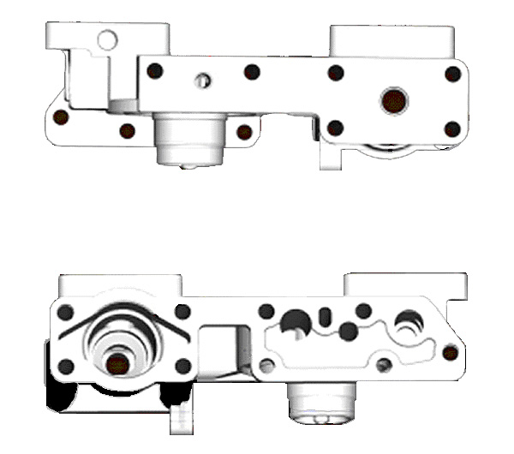 Fig. A4.2 Oil Filter Pressure Measurement and Pressurized Oil Fill Locations
filter bypass return to sump (plug)
filter bypass return to sump (plug)
oil filter pressure inlet
oil filter pressure outlet
Front View
Rear View
thermostat location (remove
thermostat and plug)
pressurized
oil fill location
Casting shown above is available from Cummins in assembly PN 3895946.

Fig. A4.3 Oil Pan Modifications

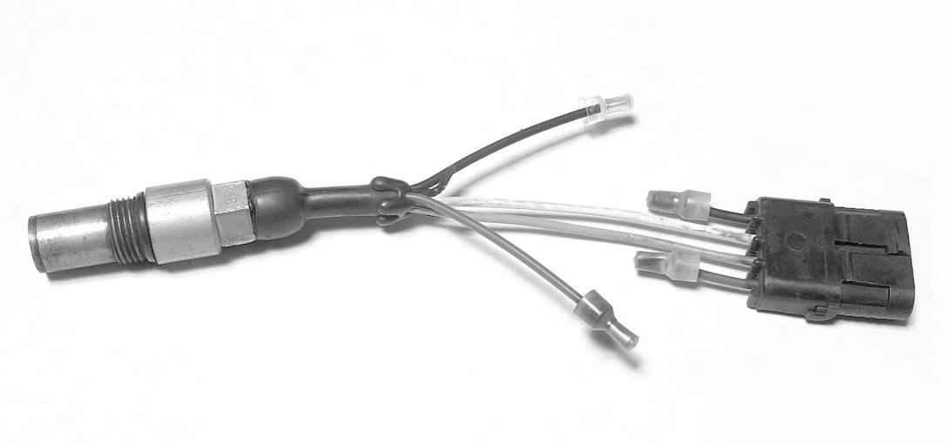
A
B
C
D

Note 1 Cut red and black leads (shown as A and D respectively in image above)

Fig. A4.4 Engine Position Sensor Modifications for ECM 870

Fig. A4.5 Fuel In Temperature, Fuel Pressure, Oil Gallery Temperature, and Oil Gallery Pressure Locations
Fig. A4.6 Intake Air Pressure and Temperature Measurement Locations
Fig. A4.7 Exhaust Temperature, Exhaust Pressure and Exhaust CO2 Probe Locations

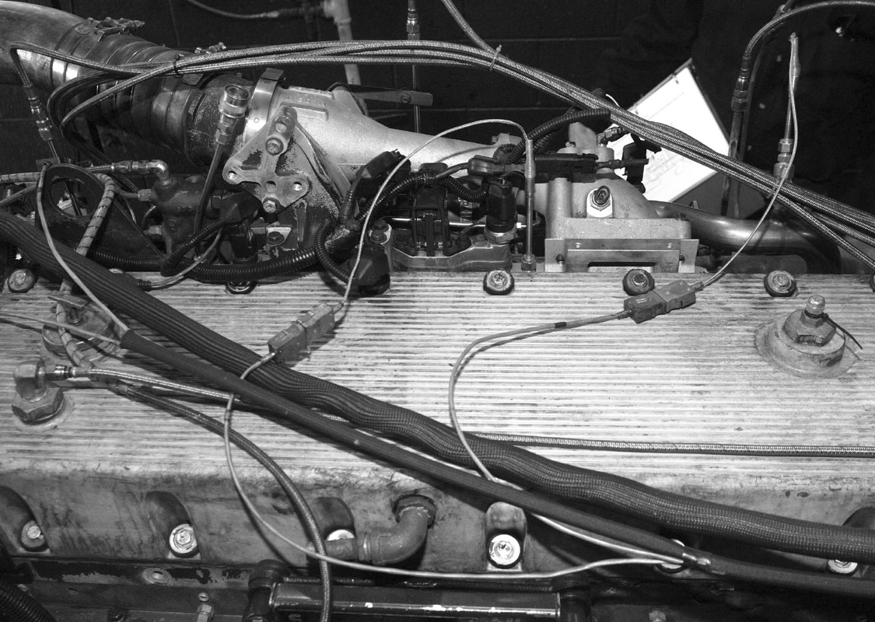
crankcase vent
crankcase pressure
intake manifold temperature
Fig. A4.8 Crankcase Vent, Intake Manifold Temperature and Crankcase Pressure Measurement Locations
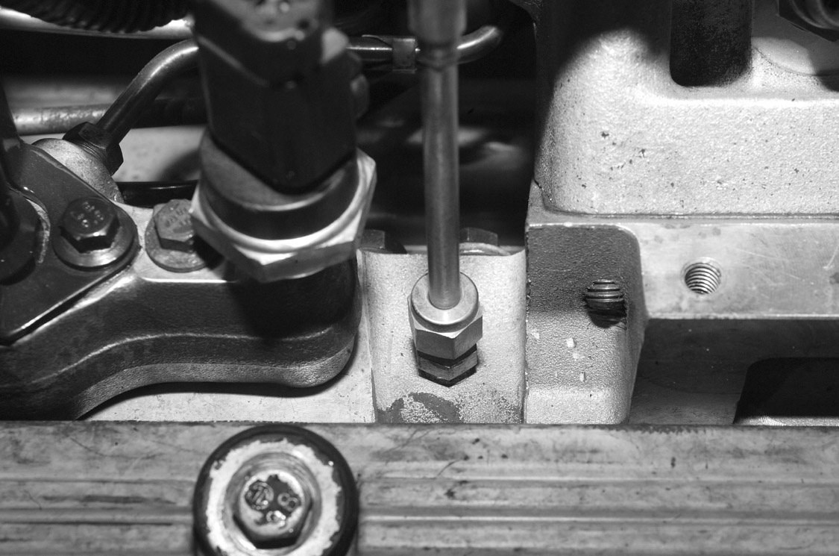
intake manifold temperature
Fig. A4.9 Intake Manifold Temperature Measurement Location Close-up

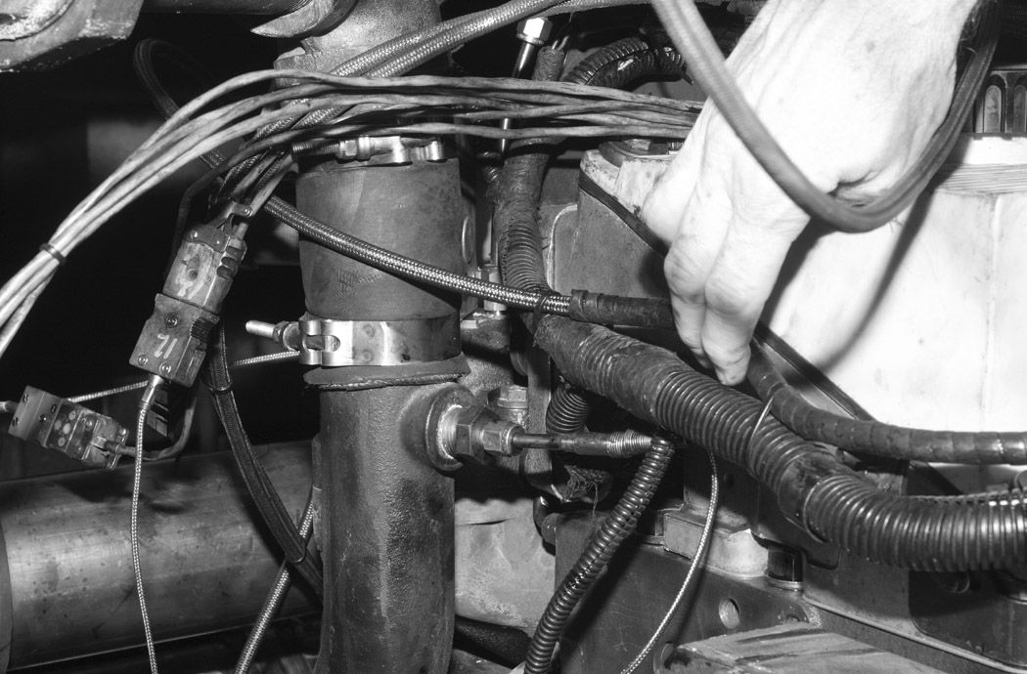
coolant out temperature manifold temperature
Fig. A4.10 Coolant Out Temperature Measurement Location
Fig. A4.11 Coolant In Temperature Measurement Location
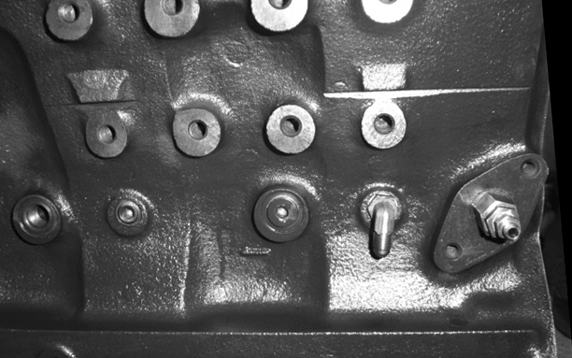
oil gallery temperature measurement location
oil gallery pressure measurement location
Fig. A4.12 Oil Gallery Temperature and Oil Gallery Pressure Measurement Locations
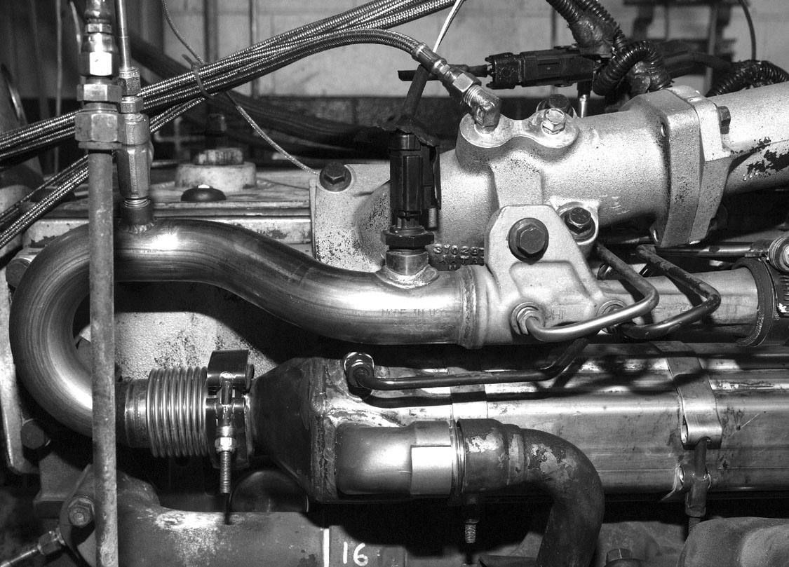
Fig. A4.13 Intake Manifold Pressure Measurement Location
intake manifold pressure
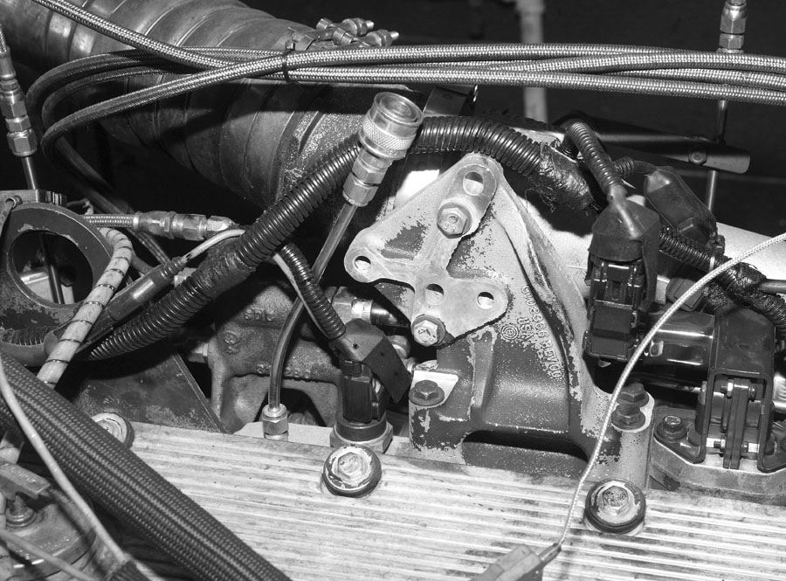
Fig. A4.14 Intake Manifold CO₂ Probe Location
intake CO₂

Fig. A4.15 Exhaust CO₂ Sampling Probe Insertion Depth

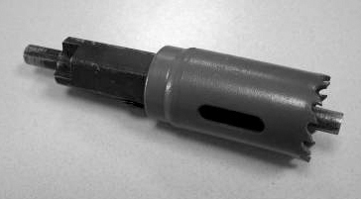
drill bit replaced by rod

Fig. A4.16 Modified Hole Saw for Oil Capacitor Removal

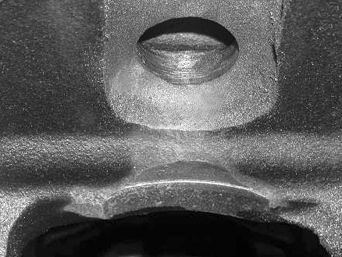

Fig. A4.17 Finished Hole in Wall of Oil Capacitor
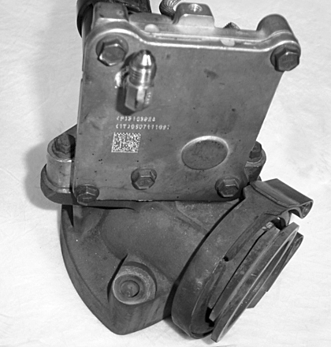
Fig. A4.18 Vent Holes in EGR Valve
drill vent holes within box
A5. External Oil System

A5.1 See Fig. A5.1
FIG. A5.1 External Oil System
A6. fuel SpecificationS

A6.1 See Table A6.1.

Table A6.1 Fuel Specifications
Property Test Method Minimum^{A} Maximum^{A}
Sulfur, % mass D 2622 0.04 0.05
Gravity, degrees API D 287 or D 4052 34.5 36.5 (37)
Hydrocarbon Composition, % volume
Aromatics D 1319 (FIA) 28 (27) 33
Olefin D 1319 (FIA) Report
Cetane Number D 613 42 (40) 48
Cetane Index D 4737 and D 976 Report
Copper Strip Corrosion D 130 1
Flash Point, °C D 93 54
Pour Point, °C D 97 -18
Cloud Point, °C D 2500 Report
Carbon Residue on 10% Residuum, % D 524 (10% Bottoms) 0.35
Water and Sediment, % volume D 2709 0.05
Viscosity, cSt @ 40°C D 445 2.4 3.0
Ash, % mass D 482 0.005
Total Acid Number D 664 0.05
Strong Acid Number D 664 0.00
Accelerated Stability D 2274 TBD
Distillation, °C D 86
IBP Report
10% Report
50% Report
90% 282 338
EP Report
______________________________________________________________________________
^{A} Minimum and Maximum numbers in parentheses are EPA Certification Fuel Specifications.

A7. CUMMINS SERVICE PUBLICATIONS

A7.1 General preparation techniques for Cummins M11 engines are detailed in the Cummins publication titled, Shop Manual - M11 Series Engines, Bulletin No. 3666075-00.
A7.2 Engine specifications, component specifications and torque values can be found in the Cummins publication titled, Specification Manual - M11 / ISM, Bulletin No. 3666476.
A7.3 Troubleshooting and repair information can be found in the Cummins publication titled, Troubleshooting and Repair Manual – ISM, ISMe, QSM11, Bulletin No. 3666322.
A7.4 Troubleshooting and repair information concerning the CM870 electronic control system can be found in the Cummins publication titled Troubleshooting and Repair Manual - ISM CM870 and CM570 Electronic Control System, Bulletin No. 4021381.
A7.5 Troubleshooting and repair information concerning the CM875 electronic control system can be found in the Cummins publication titled Troubleshooting and Repair Manual - ISM CM875 Electronic Control System, Bulletin No. 4021477.

A8. SPECIFIED UNITS AND FORMATS
A8.1 Specified Units:
A8.1.1 The parameters in this test method are specified in metric units except for pipe fittings, tubing, tubing fittings, and Compucheck fittings. Pipe fittings, tubing and tubing fittings are available worldwide and are not interchangeable with metric-sized equivalents because of differences in thread dimensions. Therefore no metric conversion is stated. The Compucheck fittings are diagnostic ports in the Cummins M11 engine block. The ports are standard straight thread and are not interchangeable with metric-sized equivalents.
A8.1.2 Test Report — Record operational parameters according to Table A8.1. Report test results in the units and with the significant digits shown in Table A8.2. Round test results in compliance with Practice E29.
A8.1.3 Measurements and Conversions — With the exceptions noted in A8.1.1, all parameters have been specified in S.I. units. The intent of this test method is to measure all parameters directly in S.I. units. If parameters are measured in inch-pound units, then the laboratory shall be able to demonstrate to the TMC that the measurements are within the tolerance after conversion to S.I. units.
A8.1.3.1 Significant error may occur due to rounding or tolerance stacking, or both, when converting from inch-pound units to S.I. units.

Table A8.1 Minimum Resolution of Recorded Measurements
Parameter Record data to Nearest
Speed 1 r/min
Power 1 kW
Torque 1 N•m
Fuel Flow 0.1 kg/hr
Coolant In Temperature 0.1 °C
Coolant Out Temperature 0.1 °C
Fuel In Temperature 0.1 °C
Oil Gallery Temperature 0.1 °C
Intake Air Temperature 0.1 °C
Exhaust (Tailpipe) Temperature 1 °C
Intake Manifold Pressure 0.1 kPa
Crankcase Pressure 0.01 kPa
Exhaust Pressure 0.1 kPa

Table A8.2 Significant Digits for Test Results

Parameter Round off to Nearest
Mass Loss 0.1 mg
Sludge 0.1 merit
Filter Plugging 1 kPa

A8.2 Specification Format — Specifications are listed in three formats:
(1) target
(2) target and range
(3) range with no target.
A8.2.1 Target – A target specification has no tolerance. Therefore the only acceptable value is the target. A representative specification format is xx.xx (target). For example, the oil pan oil charge is listed as 24.7 kg.
A8.2.1.1 A parameter with a target shall not be intentionally calibrated or controlled at a level other than the target.
A8.2.2 Target and Range – A target and a range specification implies the correct value is the target and the range is intended as a guide for maximum acceptable variation about the mean. A representative specification format is xx.xx ± x.xx (target ± range). For example, the engine speed is 1800 ± 5 r/min.
Note A8.2: The mean of a random sample should be equivalent to the target. Operation within the range does not imply that parameter will not bias the final test results.
A8.2.3 Range with No Target – A range with no target specification is used when 1) the parameter is not critical and control within the range is sufficient or 2) the measurement technique is not precise, or both. A representative specification format is xx.xx - xx.xx (range_{low} – range_{high}). For example, the coolant system pressure is 99 – 107 kPa.

A9. REPORT Figures (FORMS) AND DATA DICTIONARY
A9.1 Download the actual report figures (forms) and data dictionary separately from the ASTM Test Monitoring Center Web Page at http://www.astmtmc.cmu.edu/ or they can be obtained in hardcopy format from the TMC.

Table A9.1 List of Report Forms
______________________________________________________________________________
1. Final Report Cover Sheet Fig. A9.1 (Form 1)
2. Table of Contents Fig. A9.2 (Form 2)
3. Summary of Test Method Fig. A9.3 (Form 3)
4. Test Results Summary Fig. A9.4 (Form 4)
5. Operational Summary Fig. A9.5 (Form 5)
6. Crosshead Mass Loss Summary Fig. A9.6 (Form 6)
7. Oil Filter Delta Pressure Plot Fig. A9.7 (Form 7)
8. Sludge Rating Summary Fig. A9.8 (Form 8)
9. Ring Mass Loss Summary Fig. A9.9 (Form 9)
10. Oil Analysis Summary Fig. A9.10 (Form 10) 11. Test Fuel Analysis Fig. A9.11 (Form 11)
12. Injector Adjusting Screw Mass Loss Fig. A9.12 (Form 12)
13. Unscheduled Downtime & Maintenance Summary Fig. A9.13 (Form 13)
14. Characteristics of the Data Acquisition System Fig. A9.14 (Form 14)
_______________________________________________________________________________

A10 . sludge rating worksheets
A10.1 See Figs. A10.1 – A10.2

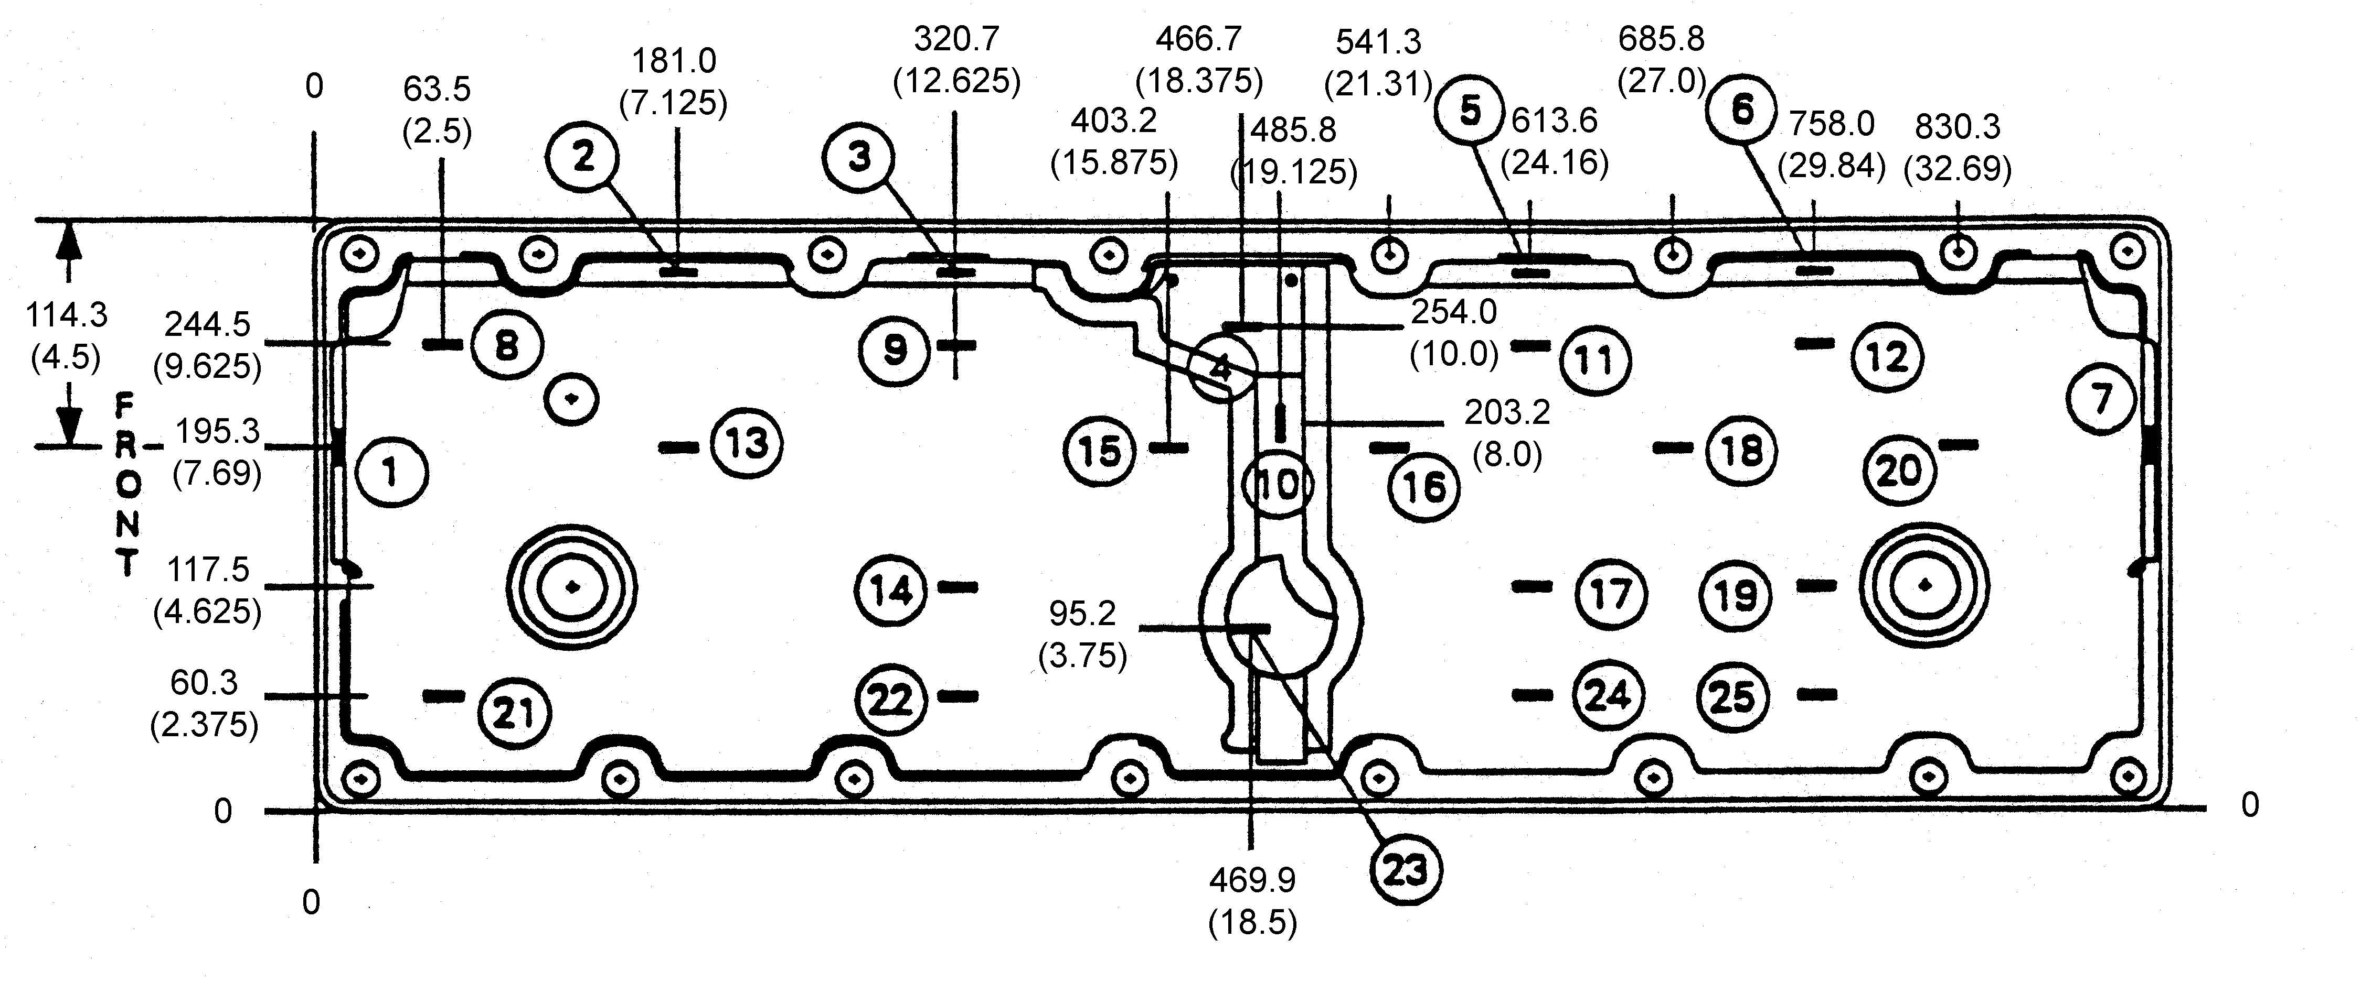

Note 1 — Dimensions are in millimeters and (inches).
Note 2 — Rating sites 1 and 7 are located 114.3 mm (4.5 in.) from the outside edge of the gasket surface on the deep side of the cover.
Note 3 — Rating sites 2, 3, 5, and 6 are located on the vertical surface 38.1 mm (1.5 in.) from the top of the cover.
Note 4 — The depth gauge should be oriented has indicated by the (-) symbol at each rating site and the dimensions shown on the drawing.

Rocker Arm Cover Sludge Rating ______________

Fig. A10.1 Rocker Arm Cover Sludge Rating Worksheet

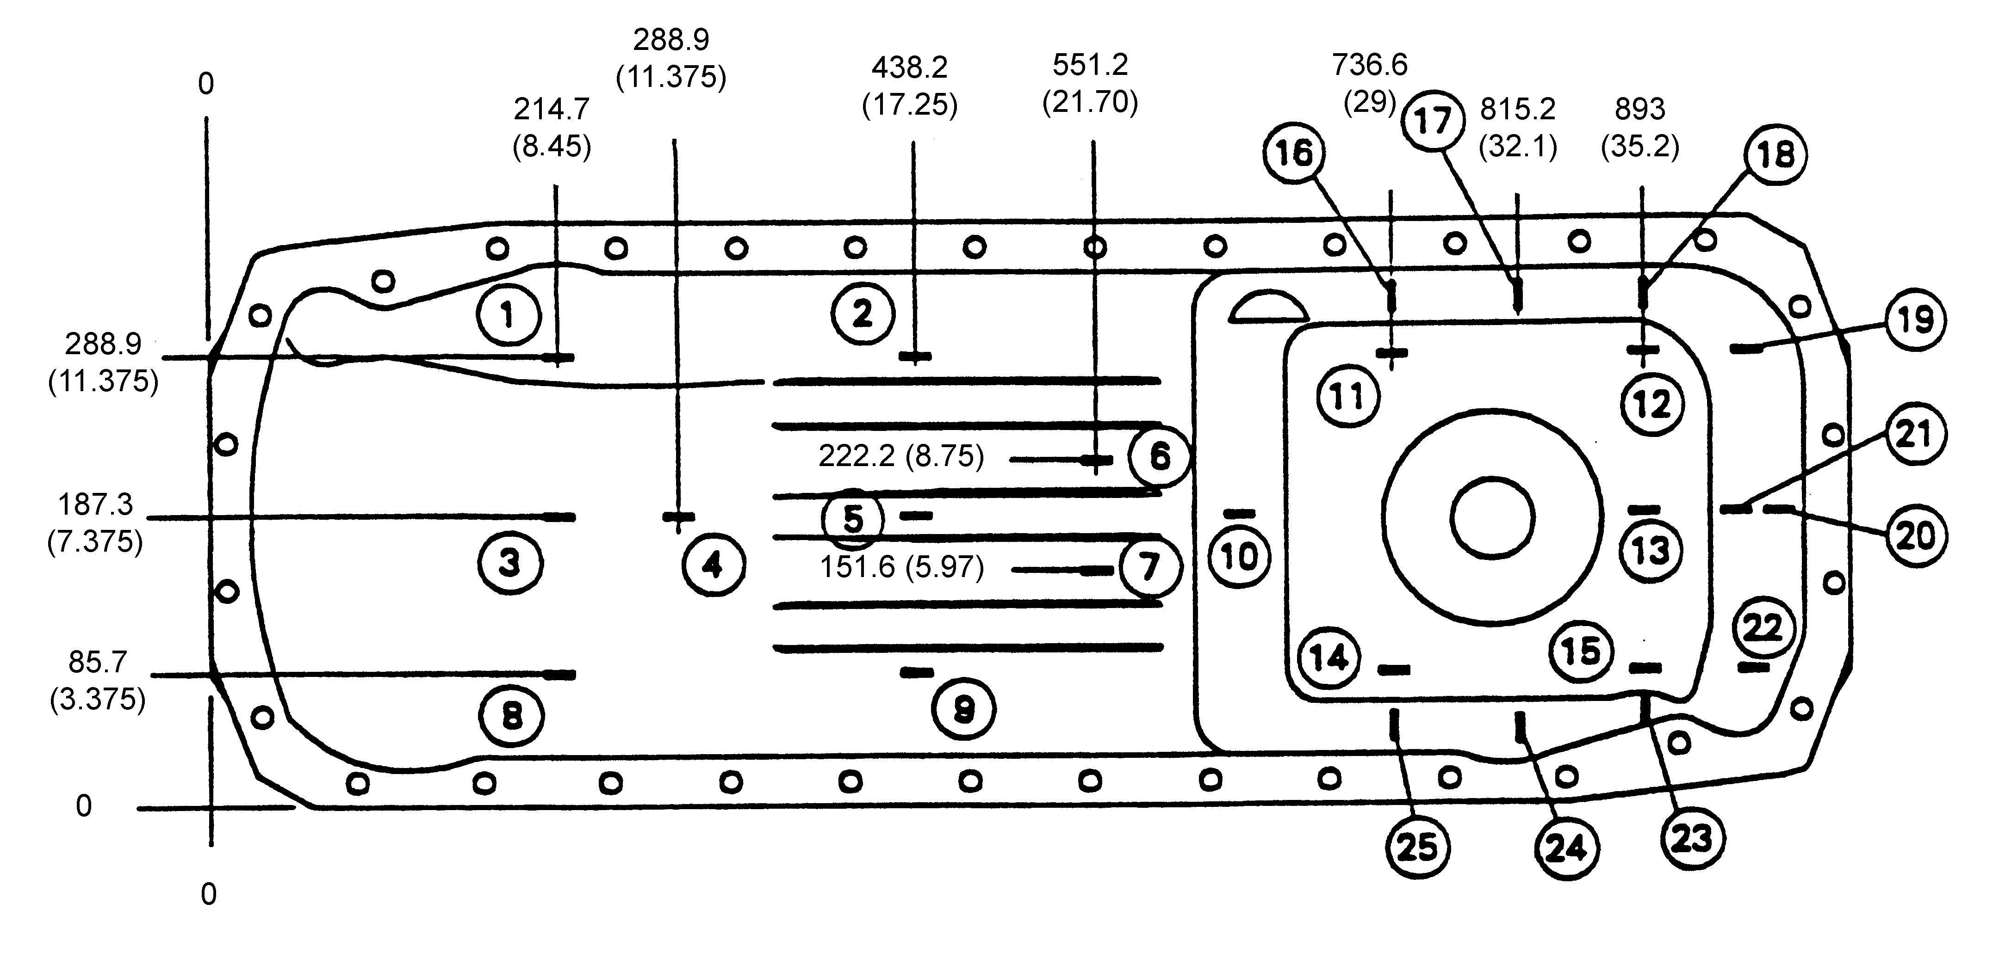
Note 1 — Dimensions are in millimeters and (inches).
Note 2 — Rating sites 3, 4, 5, 13, 20, and 21 are located along the longitudinal centerline.
Note 3 — Rating sites 3, 4, and 5 are 215.9 mm (8.5 in.), 304.8 mm (12 in.), and 431.8 mm (17 in.) respectively from the outside edge of the gasket surface on the shallow end.
Note 4 — Rating site 13 is located 114.3 mm (4.5 in.) from the outside edge of the gasket surface on the deep end.
Note 5 — Rating sites 20 and 21 are located 127 mm (5 in.) and 228.6 mm (9 in.) respectively from the gasket surface on the deep end vertical wall.
Note 6 — Rating sites 16, 17, 18, 19, 22, 23, 24, and 25 are located 127 mm (5 in.) from the gasket surface on the deep end vertical wall.
Note 7 — Rating sites 11, 12, and 14 are located 50.8 mm (2 in.) from the vertical wall.
Note 8 — Rating site 15 is located 25.4 mm (1 in.) from the vertical surface.
Note 9 — Rating site 10 is located on the centerline 88.9 mm (3.5 in.) from the bottom of the oil pan sump.
Note 10 — The depth gauge should be oriented has indicated by the (-) symbol at each rating site and the dimensions shown on the drawing.

Oil Pan Sludge Rating_______________
Fig. A10.2 Oil Pan Sludge Rating Worksheet

A12. OIL ANALYSES
A12.1 See Table A12.1
Table A12.1 Oil analysis

Parameter
Sample Hour Metals^{A} TAN^{B} TBN^{C} Vis @ 100 °C^{D} Soot^{E}
New X X X X X
25 X X X
50 X X X X X
75 X X X
100 X X X X X
125 X X X X X
150 X X X X X
175 X X X X X
200 X X X X X
^{A} D 5185 (Copper, Iron, Lead, Chromium, Aluminum)
^{B} D 664
^{C} D 4739
^{D} D 5967 Annex 3 or D 445
^{E} D 5967 Annex 4
A14. DETERMINATION OF OPERATIONAL VALIDITY
A14.1 Quality Index Calculation
A14.1.1 Calculate Quality Index (QI) for all control parameters according to the DACA II Report. Account for missing or bad quality data according to the DACA II Report.
A14.1.2 Use the U, L, Over Range, and Under Range values shown in Table A14.1 for the QI calculations.
A14.1.3 Round the calculated QI values to the nearest 0.001.
A14.1.4 Report the QI values on Fig. A9.5 (Form 5) listed in A9.1.
A14.2 Averages
A14.2.1 Calculate the average for control and non-control parameters, and report the values on Form 5 shown in Table A9.1. Note that the averages are not directly used to determine operational validity but may be helpful when an engineering review is required (A14.4).
A14.3 Determining Operational Validity
A14.3.1 QI threshold values for operational validity are shown in Table A14.1.
A14.3.1.1 A test with all control parameter QI values greater than or equal to the threshold value is operationally valid.
A14.3.1.2 Perform an engineering review to determine operational validity for a test with any control parameter QI value less than the threshold value shown in Table A14.1.
A14.4 Engineering Review
A14.4.1 An engineering review shall be performed when a control parameter QI value is below the threshold value. A typical engineering review involves investigation of the test data to determine the cause of the QI value below threshold. The purpose of the review is to determine whether a real control problem existed and the possible impact on the test. For example, a test has a low QI value for fuel flow. An examination of the fuel flow data may show that the fuel flow data contains several over range values. An examination of exhaust temperatures may help determine whether the instrumentation problem affected real fuel flow or only affected the data acquisition.
A14.4.2 Conduct engineering reviews for reference tests jointly with the TMC. For non-reference tests, optional input is available from the TMC for the engineering review.
A14.4.2 Determine operational validity based upon the engineering review and summarize the decision in the comment section of Fig. A9.1 (Form 1) listed in A9.1. Supporting documentation may be included at the end of the test report. The final decision regarding operational validity rests with the laboratory.

TABLE A14.1
QUALITY INDEX CALCULATION VALUES
 |  | Quality Index | Quality Index U & L Values |  |  |  | Over & Under Range Values
Control Parameter | Units | Threshold | U |  | L |  | Low | High
Speed^{A} | r/min | 0.000 | 1803.5 | 1603.5 | 1796.5 | 1596.5 | 1408 | 1992
Fuel Flow^{A} | kg/h | 0.000 | 58.5 | 64.9 | 57.5 | 63.9 | 30.6 | 91.8
Coolant Out Temp. | °C | 0.000 | 65.9 |  | 65.1 |  | 43.6 | 87.4
Fuel In Temp. | °C | 0.000 | 40.5 |  | 39.5 |  | 12.6 | 67.4
Oil Gallery Temp. | °C | 0.000 | 115.7 |  | 114.3 |  | 76.7 | 153.3
Intake Manifold Temp. ^{A} | °C | 0.000 | 81.0 | 66.5 | 79.0 | 64.5 | 10.7 | 134.8
Exhaust Back Pressure | kPa | 0.000 | 107.5 |  | 106.5 |  | 79.6 | 134.4
^{A}U and L values for speed are split by test stage.

A15. Exhaust CO₂ Sampling Probe
A15.1 Details concerning fabrication of the exhaust sampling probe are shown in the Code of Federal Regulations (CFR), Title 40, Part 86. CFR Title 40, Part 86 can be downloaded from the following Internet address: http://www.access.gpo.gov/nara/about-cfr.html
Hardcopy of the CFR Title 40 Part 86 may be obtained from:
Superintendent of Documents
Attn: New Orders
P.O. Box 371954
Pittsburgh, PA 15250-7954
Charge orders may be telephoned to the Government Printing Office order desk at 202-512-1800.
APPENDIXES
(Non Mandatory Information)
X1. Typical System Configurations:
X1.1 Intake Air System (Fig. X1.1)
X1.2 Fuel System (Fig. X1.2)
X1.3 Coolant System (Fig X1.3)
Fig. X1.1 Intake Air System (Typical)
Fig. X1.2 Fuel System (Typical)
FIG. X1.3 Coolant System (Typical)
Cummins ISM Footnotes

¹ This test method is under the jurisdiction of ASTM Committee D02 on Petroleum Products and Lubricants and is the direct responsibility of Subcommittee D02.0B on Automotive Lubricants. Current edition approved XXX. Published YYYY.
² American Society for Testing and Materials takes no position respecting the validity of any patent rights asserted in connection with any item mentioned in this standard. Users of this standard are expressly advised that determination of the validity of any such patent rights, and the risk of infringement of such rights, are entirely their own responsibility.
³ The ASTM Test Monitoring Center will update changes in this test method by means of Information Letters. Information letters may be obtained from the ASTM Test Monitoring Center, 6555 Penn Avenue, Pittsburgh, PA 15206-4489, Attention: Administrator.
⁴ Annual Book of ASTM Standards, Vol 05.01
⁵ Annual Book of ASTM Standards, Vol 05.04
⁶ Annual Book of ASTM Standards, Vol 05.02
⁷ Annual Book of ASTM Standards, Vol 05.03
⁸ Annual Book of ASTM Standards, Vol 14.02
⁹ Annual Book of ASTM Standards, Vol 14.03
¹⁰ Available from the Coordinating Research Council, Inc., 219 Perimeter Parkway, Atlanta, Georgia 30346.
¹¹ Available from Superintendent of Documents, Attn: New Orders, P.O. Box 371954,
Pittsburgh, PA 15250-7954. Charge orders may be telephoned to the Government Printing Office order desk at 202-512-1800.

¹² Available from Test Engineering Inc., 12758 Cimmaron Path, Suite 102, San Antonio, TX 78249-3417 Phone: (210) 690-1958, Fax: (210) 690-1959.
¹³ Available from Southwest Research Institute, P.O. Drawer 28510, San Antonio, TX 78228 Phone: (210) 522-3567, Fax: (210) 522-5913.
¹⁴ Available from a Cummins parts distributor.
¹⁵ Available from Moroso Performance Products Inc., 80 Carter Drive, P.O. Box 1470, Guilford, CT 06437 Phone: (203) 453-6571, Fax: (203) 453-6906
¹⁶Available from the ASTM Test Monitoring Center, 6555 Penn Avenue, Pittsburgh, PA 15206-4489, Attention: Administrator.
¹⁷Available from Chevron Phillips Chemical Company LP, 10001 Six Pines Drive, Suite 4036B, The Woodlands, Texas 77387-4910, (832) 813-4859, (832) 813-4907 (fax), fuels@cpchem.com
¹⁸ Available from ASTM, 100 Barr Harbor Drive, West Conshohocken, PA 19428-2959.
¹⁹ ASTM Test Monitoring Center, 6555 Penn Avenue, Pittsburgh, PA 15206-4489 Phone: (412) 365-1000, Fax: (412) 365-1047.
²⁰ Annual Book of ASTM Standards, Vol 06.04
²¹ Cleaning solvent that meets the requirements of Section 7.4 is available from local petroleum products suppliers.

