t Test

The TTEST Procedure
Statistics
Variable | Rings | N | Lower CL  Mean | Mean | Upper CL  Mean | Lower CL  Std Dev | Std Dev | Upper CL  Std Dev | Std Err | Minimum | Maximum
SOOT | T11 | 32 | 5.7079 | 5.7832 | 5.8585 | 0.1675 | 0.2089 | 0.2778 | 0.0369 | 5.4 | 6.36
SOOT | T12 | 9 | 5.9591 | 6.1667 | 6.3743 | 0.1824 | 0.2701 | 0.5174 | 0.09 | 5.8 | 6.58
SOOT | Diff (1-2) |  | -0.554 | -0.383 | -0.213 | 0.1826 | 0.2229 | 0.2862 | 0.0841
MRV | T11 | 32 | 14573 | 14969 | 15365 | 879.69 | 1097.3 | 1458.8 | 193.97 | 12900 | 17000
MRV | T12 | 9 | 12849 | 13695 | 14541 | 743.62 | 1100.9 | 2109.1 | 366.97 | 11900 | 15900
MRV | Diff (1-2) |  | 435.76 | 1273.7 | 2111.7 | 899.46 | 1098 | 1409.9 | 414.29

T-Tests
Variable | Method | Variances | DF | t Value | Pr > |t|
SOOT | Pooled | Equal | 39 | -4.56 | <.0001
SOOT | Satterthwaite | Unequal | 10.8 | -3.94 | 0.0024
MRV | Pooled | Equal | 39 | 3.07 | 0.0038
MRV | Satterthwaite | Unequal | 12.8 | 3.07 | 0.0091

Equality of Variances
Variable | Method | Num DF | Den DF | F Value | Pr > F
SOOT | Folded F | 8 | 31 | 1.67 | 0.2909
MRV | Folded F | 8 | 31 | 1.01 | 0.9022

Generated by the SAS System (Local, XP_PRO) on 14SEP2005 at 7:54 AM

Box Plot

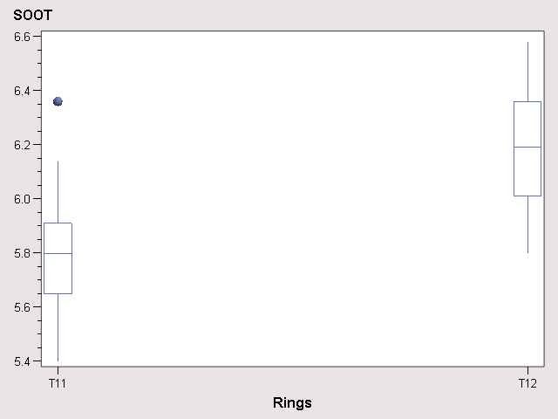

Generated by the SAS System (Local, XP_PRO) on 14SEP2005 at 7:54 AM

Box Plot

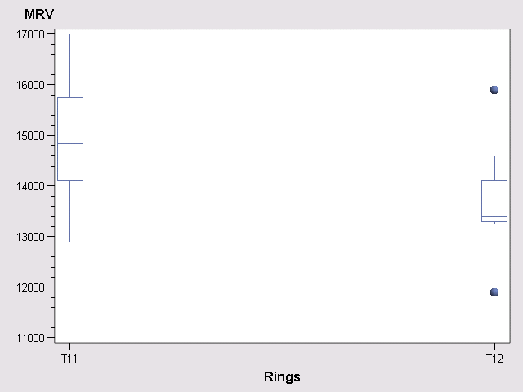

Generated by the SAS System (Local, XP_PRO) on 14SEP2005 at 7:54 AM

