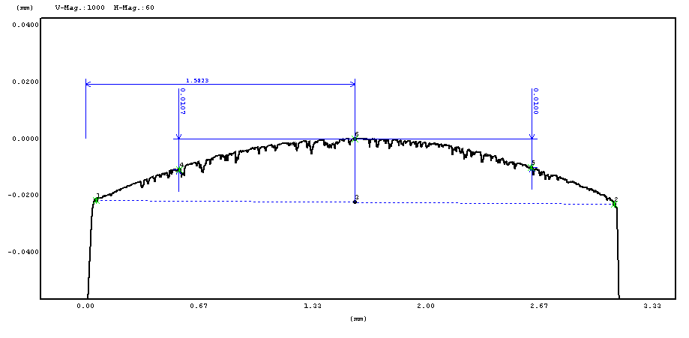
Customer MEC USA
Job Number M2279
Measurement UCR R 1 Ring Face
Operator TH

Output Unit mm,um
Polarity Positive
Pickup Standard Pickup
Standard ISO '97
Measurement Type Profile
Measurement Length 3.2mm
Cutoff Wavelength
Measurement Mag. * 500
Measurement Speed 0.15mm/s

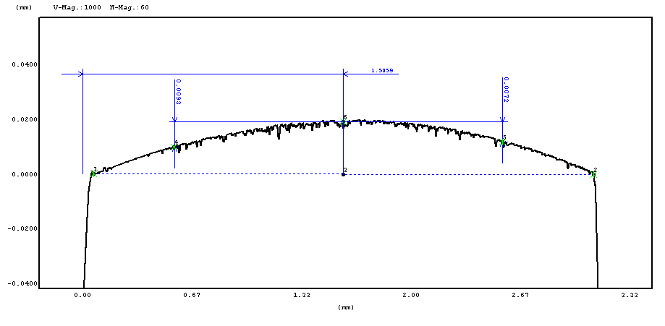
Customer MEC USA
Job Number M2279
Measurement UCR R 2 Ring Face
Operator TH

Output Unit mm,um
Polarity Positive
Pickup Standard Pickup
Standard ISO '97
Measurement Type Profile
Measurement Length 3.2mm
Cutoff Wavelength
Measurement Mag. * 500
Measurement Speed 0.15mm/s

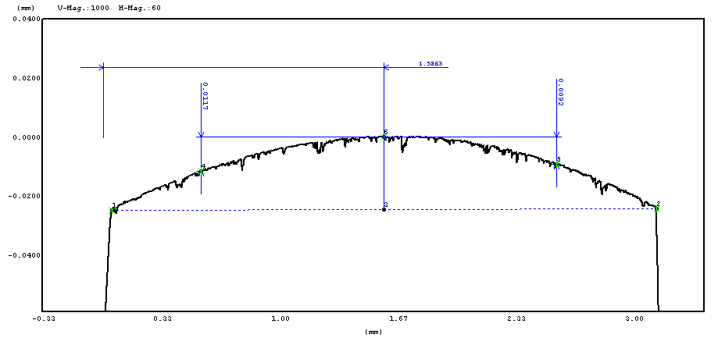
Customer MEC USA
Job Number M2279
Measurement UCR S 1 Ring Face
Operator TH

Output Unit mm,um
Polarity Positive
Pickup Standard Pickup
Standard ISO '97
Measurement Type Profile
Measurement Length 3.2mm
Cutoff Wavelength
Measurement Mag. * 500
Measurement Speed 0.15mm/s

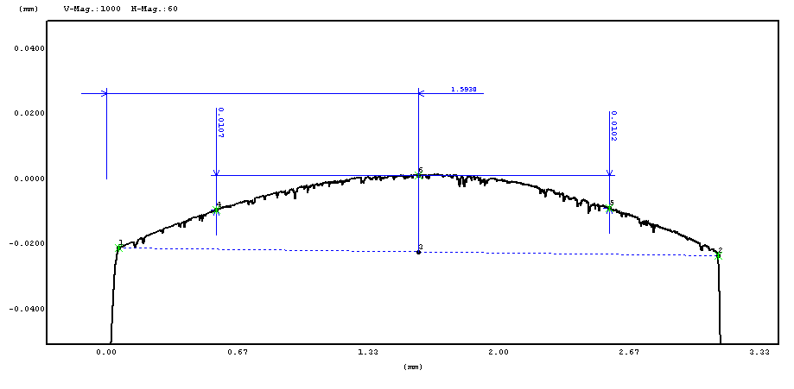
Customer MEC USA
Job Number M2279
Measurement UCR S 2 Ring Face
Operator TH

Output Unit mm,um
Polarity Positive
Pickup Standard Pickup
Standard ISO '97
Measurement Type Profile
Measurement Length 3.2mm
Cutoff Wavelength
Measurement Mag. * 500
Measurement Speed 0.15mm/s

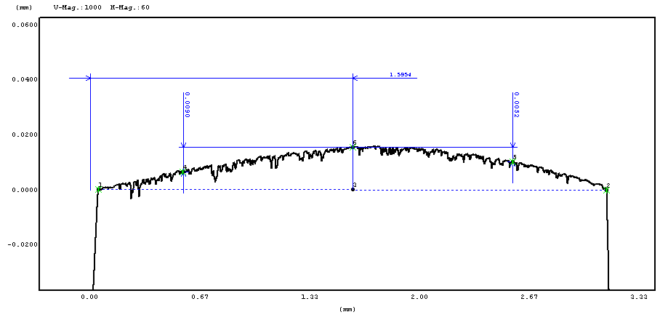
Customer MEC USA
Job Number M2279
Measurement UCR T 1 Ring Face
Operator TH

Output Unit mm,um
Polarity Positive
Pickup Standard Pickup
Standard ISO '97
Measurement Type Profile
Measurement Length 3.2mm
Cutoff Wavelength
Measurement Mag. * 500
Measurement Speed 0.15mm/s

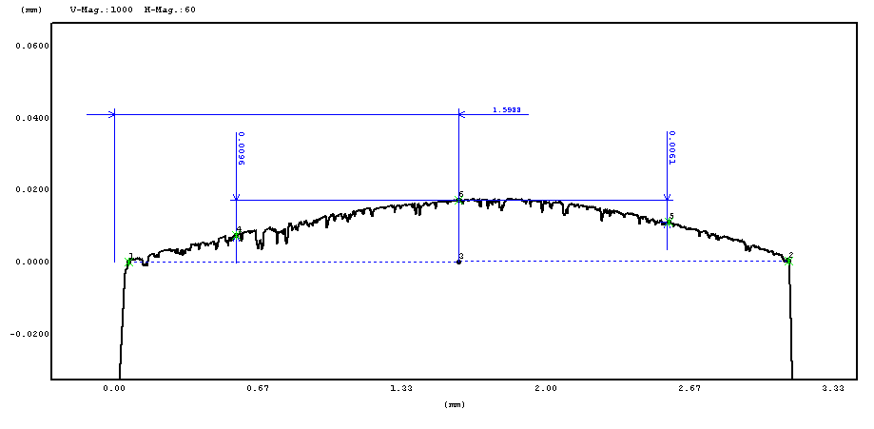
Customer MEC USA
Job Number M2279
Measurement UCR T 2 Ring Face
Operator TH

Output Unit mm,um
Polarity Positive
Pickup Standard Pickup
Standard ISO '97
Measurement Type Profile
Measurement Length 3.2mm
Cutoff Wavelength
Measurement Mag. * 500
Measurement Speed 0.15mm/s

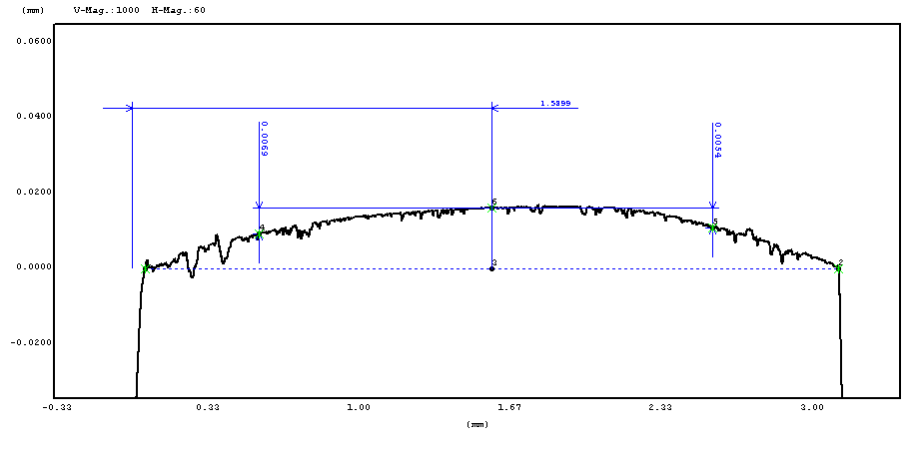
Customer MEC USA
Job Number M2279
Measurement UCR I 1 Ring Face
Operator TH

Output Unit mm,um
Polarity Positive
Pickup Standard Pickup
Standard ISO '97
Measurement Type Profile
Measurement Length 3.2mm
Cutoff Wavelength
Measurement Mag. * 500
Measurement Speed 0.15mm/s

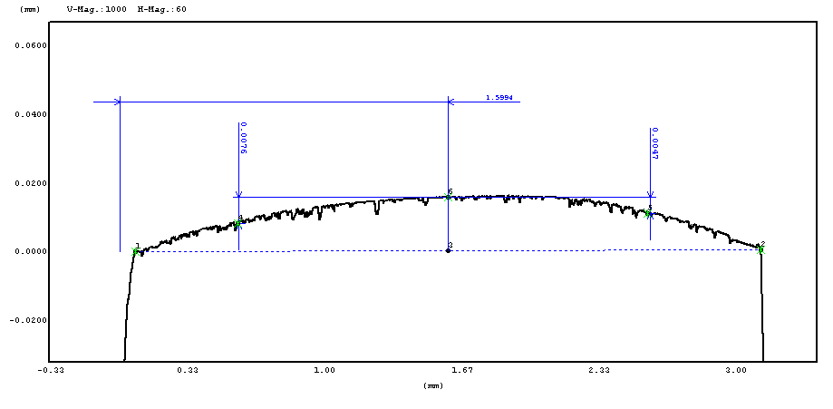
Customer MEC USA
Job Number M2279
Measurement UCR I 2 Ring Face
Operator TH

Output Unit mm,um
Polarity Positive
Pickup Standard Pickup
Standard ISO '97
Measurement Type Profile
Measurement Length 3.2mm
Cutoff Wavelength
Measurement Mag. * 500
Measurement Speed 0.15mm/s

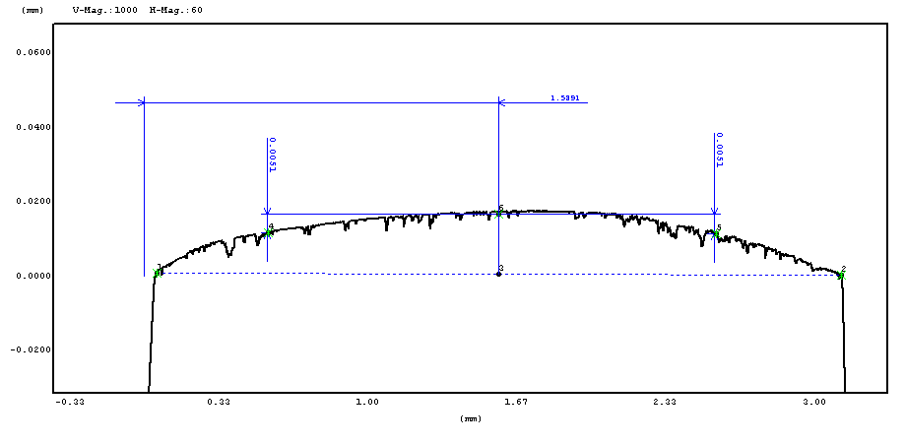
Customer MEC USA
Job Number M2279
Measurement UCR L 3 Ring Face
Operator TH

Output Unit mm,um
Polarity Positive
Pickup Standard Pickup
Standard ISO '97
Measurement Type Profile
Measurement Length 3.2mm
Cutoff Wavelength
Measurement Mag. * 500
Measurement Speed 0.15mm/s

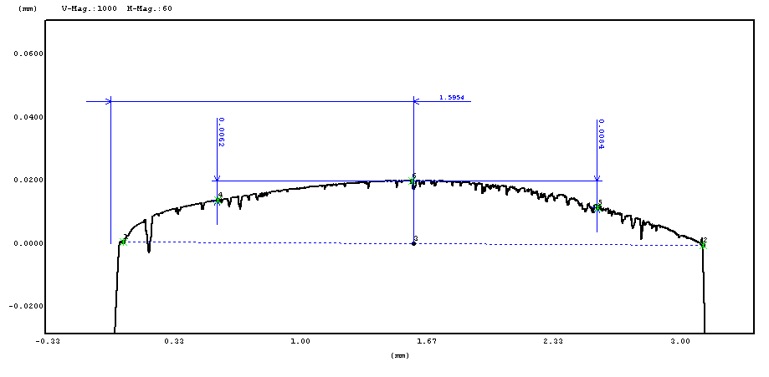
Customer MEC USA
Job Number M2279
Measurement UCR L 4 Ring Face
Operator TH

Output Unit mm,um
Polarity Positive
Pickup Standard Pickup
Standard ISO '97
Measurement Type Profile
Measurement Length 3.2mm
Cutoff Wavelength
Measurement Mag. * 500
Measurement Speed 0.15mm/s

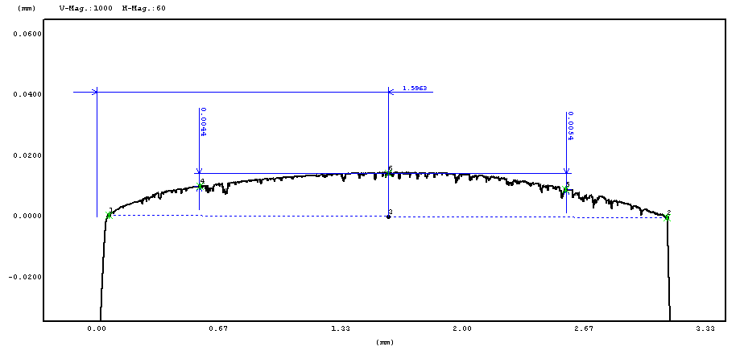
Customer MEC USA
Job Number M2279
Measurement UCR SW 3 Ring Face
Operator TH

Output Unit mm,um
Polarity Positive
Pickup Standard Pickup
Standard ISO '97
Measurement Type Profile
Measurement Length 3.2mm
Cutoff Wavelength
Measurement Mag. * 500
Measurement Speed 0.15mm/s

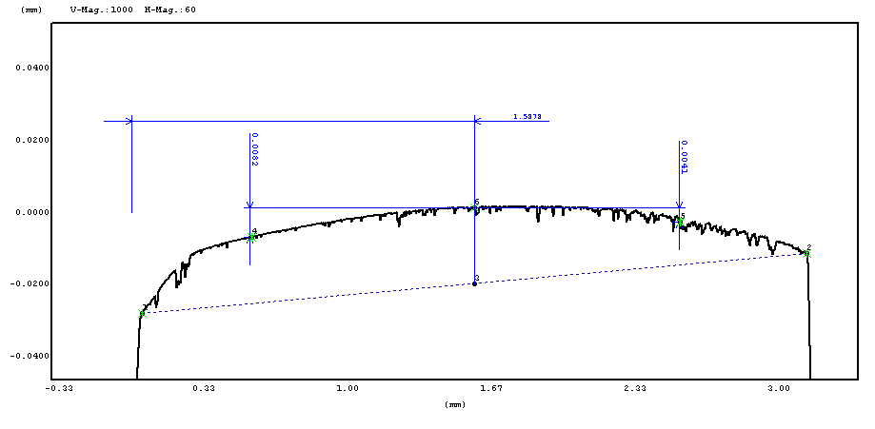
Customer MEC USA
Job Number M2279
Measurement UCR SW 5 Ring Face
Operator TH

Output Unit mm,um
Polarity Positive
Pickup Standard Pickup
Standard ISO '97
Measurement Type Profile
Measurement Length 3.2mm
Cutoff Wavelength
Measurement Mag. * 500
Measurement Speed 0.15mm/s

