Mack T-13 Test Instructions Outline, Rev.8

- Engine Configuration
  - Engine mounted with flywheel perpendicular to floor and tilted 4° side-to-side toward intake manifold
  - PVD Coated Exhaust Rocker Arms, P/N 21809012 with PVD Coated Rocker-Arm Shaft, P/N 21534995
  - Remove thermostat and replace it with sleeve P/N 21474103 (see attached) and seal P/N 1549651
  - US07 Oil Filter Housing P/N 21183257 with mods including removal of oil temperature thermostat
  - No-Brake Camshaft P/N 21219818 with “Dummy” Solenoid Valve P/N 21105100
  - Remove housing element with heater attached to intake manifold and replace it with:
    - Intermediate Housing w/o Pre-Heater, P/N 20730387
    - Bolts, P/N 965184
    - Washers, P/N 976944
    - Gaskets, P/N 3979639
  - Oil Mist Separator speed detection (2 pulses per revolution):
    - Speed Sensor Bracket – Detroit Diesel P/N A4720180340
    - Speed Sensor - Detroit Diesel P/N A0061535528
    - Speed Sensor Connector - Detroit Diesel P/N A0001506336
  - Front Mount Steel Oil Pan P/N 21585801 with Gasket P/N 21293367, pick up height, oil sump thermocouple and oil drain set per attached dimensions (target 3,000-3,500 grams after 1 hour at test conditions)
    - Oil level sensor to be removed
  - Coolant, Chevron Delo Extended Life Coolant diluted 50/50
    - P/N 227811 (50/50 pre-mixed)
    - P/N 227808 (concentrated)
  - Coolant Filter w/o additives, Volvo P/N 21388479 21937327
  - Full Flow Oil Filter (2), P/N 21707136
  - By-Pass Oil filter, P/N 21707135
  - Compressor Block-Off Plate, Volvo Penta P/N 21226107
  - Turbocharger Inlet Rubber Hose P/N 21659720
  - Damper Cooling Fan
  - Cylinder Head, P/N 21458124, EU6 21995786
  - Cylinder Head Kit, P/N 21460896, (EU6) P/N 22251160 22498402
  - Valve Stem Seal P/N 21990221
  - Injector (6), P/N 21458369 22027808, reman # 85013612. Use Graphite paste P/N 85134750 for installation.
  - Turbocharger, P/N 85128135 85136177 85141061 with Gasket with large opening P/N 20781146
  - Oil Cooler, ITT Model SSCF 5-160-03-014-004 Two pass, All Stainless steel
    - Remove cooler core and baffle from engine (right side)
    - Max length of combined 1” (No. 16 Aeroquip or equivalent) flex lines to/from cooler to be 36”
  - Oil Gallery Thermocouple insertion depth: middle of oil gallery at 2.5265 “ from face of engine block
  - Fuel Gallery Thermocouple insertion depth: 2.00“ from face of cylinder head
  - Oil Jet Thermocouple insertion depth: 3.0925“ from face of oil filter housing
  - Oil Cooler Out Thermocouple insertion depth: 0.950“ from face of oil filter housing
  - Coolant Out Thermocouple to be located midstream in the 4 bolt flange of the coolant outlet pipe
  - Remove vanes and cartridge from fuel&steering pump assembly
  - External Oil System Pumps, same as Mack T-12 with exception of line from oil pan to weigh tank (suction line) be No. 12 size (Inside Diameter 16 mm)
    - Return line from external oil vessel connected to center of compressor block-off plate
    - Vent of external oil vessel connected to cylinder head cover between cylinder 1 and cylinder 2 (see attached)
    - Max length of supply and return line combined: 18’ (5.4 m)
  - Flywheel, P/N 20941525 21514067
  - Use Mack Valve Cover P/N 20728586
  - Crankcase pressure port located on cylinder head cover between cylinder 3 and cylinder 4
  - Crank pulley P/N 20799474, fan pulley P/N 20872502, belt idler (including pulley) P/N 20582550, belt tensioner P/N 21779276, belt P/N 88GB447P615 for correct water pump speed
  - Compressor Discharge Temp Sensor (see attached table)
  - Boost Pressure Sensor, (see attached table)
  - Leave Ambient Temp Sensor disconnected
  - Engine coolant through turbocharger (standard factory set-up)
  - Aftertreatment fuel doser removed. Connector jumper? Yes. Run with fault codes (running fault codes in attached table)
  - Intertek Design EGR cooler adapter
  - Fuel Filter Housing P/N 21336013
  - Fuel Filter P/N 20972295
  - Fuel Water Separator P/N 21380521 (plastic bowl/drain P/N 21337071)
  - Oil Sampling Port
    - Size: ¼” (No. 4 Aeroquip or equivalent)
    - Max. Length: 8’
    - Port Location (see attached): pre-filter pressure port
  - Pressurized Oil Filling Connection (see attached): between oil cooler and oil filter housing on return to filter housing
  - Charge Air Cooler
    - Specifications:
      - Pressure drop at test conditions ≤ 5 kPa;
      - Provide enough cooling capacity to maintain specified Intake Manifold temperature;
      - Equipped with drain to remove condensate.
  - CO₂ Intake and Exhaust Measurements
    - Same probe specifications as Mack T-12;
    - Cool sample to a Dew Point ≤ 5°C

- List of PCU and Bearing P/N’s provided by Ken (needs to be verified against the list provided by Allison):
  - Piston – 21170742 P06 (6)
  - Liner – 20852790 P05 (6)
  - Rings – top – 21251596 P03 (6)
    - second – 20590309 P32 (6)
    - oil - 20568155 P34(6)
  - Pin – 20569833 P32 (6)
  - Snap Rings – 914531 P01 (12)
  - Liner Seals – top at flange – 470922 P03 (6)
    - lower – top and middle – 470190 P05 (12)
    - lower – bottom – 21430623 P01 (6)
  - Main Bearings – Upper – 20530902 (7)
    - Lower – 20530900 (7)
  - Rod Bearings – Upper – 20508264 (6)
    - Lower – 20530094 (6)

- Test Stand Configuration and Test Operation
  - 1500 rpm, 2200 Nm, 3000 psi, “3573E09A59_t13_Rev9_1500_3000psi_ “ Flash file
  - Mack T13 Test Development AL824MOD01 V11a.xls test protocol
  - Cam-Crankshaft Timing Verification
  - Controlled Parameters:
    - CO₂ Intake Manifold: 2.06 ± 0.05 %
    - Intake Manifold Pressure: 232 ± 5 kPaG
  - Ranged Parameters:
    - Exhaust Pipe: TBD (range from 5 tests with 821-3: 10.57-11.23%)
  - Active EGR and VGT Control
    - Use VGT and EGR valve to control Intake Manifold CO₂ and Intake Manifold Pressure
  - Test Length: 360-h
  - Both external oil vessel and external oil cooler to be drained at completion of Break-In

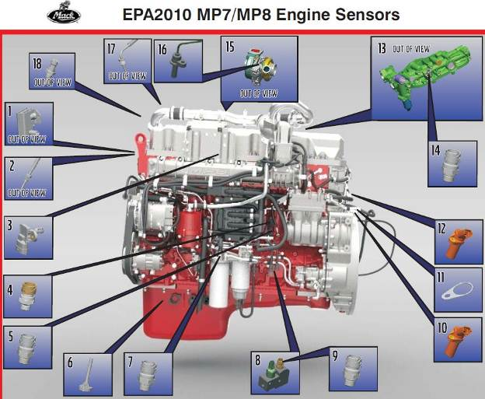

#1 – EGR Delta Pressure Sensor - Must use sensor PN# 21713917 with new harness.

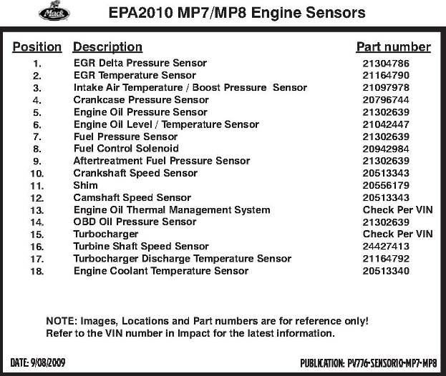
NOTES
- FYI - #4 and #5 Position sensors - are reversed for position on MP8 Engine /Sensor display above.
- #6 sensor: the correct PN# is 21521353. Remove sensor from oil pan.
- #13 – is not used
- #14 – is not used

Ambient Air Temperature Sensor to be left disconnected

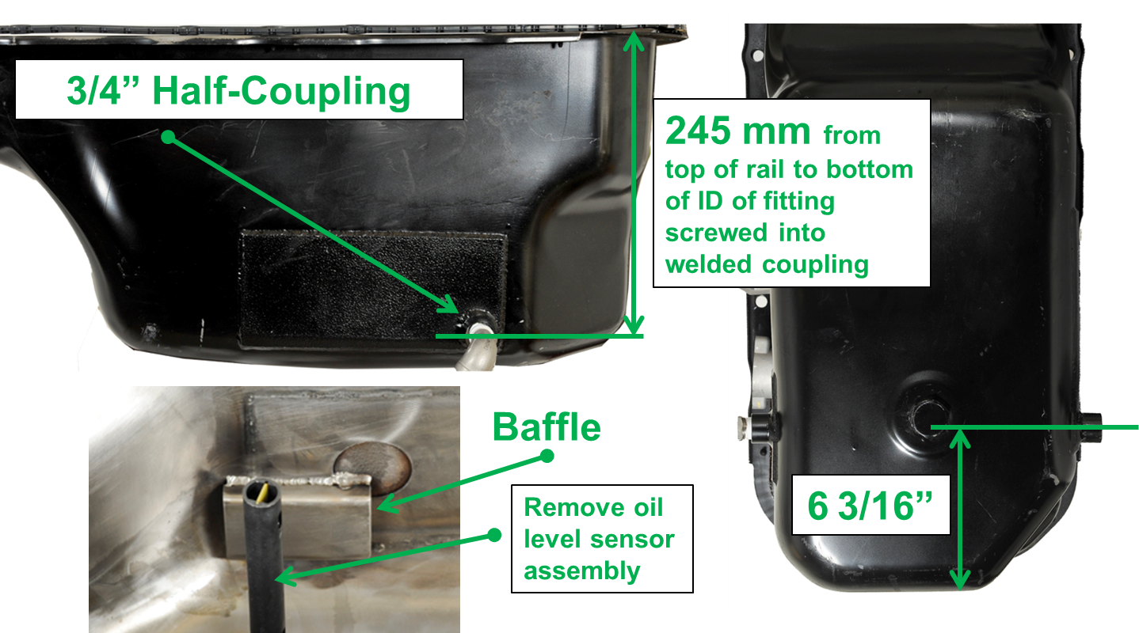
External Oil System Suction Port

Oil Sump Thermocouple Location

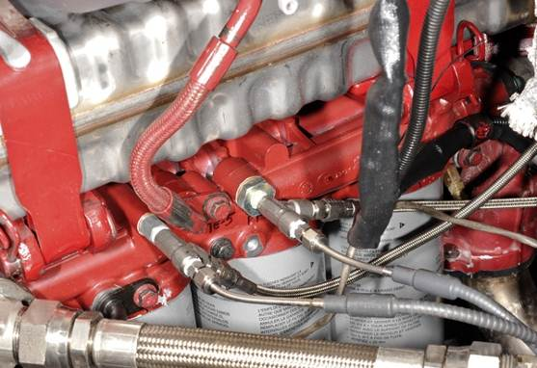
Sampling Port

Oil Sampling Port

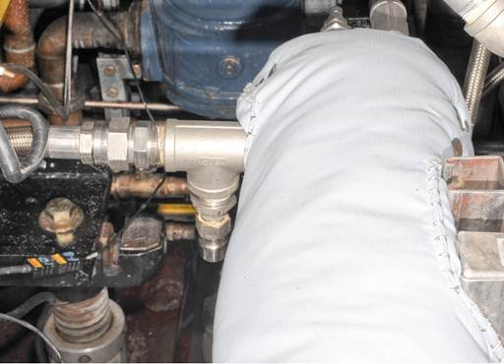
Filling Port

Pressurized Oil Fill Location

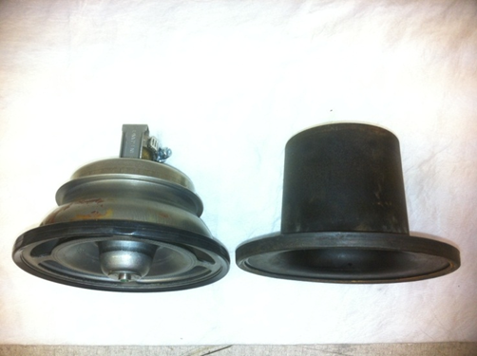

Sleeve replacing Thermostat

