New Cylinder Head Assembly Procedure
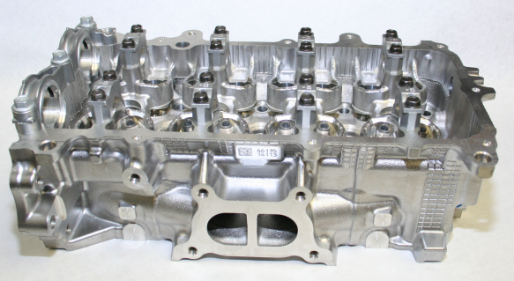 | Refer to Figure 1:  - Obtain a new Toyota 2NR-FE cylinder head (OHT p/n OHTIVB-11101-1).  - Wash the cylinder head in an ultra-sonic cleaner for 20-30 minutes. Air-dry with clean, compressed air.  - Spray cylinder head with a 50/50 mixture of EF-411 assembly fluid and degreasing solvent. Air-dry with clean, dry compressed air.
Figure 1
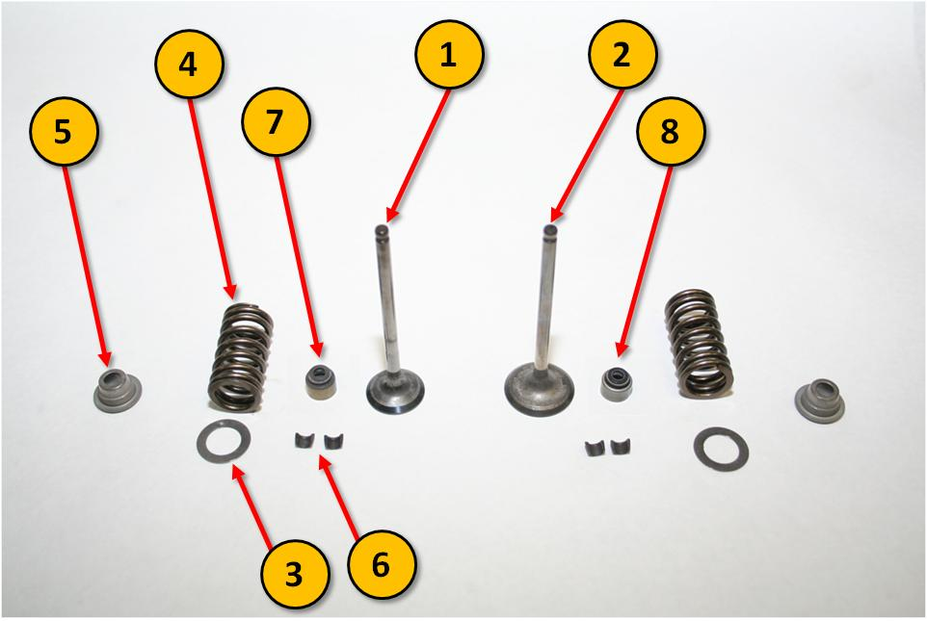 | Refer to Figure 2:  - Obtain the set of new parts specified in Table 1. Note: Break-in valve springs should be used.  - Apply a light coat of EF-411 assembly fluid on all valve stems.
Figure 2

Table 1: New parts required to complete cylinder head assembly
Item no. | Description | OHT p/n | Qty
1 | Intake valve | OHTIVB-13711-1 | 8
2 | Exhaust valve | OHTIVB-13715-1 | 8
3 | Valve spring seat | OHTIVB-13734-1 | 16
4 | Valve spring | OHTIVB-25063-1 | 16
5 | Valve spring retainer | OHTIVB-13741-1 | 16
6 | Valve spring retainer lock | OHTIVB-03028-1 | 32
7 | Intake valve stem oil seal | OHTIVB-02101-1 | 8
8 | Exhaust valve stem oil seal | OHTIVB-02112-1 | 8
9 | Spark plug tubes (not shown in Figure 2) | OHTIVB-11191-1 | 4

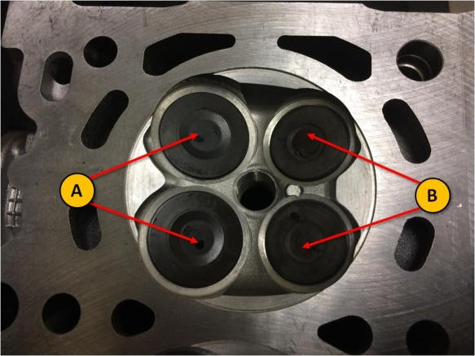 | - Flip the cylinder head over, such that the top of the combustion chamber is the topside.  Refer to Figure 3:  - Place the valves in their appropriate ports. Slide the valve stems into each valve guide. The exhaust valves are denoted as (A), and the intake valves are denoted as (B).  - Flip cylinder head over, such that the combustion chamber is lying flat on the bench top. Ensure that the valves stay installed in the cylinder head.
Figure 3
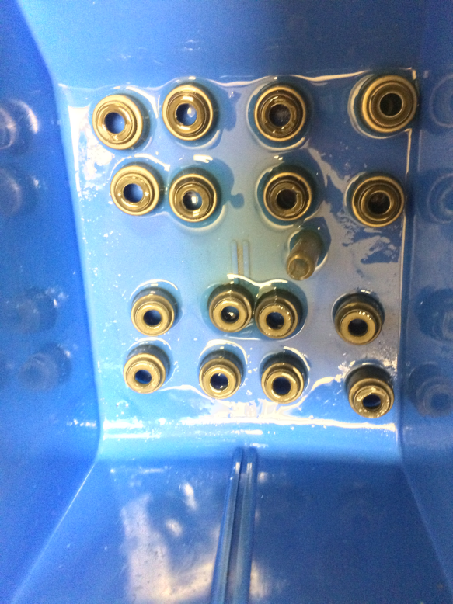 | Installing valve stem oil seals:  Refer to Figure 4:  - Place all valve stem oil seals in a plastic container. Fill the container with EF-411 assembly fluid until the valve seals are submerged.  - Apply a small amount of EF-411 assembly fluid on the tip of the valve stem.
Figure 4
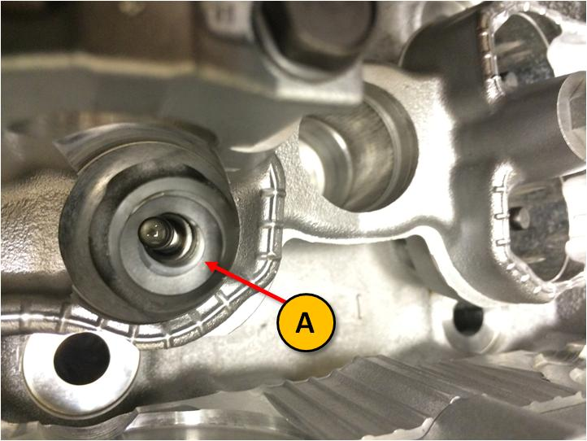 | Refer to Figure 5:  - Insert valve spring seat (A) onto the valve spring recess.
Figure 5
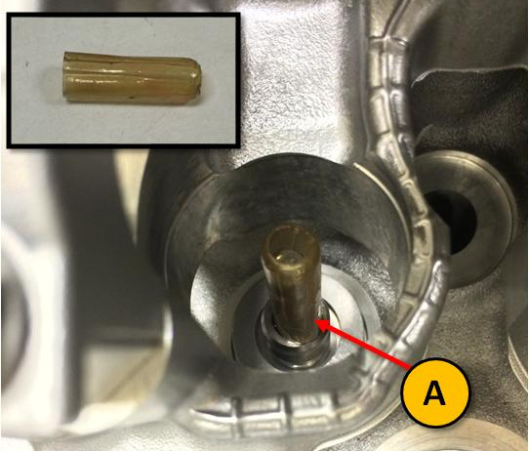 | Refer to Figure 6:  - Slide a 7 mm (0.276 in) OD valve stem protector (A) onto the valve stem.
Figure 6
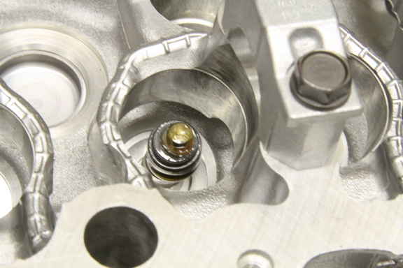 | Refer to Figure 7:  - Install the appropriate valve seal (bronze color for intakes, silver color for exhaust) over the valve stem protector.  Warning: Do not try to force to valve seal to seat onto the top of the valve guide by hand.
Figure 7
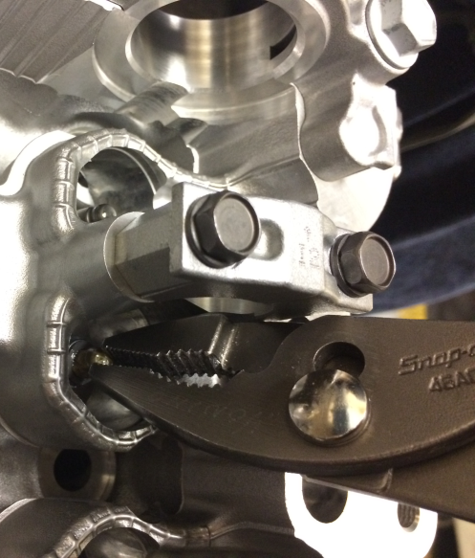 | Refer to Figure 8:  - Using a pair of needle nose pliers, clamp onto the tip of the valve stem protector without damaging the valve stem tip. Pull the valve stem protector out while leaving the valve seal in place.
Figure 8
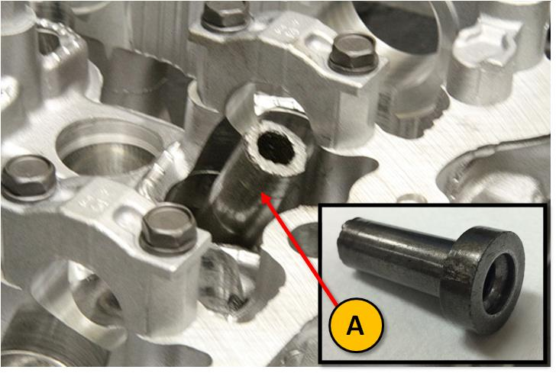 | Refer to Figure 9:  - Place the appropriate valve seal installation tool (A) onto the top of the valve seal.
Figure 9
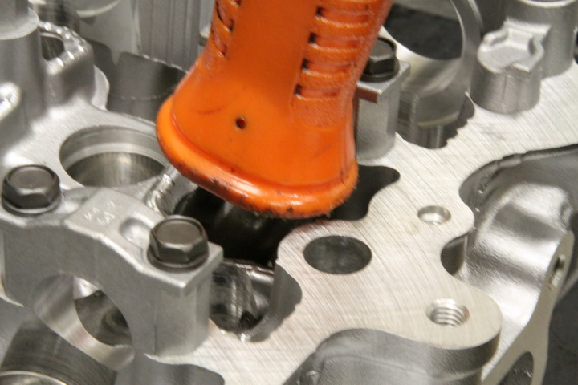 | Refer to Figure 10:  - Apply force evenly on the tool to push the valve seal down.  Note: Apply force by hand; no hammering should be required for valve seal installation. The technician in Figure 10 is applying force by pushing down on the tool with the end of a hammer.  - Repeat steps 9-15 for the other fifteen (15) valve positions.
Figure 10
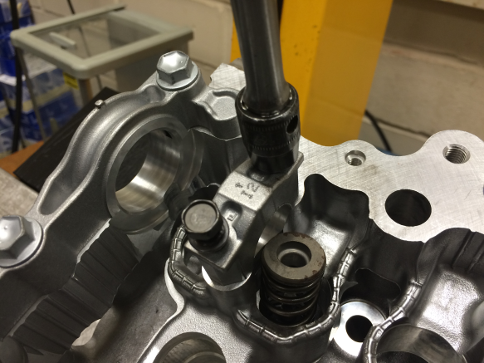 | Installing valve springs:  Refer to Figure 11:  - Using a 10mm socket driver adapted to a speed handle, remove all bolts securing the bearing end caps. Be sure to preserve the positions of the bearing end caps with respect to each other as they are being removed for ease of installation later.
Figure 11
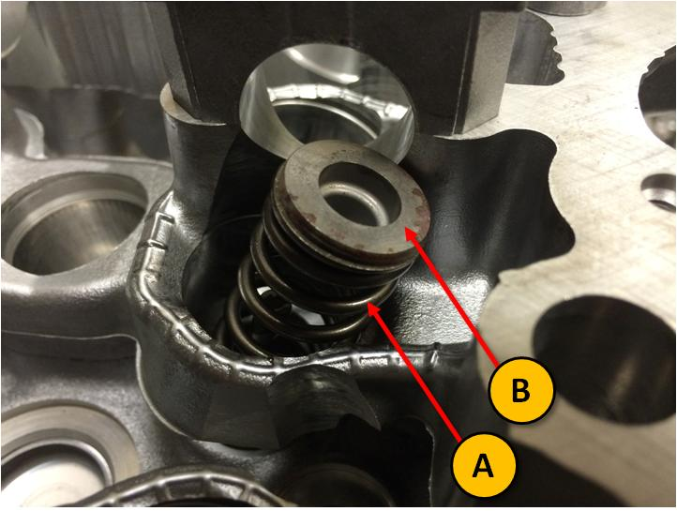 | Refer to Figure 12:  - Place a valve spring (A) and retainer (B) into the valve spring recess.
Figure 12
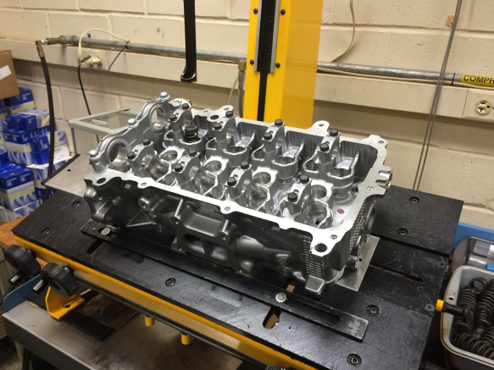 | Refer to Figure 13:  - Place the cylinder head with the combustion chamber down onto a pneumatic valve spring press. If a valve spring press is unavailable, use the proper valve spring installation tool.
Figure 13
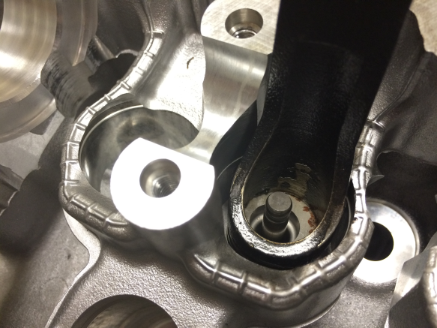 | Refer to Figure 14:  - Compress the valve spring until the valve spring retainer is below the tip of the valve stem. Apply load normal to the valve spring, which is 20° off normal along the longitudinal axis of the cylinder head.
Figure 14
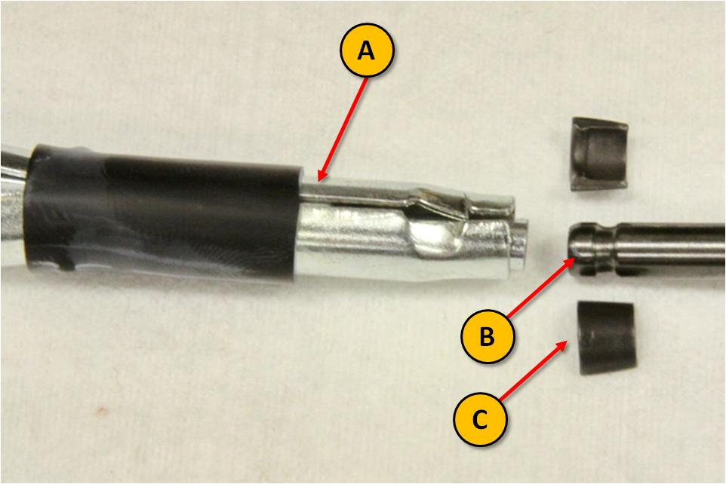 | Refer to Figure 15:  - Install two valve spring retainer locks (C) in the valve retainer lock installation tool (A) (Bosch p/n J-43059, or equivalent). Ensure that the wider end of the taper on the retainer lock is oriented upwards with respect to the valve stem tip (B).
Figure 15
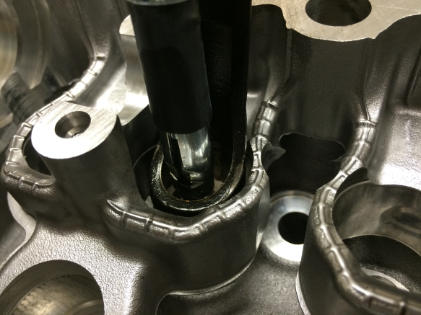 | Refer to Figure 16:  - With the valve retainer lock installation tool holding onto the two halves of the retainer locks, slide the retainer locks onto the valve stem tip.  Warning: Do not release the retainer locks yet.
Figure 16
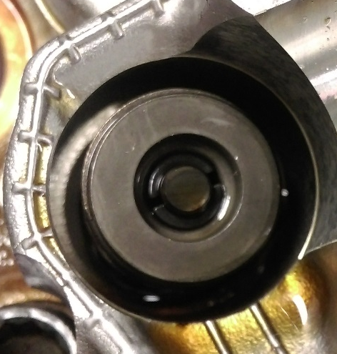 | Refer to Figure 17:  - Decompress the valve spring. As the retainer moves upwards and receives the retainer locks, release the valve retainer lock installation tool.  Note: When the valve spring is in its installed state, the valve spring retainer should be holding the retainer locks in place at the valve stem tip.  - Repeat steps 18-23 for remaining fifteen (15) valve springs.  - Reinstall the bearing end caps in their appropriate positions. Hand-tighten the bearing end cap bolts.
Figure 17
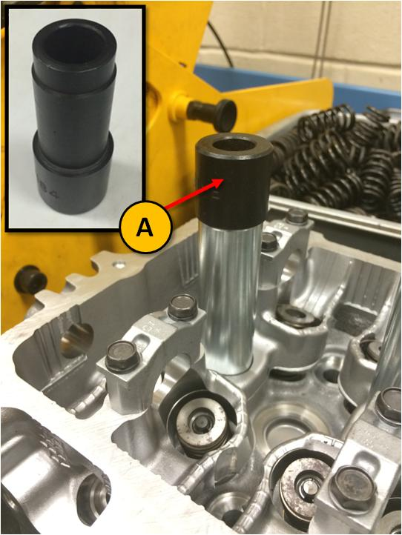 | Installing spark plug tubes:  - Apply a light coat of EF-411 assembly fluid at one end of the spark plug tube.  - Hold the lubricated end of the spark plug tube in contact with the corresponding recess in the cylinder head.  Refer to Figure 18:  - Place the installation tool (A) onto the open end of the spark plug tube.
Figure 18
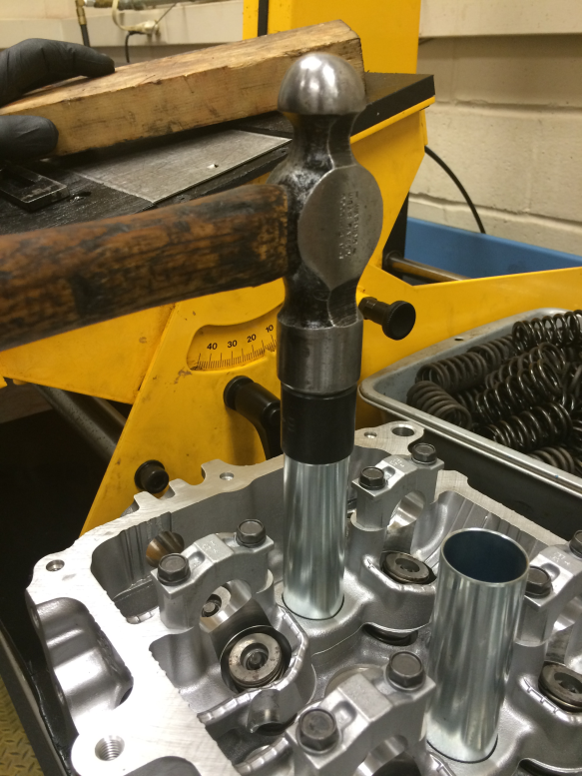 | Refer to Figure 19:  - Hit the tool with a hammer to drive the spark plug tube into the recess. Stop hammering when the spark plug tube reaches the bottom of the recess.
Figure 19

Cylinder Head Removal Procedure
This procedure is to be conducted in the event that the installed cylinder head needs to be replaced with a new cylinder head. This procedure proceeds with the assumption that the camshaft and valve lifters have been removed. If this has not been completed, please refer to Section 2 of the Toyota Engine Assembly Manual for instructions on removing the camshaft and lifters.

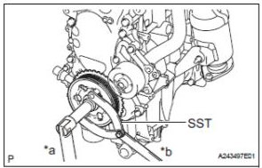 | Refer to Figure 20:  - Using a crankshaft pulley installation tool (OHT p/n OHTIVB-09960-1), hold the crankshaft pulley to prevent the engine from rotating.  - Using a 19 mm socket wrench, remove the crankshaft pulley bolt.  - Remove crankshaft pulley.
Figure 20
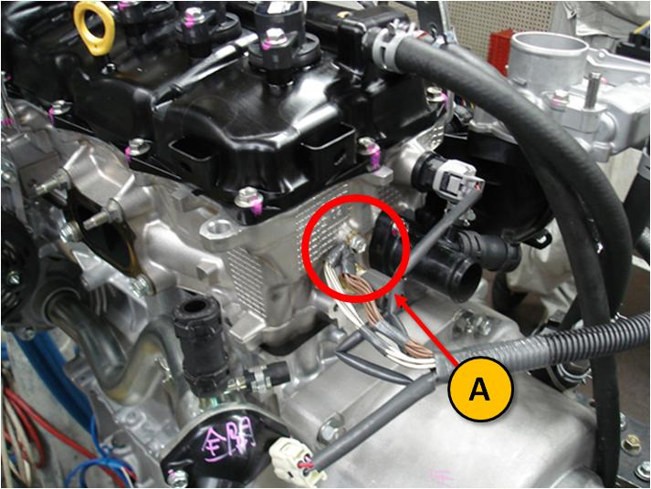 | Refer to Figure 21:  - Using a 14 mm socket wrench, remove the wiring harness ground (A) at the rear of the cylinder head.
Figure 21
Refer to Figure 22:
- Using a 14 mm socket wrench, remove the three (3) bolts that hold the engine mounting bracket to the OHT modified front cover (OHT p/n OHTIVB-003-1).
Figure 22
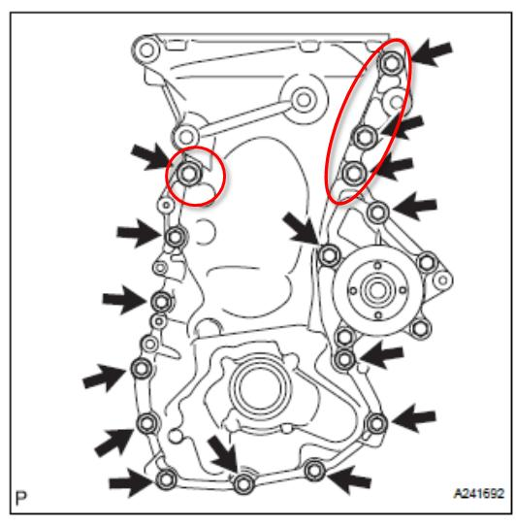 | Refer to Figure 23:  - Using the appropriate socket wrench, remove the thirteen (13) bolts on the engine front cover. The four (4) circled bolts must be removed with a 14 mm socket wrench. The remaining nine (9) bolts must be removed with a 10 mm socket wrench.  Note: Stock front cover is displayed in Figure 23 for illustration purposes only. OHT modified front cover should be used.  - Remove the OHT front cover and O-ring.
Figure 23
Refer to Figure 24:
- Remove the plastic wedge that is forcing the timing chain tensioners apart.

- Push the plunger (marked with an arrow) into the timing chain tensioner.

- Insert a 1.2mm (0.0472in) diameter pin into the hole (marked with a “1”) to lock the plunger.
Figure 24
Refer to Figure 25:
- Using a 10 mm socket wrench, remove the two (2) bolts holding the timing chain tensioner to the engine block.

- Remove the timing chain tensioner.

- Remove and discard the underlying timing chain tensioner gasket.
Figure 25
Refer to Figure 26:
- Using a 10 mm socket wrench, remove the bolt holding the timing chain tension arm to the engine block (marked with an arrow).

- Remove the timing chain tension arm.
Figure 26
Refer to Figure 27:
- Using a 10 mm socket wrench, remove the two (2) bolts holding the timing chain guide to the engine block (marked with two arrows).

- Remove the timing chain tensioner.

- Remove the timing chain.
Figure 27
Refer to Figure 28:
- Using a 12 mm socket wrench, remove the three bolts (black arrows) and two nuts (white arrows) that hold the intake manifold to the cylinder head.

- Remove the intake manifold, and place it securely on the engine stand.

- Remove and discard the intake manifold gasket.
Figure 28
Refer to Figure 29:
- Using a 12 mm socket wrench, remove the two bolts (numbers) and two nuts (numbers) that hold the exhaust pipe assembly to the cylinder head.

- Remove the exhaust pipe assembly, and place it securely on the engine stand.

- Remove and discard the exhaust manifold gasket.
Figure 29
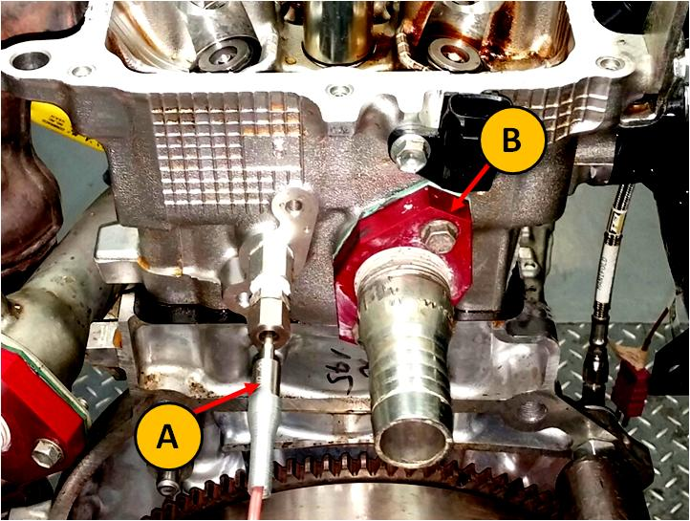 | Refer to Figure 30:  - Using a 10 mm box-end wrench, loosen the compression fitting nut that holds the engine coolant out thermocouple (A).  - Remove the engine coolant out thermocouple.  - Remove the OHT engine coolant out hose barb adapter plate (OHT p/n OHTIVB-005-1) (B).
Figure 30
Refer to Figure 31:
- Using a 10mm bi-hexagonal drive wrench, loosen the ten (10) head bolts in the sequence shown. Loosen in at least three (3) quarter-turn steps.

- Remove head bolts and plate washers.
Figure 31
Refer to Figure 32:
- Using a vernier caliper, measure the length of the head bolt, as indicated. The bolt length is not to exceed 128.2mm (5.01in). Discard the head bolt if it exceeds the maximum limit. Replace with a new head bolt (Toyota p/n 90910-02174).
Figure 32
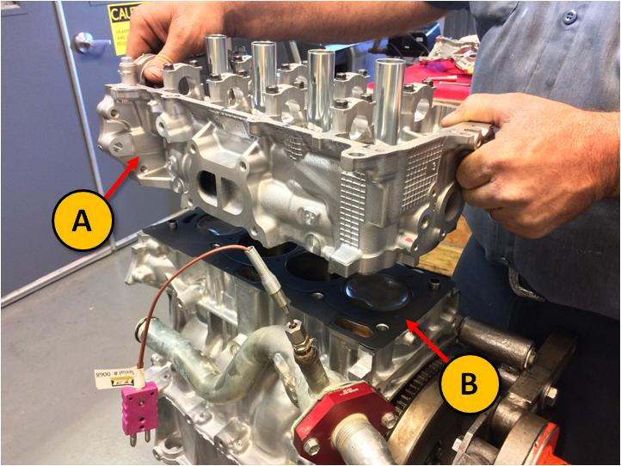 | Refer to Figure 33:  - Remove cylinder head (A).  - Remove and discard cylinder head gasket (B).
Figure 33
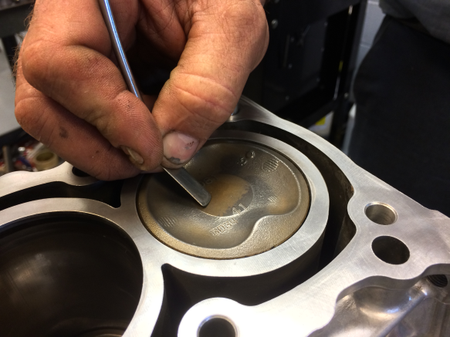 | Refer to Figure 34:  - Using a metal pick, carefully scrape carbon deposits off the piston tops.
Figure 34
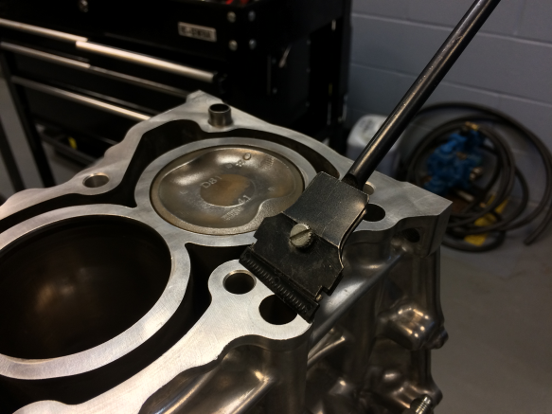 | Refer to Figure 35:  - Using a plastic scraper, scrape off any residual gasket material, silicone, and/or carbon deposits from the cylinder head deck surface and front cover surface.
Figure 35
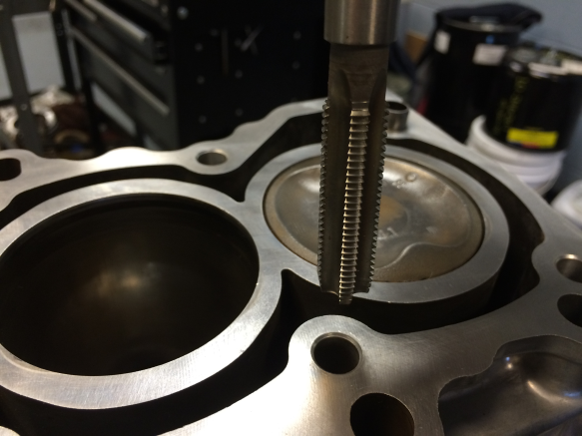 | Refer to Figure 36:  - Using a M10x1.5 tap bit, clean the head bolt hole threads in the engine block.  - Spray degreasing solvent into each bolt hole. Air-dry each bolt hole with clean, dry compressed air. Ensure that no debris remains within each hole.
Figure 36

Cylinder Head Installation Procedure
Refer to Figure 36:
- Install a new cylinder head gasket (OHT p/n OHTIVB-11115-1) in the orientation shown. Ensure that all cylinder head bolt holes on the gasket are aligned with those on the cylinder head deck surface.
Figure 36
- Place the new cylinder head on top of the head gasket.

- Apply a light coat of EF-411 assembly fluid to the threads of the ten (10) cylinder head bolts.

Refer to Figure 37:
- Install the ten (10) cylinder head bolts and ten (10) plate washers into the cylinder head. Using a 10mm bi-hexagonal drive torque wrench, tighten the cylinder head bolts uniformly in several steps in the sequence shown. The target torque is 32 Nm (24 ft-lbf).

- Using a 10mm bi-hexagonal drive wrench, further tighten each cylinder head bolt by one quarter turn in the sequence shown.

- Repeat step 6 to turn each bolt one more quarter turn.
Figure 37
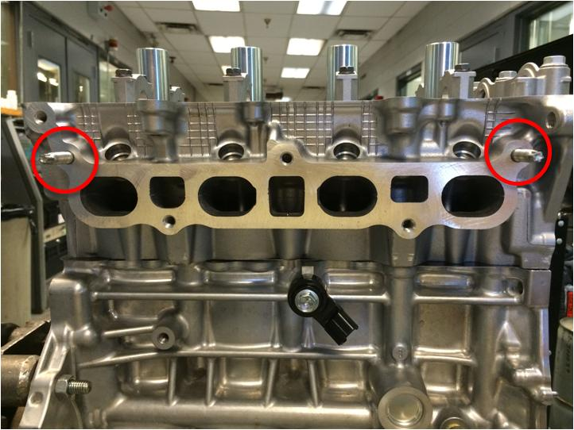 | Refer to Figure 38:  - Install two (2) studs (OHT p/n OHTIVB-08060-1) in the intake side of the cylinder head at the indicated positions.
Figure 38

Refer to Figure 39:
- Install a new intake manifold gasket (OHT p/n OHTIVB-17177-1) on the intake manifold.
Figure 39
Refer to Figure 40:
- Install the intake manifold with three (3) bolts (black arrows) and two (2) nuts (white arrows). Using a 12 mm socket torque wrench, tighten the bolts and nuts to the target torque in the sequence indicated. The target torque is 21 Nm (15 ft-lbf).
Figure 40
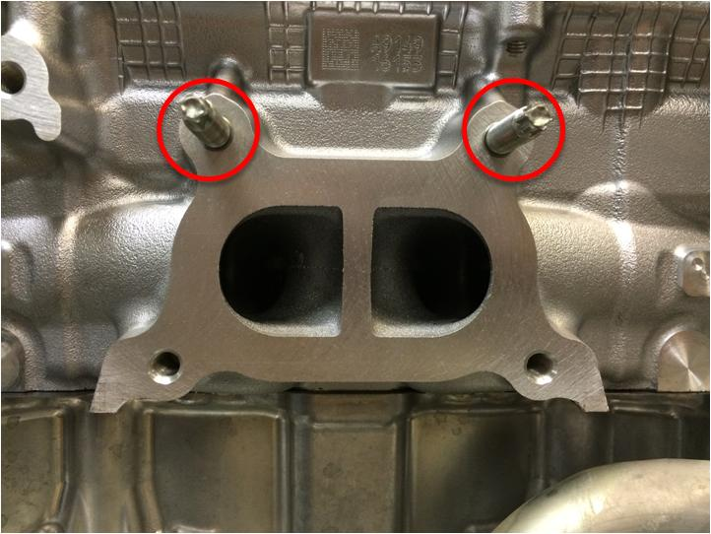 | Refer to Figure 41:  - Install two (2) studs (OHT p/n OHTIVB-08052-1) in the exhaust side of the cylinder head at the indicated positions.
Figure 41
Refer to Figure 42:
- Install a new exhaust manifold gasket (OHT p/n OHTIVB-17173-1) on the exhaust manifold in the indicated orientation. The black arrow indicates vertical direction, and the white arrow indicates the direction to the front of the engine.
Figure 42
Refer to Figure 43:
- Install the exhaust manifold with two (2) bolts (numbers) and two (2) nuts (numbers). Using a 12 mm socket torque wrench, tighten the bolts and nuts to the target torque in the sequence indicated. The target torque is 27 Nm (20 ft-lbf).
Figure 43
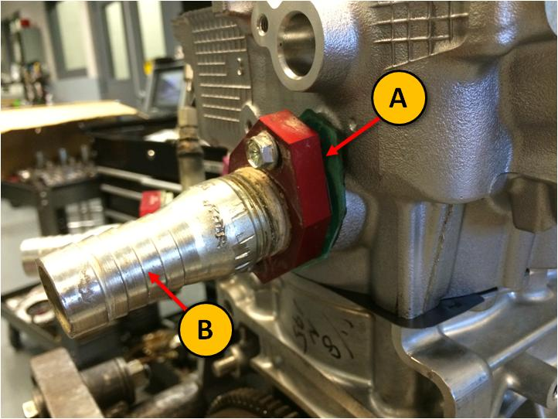 | Refer to Figure 44:  - Install a new gasket (A) for the OHT engine coolant out hose barb adapter plate (B).  - Install the OHT engine coolant out hose barb adapter plate with two (2) bolts. Using a 10 mm socket torque wrench, tighten the bolts to the target torque. The target torque is 10 Nm (7 ft-lbf).  - Install the engine coolant out thermocouple. Using a 1/2 in box-end wrench, tighten the compression fitting nut that holds the engine coolant out thermocouple until snug.
Figure 44
- Follow the instructions in Section 2, Camshaft and Lifter Installation Procedure to install a set of camshafts and lifters used for break-in purposes. Install a new set of intake and exhaust camshaft sprockets (OHT p/n OHTIVB-13523-1).
Note: Some trial and error will be required to select the appropriate lifter grades.

Refer to Figure 45:
- Install the new timing chain guide (OHT p/n OHTIVB-13566-1) to the engine block with two (2) bolts (marked with arrows). Using a 10 mm socket torque wrench, tighten the two (2) bolts holding the timing chain guide to 10 Nm (7 ft-lbf).
Figure 45
Refer to Figure 46:
- Arrange the camshaft sprockets such that the rectangular timing marks are approximately vertical. Arrange the crankshaft sprocket such that the flat edges are vertical.

- Wrap a new timing chain (OHT p/n OHTIVB-13506-1) around the camshaft and crankshaft sprockets. The colored links on the chain should line up with both camshaft sprocket timing marks.
Note: With cylinder 1 in TDC on the compression stroke, the marked plate on the timing chain should be approximately in the position shown.
Figure 46
Refer to Figure 47:
- Install a new timing chain tension arm (OHT p/n OHTIVB-13591-1) with a bolt (marked with arrow). Using a 10 mm socket torque wrench, torque the bolt holding the timing chain tension arm to 10 Nm (7 ft-lbf).
Figure 47
Refer to Figure 48:
- Install a new timing chain tensioner gasket (OHT p/n OHTIVB-13552-1) on the timing chain tensioner.
Figure 48
Refer to Figure 49:
- Install the timing chain tensioner with two (2) bolts. Using a 10 mm socket torque wrench, tighten the two (2) bolts holding the timing chain tensioner to the engine block to 10 Nm (7 ft-lbf).
Figure 49
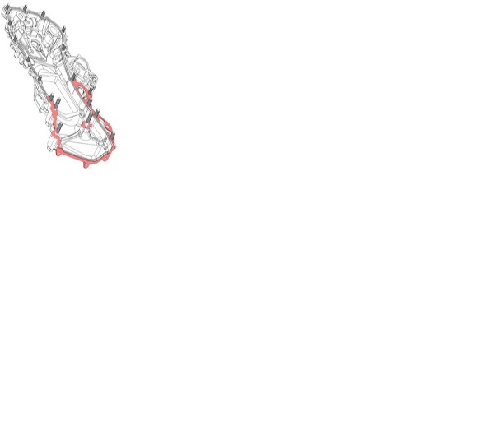 | Refer to Figure 50:  - Install a new O-ring (OHT p/n OHTIVB-003-2) in the O-ring groove on the OHT front cover (OHT p/n OHTIVB-003-1). A suitable adhesive, such as petroleum jelly, may be used to hold the O-ring in place.  - Apply Toyota Three Bond Black 1282B, or equivalent RTV sealant, on the highlighted areas.
Figure 50
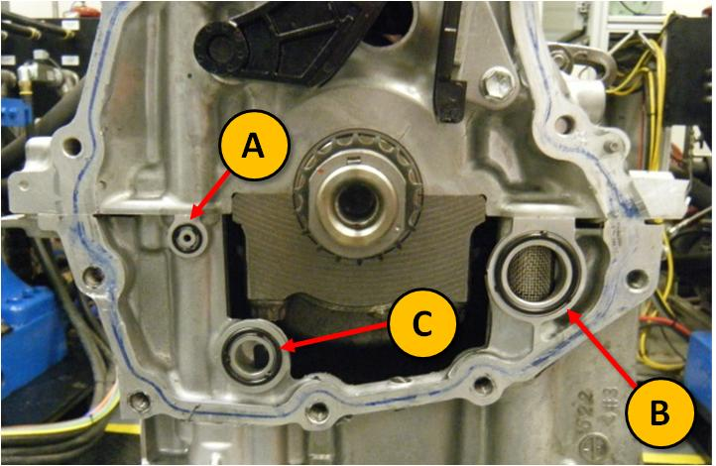 | Refer to Figure 51:  - Install a gasket and O-rings in the locations indicated in Table 2, below.  Table 2: Locations to install gasket and O-rings at front of oil pan
  Location | Description | OHT p/n
  A | O-ring | OHTIVB-09031-1
  B | O-ring | OHTIVB-27014-1
  C | Gasket | OHTIVB-19023-1
Figure 51
Refer to Figure 52:
- Ensure the spline in the oil pump gear is aligned, such that one is pointed left and the other is pointed right while the flat edges on the crankshaft sprocket are oriented vertically.

Figure 52
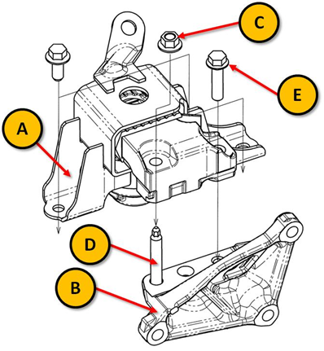 | - Install the front engine mount insulator (A) (OHT p/n OHTIVB-12305-1) on the front engine mount (B) on the engine. Secure with flanged bolt (E) (OHT p/n OHTIVB-10469-1). Note the stud (D) is no longer part of the sub-assembly  - Using a 14 mm socket torque wrench, torque the nut and bolt to 52 Nm (38 lbf-ft).
Figure 53
Refer to Figure 54:
- Install the OHT front cover on the engine with fifteen (15) bolts. The dimension of each bolt is shown in Table 3, below. Hand-tighten only.
Table 3: Dimensions of front cover bolts
Bolt | Length  [mm (in)] | Thread Diameter [mm (in)]
A and E | 25 (0.984) | 8 (0.315)
B | 40 (1.57) | 10 (0.394)
C | 40 (1.57) | 8 (0.315)
D | 70 (2.76) | 10 (0.394)

Note: Apply Toyota Three Bond 1324, or equivalent, adhesive to the threads of Bolt E.

Note: Stock front cover is displayed in Figure 54 for illustration purposes only. OHT modified front cover should be used.

Figure 54
Refer to Figure 55:
- Using the appropriate socket drive adapted to a torque wrench, tighten the eighteen (18) bolts on the timing chain cover to the target torque in the sequence indicated. The target torque for each bolt is listed in Table 4.

Table 4: Target torques for each front cover bolt
Bolt | Target Torque [Nm (ft-lbf)]
A, C, E | 24 (18)
B, D | 51 (38)

Note: Stock front cover is displayed in Figure 55 for illustration purposes only. OHT modified front cover should be used.

Figure 55
Refer to Figure 56:
- Align the set key on the crankshaft pulley with the key groove in the crankshaft. Slide the crankshaft pulley onto the crankshaft.

- Using a crankshaft pulley installation tool (OHT p/n OHTIVB-09960-1), hold the crankshaft pulley to prevent the engine from rotating.

- Using a 19 mm socket torque wrench, install the crankshaft pulley bolt by tightening to 164 Nm (121 ft-lbf).
Figure 56
Refer to Figure 57:
- Mount the wiring harness ground (A) at the rear of the cylinder head. Using a 10 socket torque wrench, torque the mounting bolt to 14 Nm (10 lbf-ft).
Figure 57

This concludes the cylinder head installation procedure. The engine is now ready to undergo the break-in and silicone pacification procedure. Refer to Section D of the Sequence IVB Operations Procedure for instructions to conduct the break-in and silicone pacification.
Test Intake Valve Spring Installation Procedure
This procedure is to be conducted after a cylinder head has completed the engine break-in and silicone pacification procedure in Section D of the Sequence IVB Operations Procedure. The objective is to remove the intake valve springs used during the break-in procedure and to install stiffer test intake valve springs. The procedure detailed in this section can be conducted with the engine on the test stand or removed and placed on an engine build-up stand.

- After the break-in and silicone pacification procedure has been completed, follow instructions in Section 2 of the Toyota Engine Assembly Manual to remove the intake and exhaust camshafts.
Note: Ensure plastic wedge is firmly in place within the timing chain access port to keep the timing chain tensioners from collapsing on the timing chain.

- Using visual cues ensure the piston in cylinder 1 is located at the top-dead-center (TDC) position on the compression stroke. The list of visual cues is detailed in Section 2 of the Toyota Engine Assembly Manual.
Note: The mechanic can check for TDC by inserting a long plastic rod into the open spark plug port. Make sure that the rod is long enough to extend beyond the top of the spark plug tubes. Turn the crankshaft slowly, and watch the rising and falling of the tip of the rod. Stop turning when the tip reaches the apex of its travel. The top of the piston should be approximately 168mm (6.61in) from the top of the spark plug hole.

Warning: When rotating the crankshaft, ensure the timing chain is always in tension to keep the chain links engaged with the crankshaft sprocket. Pull upwards on the timing chain segment exposed at the cylinder head area while rotating the crankshaft to maintain tension in the chain. This is to prevent damage at an extrusion underneath the crankshaft sprocket on the OHT front cover.

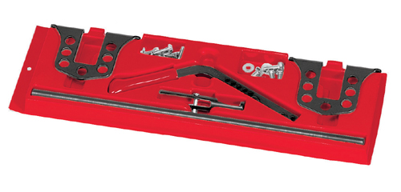 | Refer to Figure 58:  Note: The following procedure details valve spring removal using the Snap-On YA8845 Valve Spring Compressor Tool. However, any equivalent portable valve spring compressor tool can be used for this procedure.
Figure 58
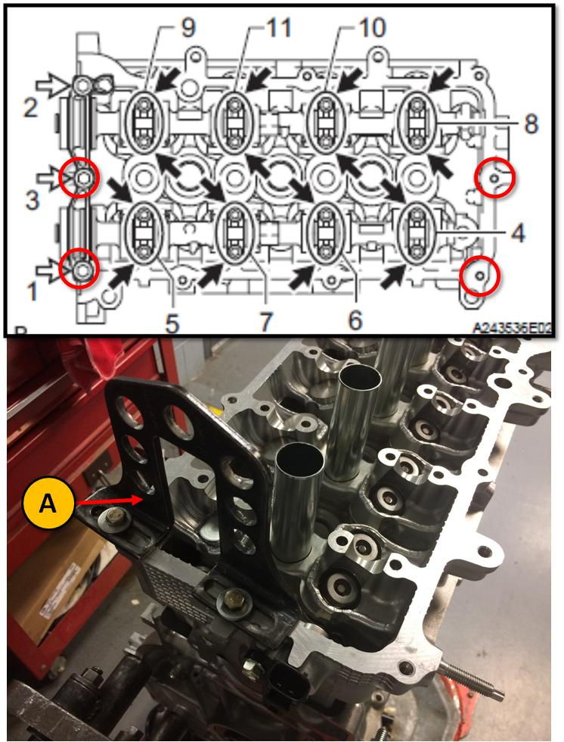 | Refer to Figure 59:  - Mount the fulcrum posts (A) at the front and rear ends of the cylinder head using the bolt holes circled in red. Use M6x1.0 bolts.
Figure 59
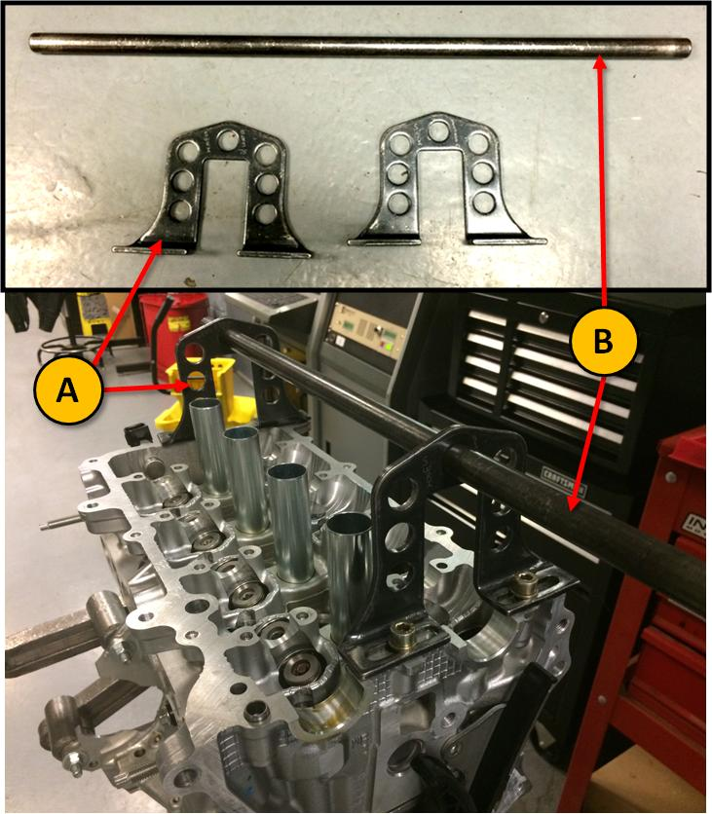 | Refer to Figure 60:  - Place fulcrum rod (B) through the topmost holes in the fulcrum posts (A).
Figure 60
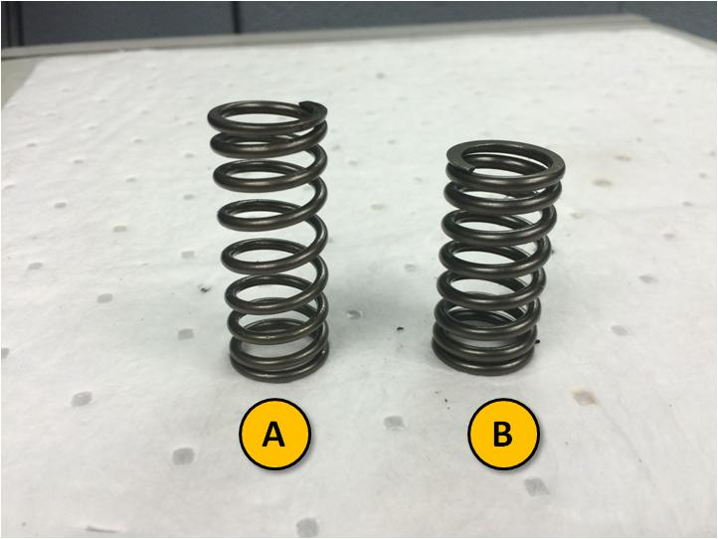 | Refer to Figure 61:  - Obtain eight (8) Sequence IVB intake valve springs (OHT p/n OHTIVB-30034-1) (B). Note the difference between a stock valve spring (OHT p/n OHTIVB-25063-1) (A).
Figure 61
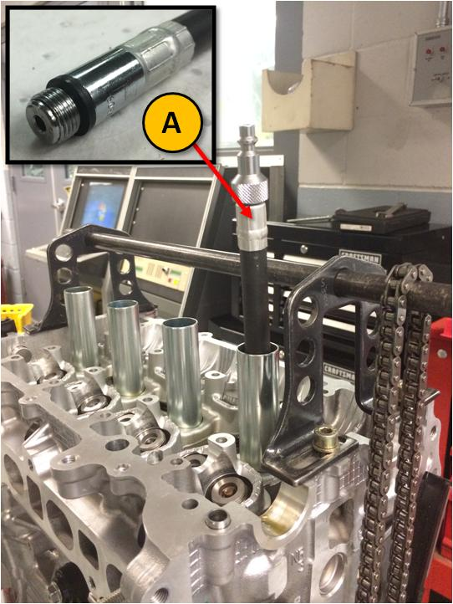 | Refer to Figure 62:  - Hang the timing chain on the fulcrum rod.  - Attach an air line with the correct adapter for the spark plug port (A) to the cylinder 1 spark plug port.  - Pressurize cylinder 1 with dry, clean compressed air.  Warning: If the piston is too far off the TDC position, the compressed air will suddenly push the piston downwards and rotate the crankshaft. Therefore, it is very important that step 2 is strictly followed.
Figure 62
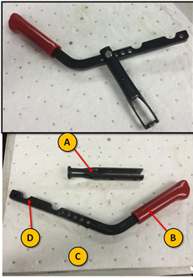 | Refer to Figure 63:  - Connect valve compressor load arm (A) with the valve compressor lever (B) using the second bolt hole from the handle (C).
Figure 63
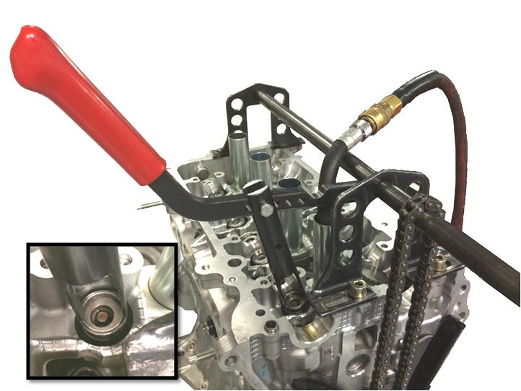 | Refer to Figure 64:  - Mount the compressor load arm on the fulcrum rod. Use the notch on the lever arm that is furthest away from the handle, (D) in Figure 6. The lever arm from the fulcrum to the connection to the load arm should be approximately 100mm. Ensure the load bearing surface of the load arm is making even contact with the top surface of the valve spring retainer (inset) for intake position 1 (closest to the front of the engine). In this configuration, the load arm should be applying even force normal to the top surface of the retainer.
Figure 64
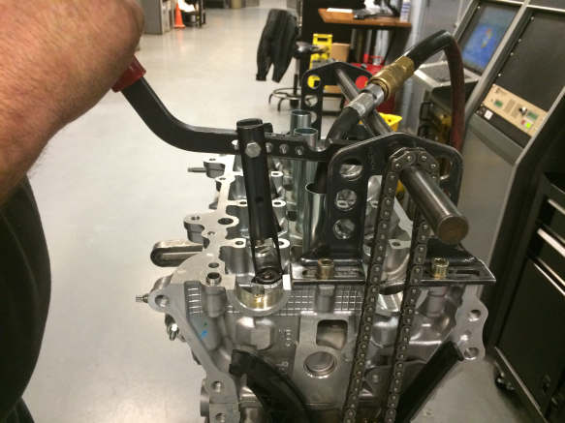 | Refer to Figure 65:  - Pull down on the lever to compress the valve spring until the valve stem tip is above the top surface of the valve spring retainer. The retainer locks should fall off the valve tip.  - Pick up the retainer locks with a magnetic tool.  - Remove the valve spring and the retainer.  - Place a Sequence IVB intake valve spring in place of the stock valve spring.
Figure 65
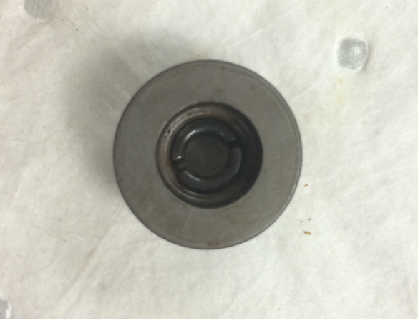 | Refer to Figure 66:  - Place valve spring retainer locks into the recess of the valve spring retainer. Ensure that the larger ends of the taper on the retainer locks are oriented towards the top surface of the retainer.  - Place the valve retainer with the retainer locks on top of the valve spring.
Figure 66
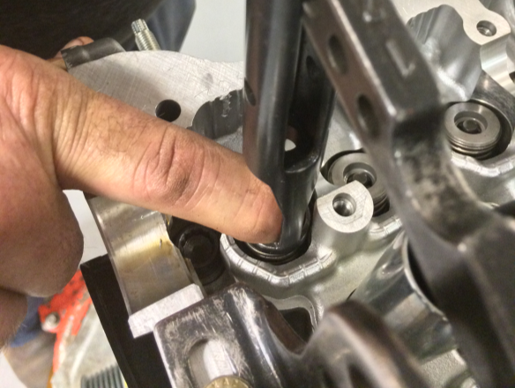 | Refer to Figure 67:  - Place index finger on top of the valve spring retainer to keep the retainer locks from being pushed out by the valve stem tip.
Figure 67
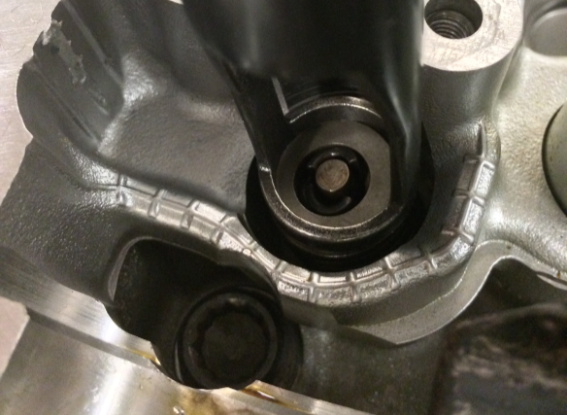 | Refer to Figure 68:  - Pull down on the valve compressor lever to compress the valve spring until the valve stem tip is above the top surface of the valve spring retainer. Allow the valve stem tip to slide upwards between the retainer locks until the extrusions in the retainer locks are roughly at the same vertical level as the receiving grooves in the valve stem tip.
Figure 68
- Slowly and carefully decompress the valve spring. As the retainer moves upwards, it should receive the retainer locks and secure them within the tapered recess.
Note: When the valve spring is in its installed state, the valve spring retainer should be holding the retainer locks in place at the valve stem tip.

- Move the valve compressor tool in position to the next intake valve position. Repeat steps 10-19 for the next valve position.
Note: The intake valve spring positions are designated from 1 to 8, with position 1 being closest to the front of the engine. The test intake valve springs should be installed in the following sequence: 1, 2, 7, 8. When moving from position 2 to position 7, the compressed air line should be moved from the cylinder 1 to cylinder 4 spark plug port.

- Rotate the crankshaft 180°.

- Using the technique detailed in step 2 to ensure that the piston in cylinder 2 is at the TDC position.

- Move the compressed air line from cylinder 4 to cylinder 2. Repeat steps 10-20 to install the test valve springs for positions 3, 4, 5,6, in that order.

This concludes the test intake valve spring installation procedure. The cylinder head is now ready to be used for Sequence IVB testing. For installation of test camshafts, please refer to Section 2 of the Toyota Engine Assembly Manual.

