Gearset Pattern

Status: E.O.T 10/13/09
Serial #: 0048 Sample Request #:CMIR 63277
Customer: Intertek PARC ASTM Model #: 0048
Gearset Number: 5A
Backlash: .005 (Man.)
Ratio: 5.86
Ring Gear Part #: P4T883A Pinion Part #: V1L528
Other Comments: Lubrited Pilot 3 Matrix
Notification To:

Pictures:
Drive Pre-Test Drive End of Test
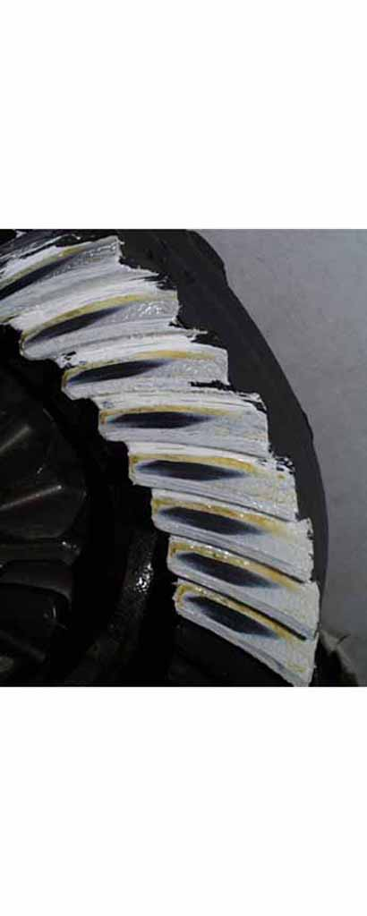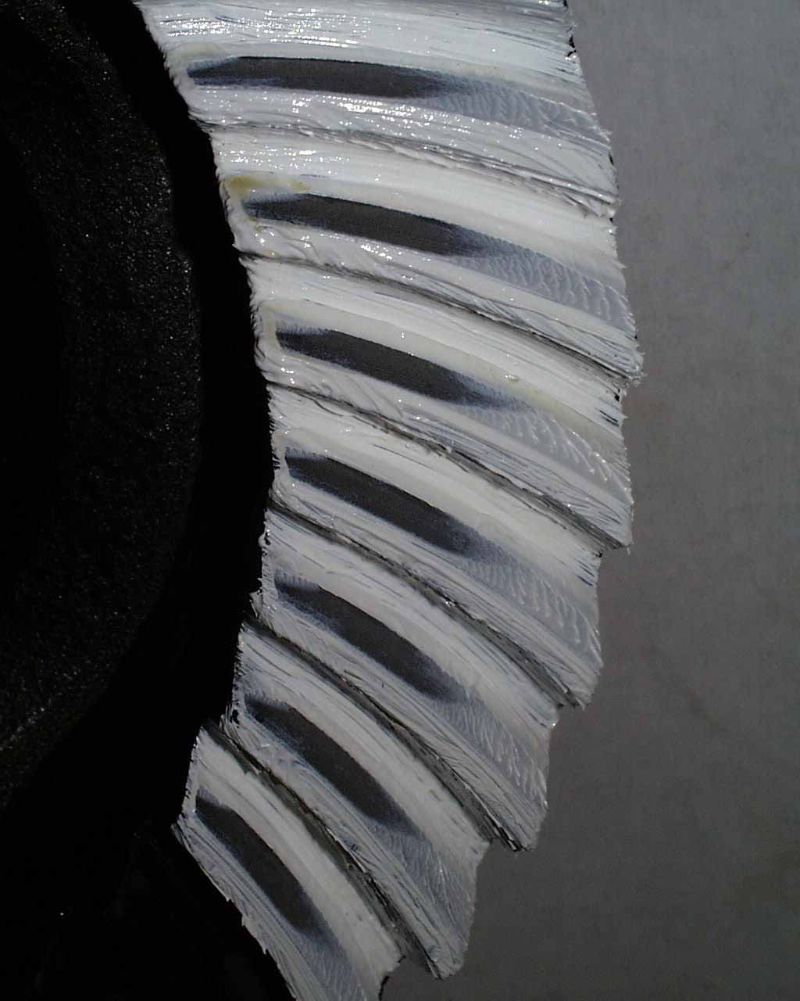

Approver Name:
Approved On:
Approver Comments:

