Gearset Pattern

Status: E.O.T. 11/10/09
Serial #: 0024A Sample Request #: CMIR 65763
Customer: Intertek PARC ASTM Model #: 0024A
Gearset Number: 5P
Backlash: Man. .005
Ratio: 5.86
Ring Gear Part #: P4T883A Pinion Part #: V1L528
Other Comments: Lubrited Pilot 3 Matrix
Notification To:

Pictures:
Drive Pre-Test Drive End of Test
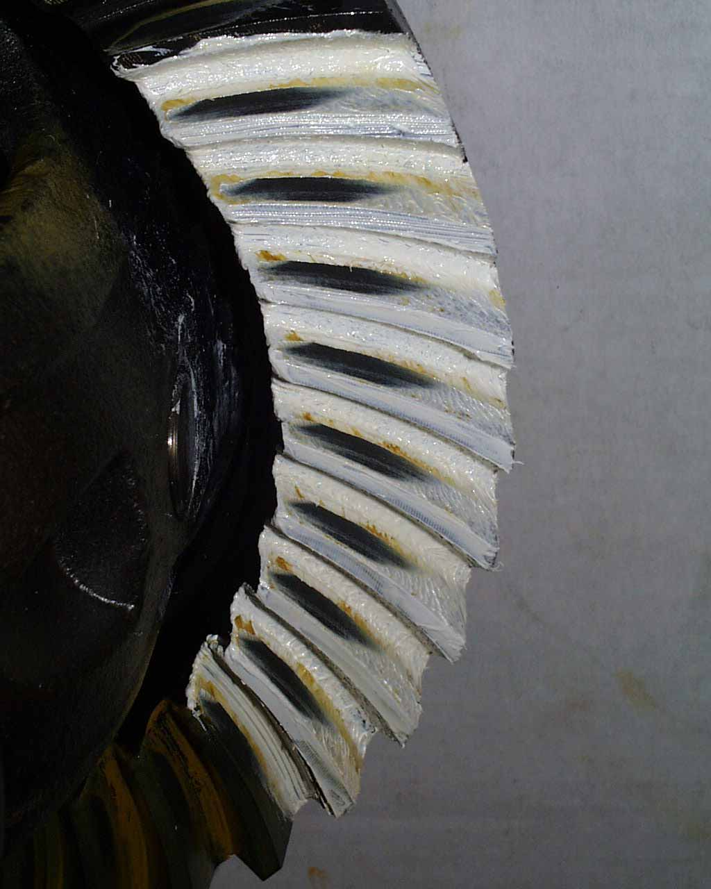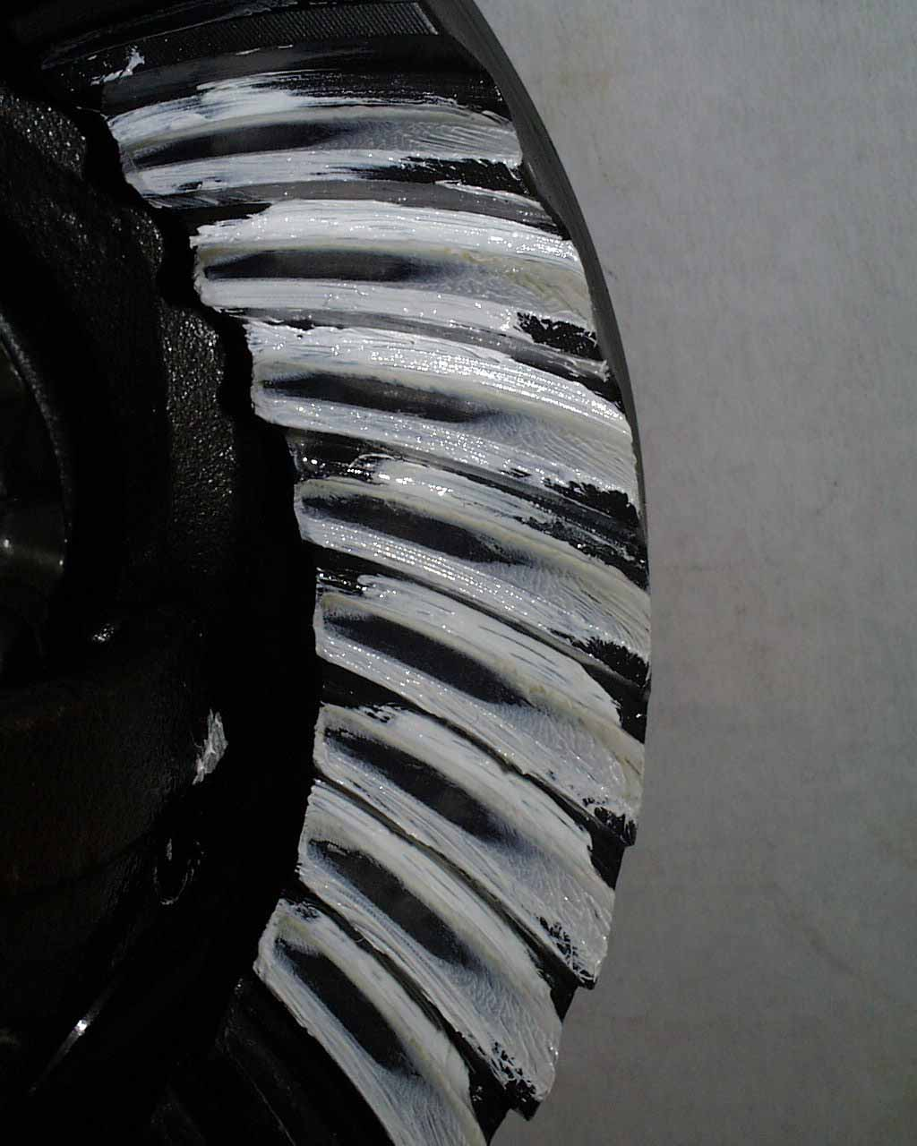

Approver Name:
Approved On:
Approver Comments:

