Gearset Pattern

Status:
Serial #: Sample Request #:
Customer: ASTM Model #:
Gearset Number:
Backlash:
Ratio:
Ring Gear Part #: Pinion Part #:
Other Comments:
Notification To:

Pictures:
Drive Pre-Test
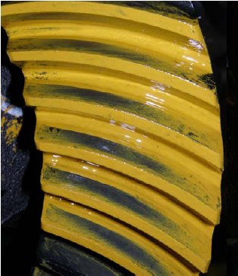

Drive End of Test
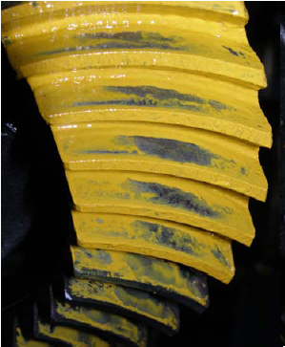

Approver Name:
Approved On:
Approver Comments:

