Gearset Pattern

Status: E.O.T. 01/18/10
Serial #: 0068 Sample Request #: CMIR 71470
Customer: Intertek PARC ASTM Model #: 0068
Gearset Number: 5T
Backlash: Man. .007
Ratio: 5.86
Ring Gear Part #: P4T870A Pinion Part #: V1L500
Other Comments: Lubrited Matrix
Notification To:

Pictures:
Drive Pre-Test Drive End of Test
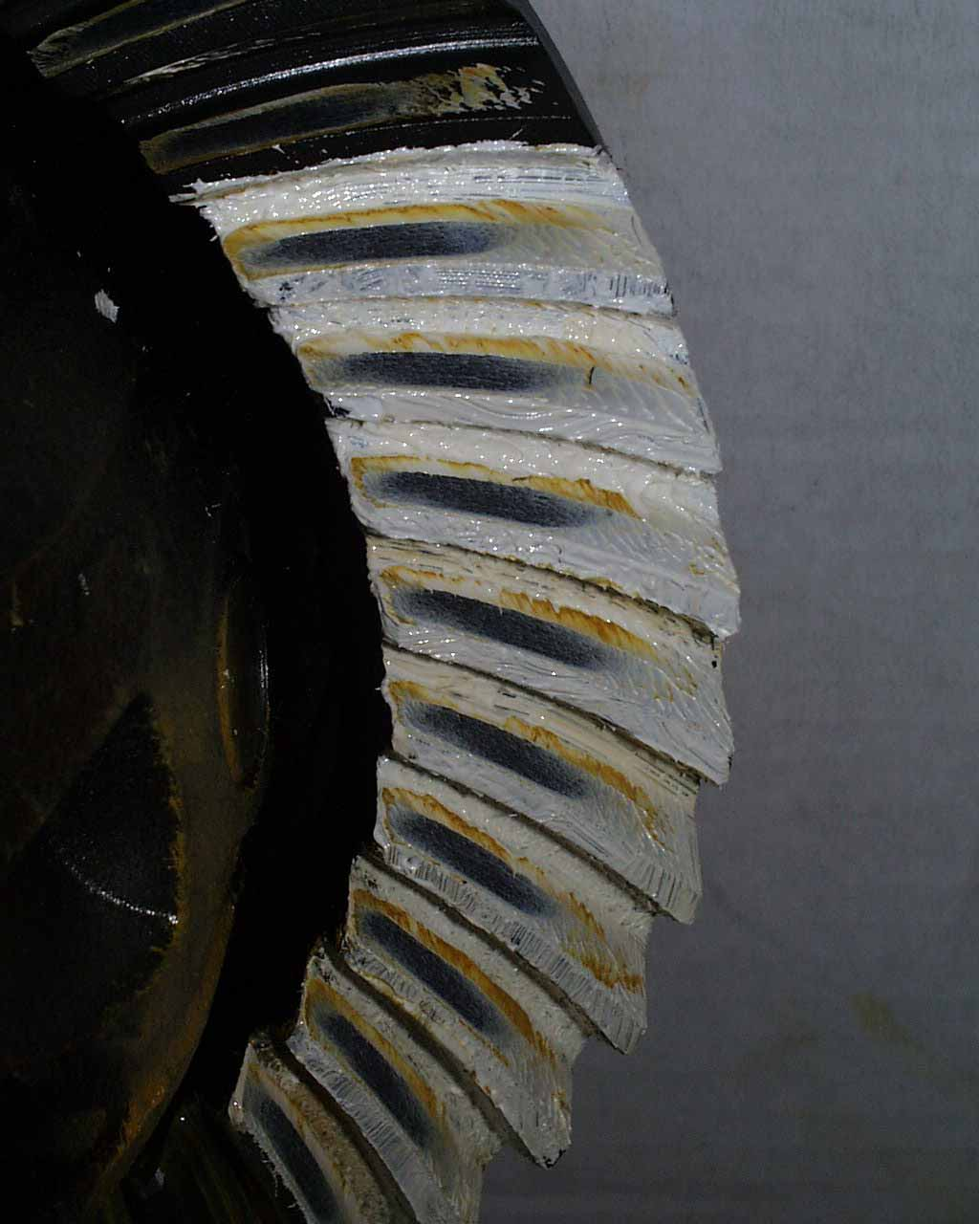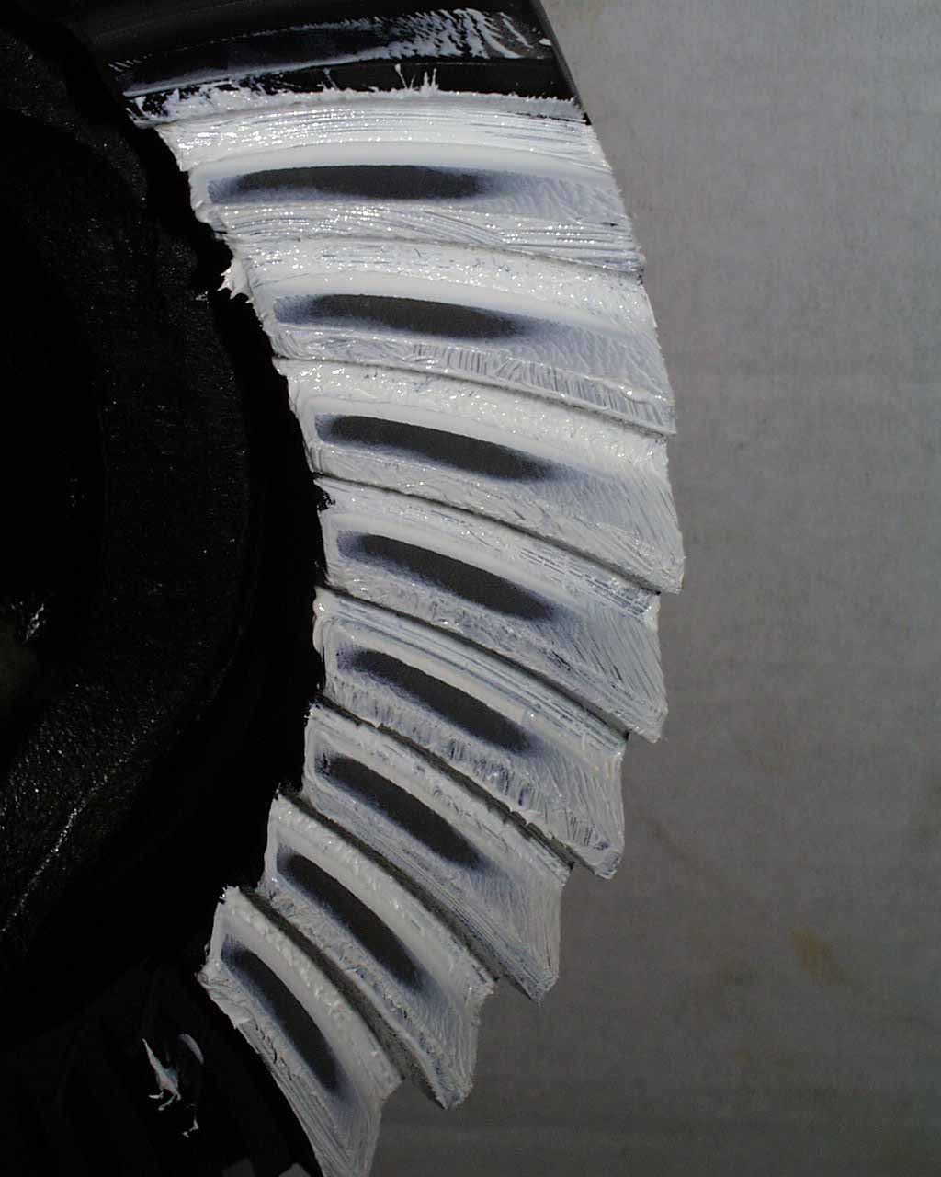

Approver Name:
Approved On:
Approver Comments:

