Gearset Pattern

Status: E.O.T. 02/04/10
Serial #: 0082 Sample Request #: CMIR 67401
Customer: Intertek PARC ASTM Model #: 0082
Gearset Number: 0J
Backlash: Man. .005
Ratio: 5.86
Ring Gear Part #: P4T870A Pinion Part #: V1L500
Other Comments: Lubrited Matrix
Notification To:

Pictures:
Drive Pre-Test Drive End of Test
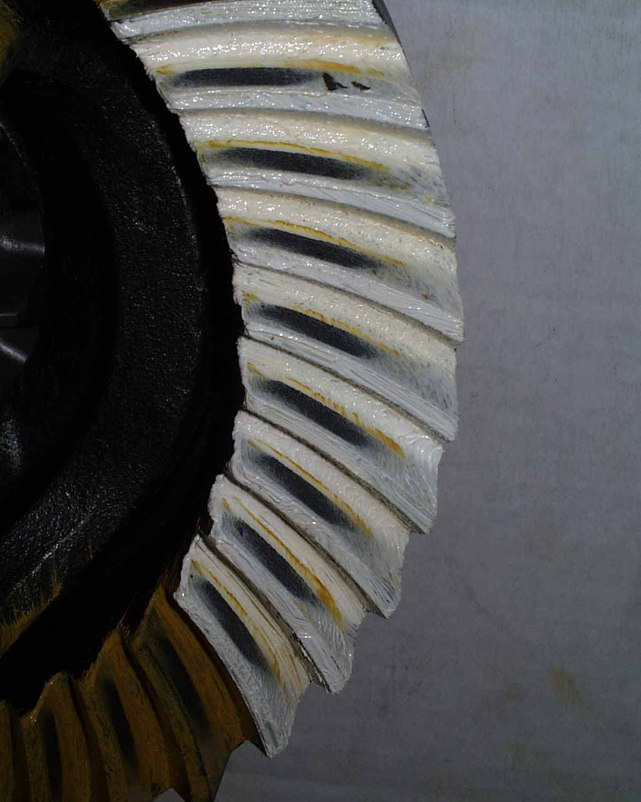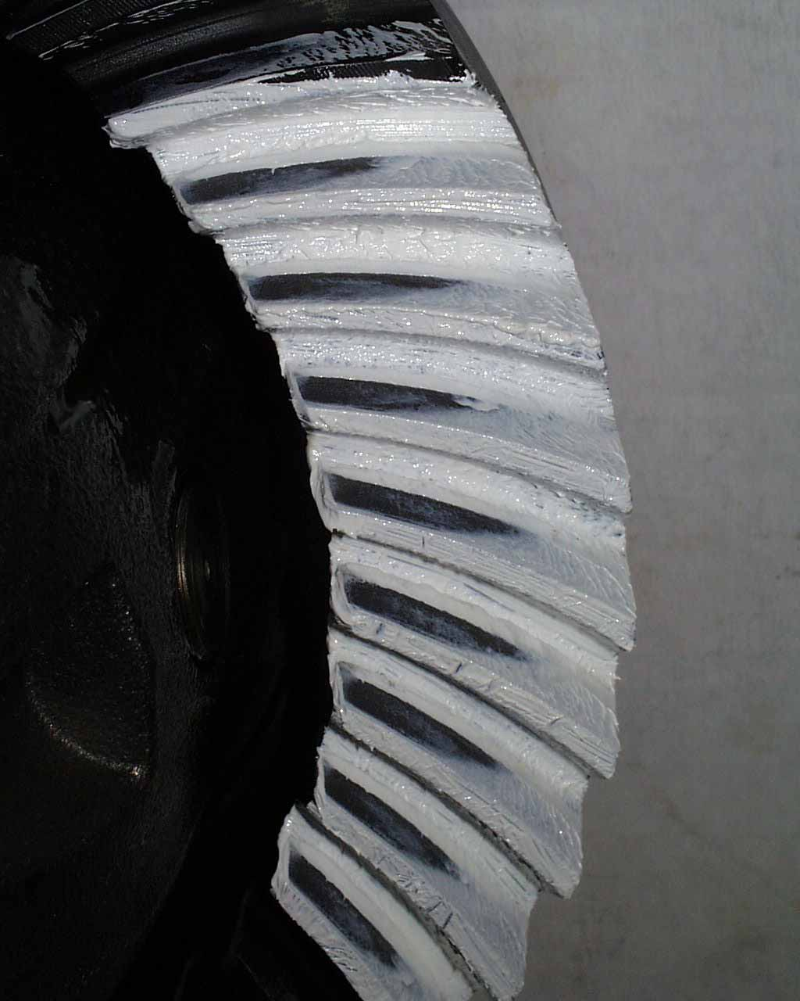

Approver Name:
Approved On:
Approver Comments:

